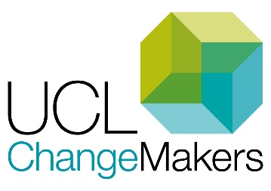

ChangeMakers: Case study template
This form can be filled out by individuals or teams. Please also Include a landscape, high resolution photograph of the team or of some of the events/activities that happened during your project.

Part 1: Background information

Your name(s):
Your contact details: (please provide the contact of at least one member of staff connected with the project)
Your department/institute and faculty:
Project title:
Other team members:

Part 2: Metadata
Which category do you think your project falls into (delete any that do not apply):
- Academic & Peer Support
- Assessment & Feedback
- Curriculum design & Development
- Equitable & Inclusive Teaching
- Learning Community & Belonging
- Learning Resources
- Online & Blended Learning
- Other

Please summarise what your ChangeMakers project is about in one or two sentences:

Part 3: Your project

Please answer the following questions so that we can write up this piece but feel free to skip questions if they are not relevant/applicable to your project or if you don’t feel you are able to answer. We would be grateful if you could keep in mind that this case study may be used on both websites for both students and staff, from all disciplines.

- What did you set out to do and why was this project important?

- How did it go?

- What was the outcome of the project? What difference has this made to staff or students?
Any statistics or quotes or evidence that the project was successful would be great e.g. changes in NSS scores, from your evaluation, quotes etc.

- What are you most proud of?

- What was involved in terms of approach, logistics, time or resources? (To give readers a sense of the amount of work it took and any challenges you faced).

- ChangeMakers projects are intended to support students and staff working in partnership. How did this aspect of the project go?

- What was your specific role in the project (if completing on behalf of the project team)? What did you learn as a result of being involved?

- What, if any, are your next steps for this project?

- What advice would you give another team or department who wanted to do a similar project? Please give your top 3-5 tips.
1.
2.
3.

---
Thank you for writing a case study. Return completed forms to: changemakers@ucl.ac.uk
(See our local privacy notice to understand how your information will be stored and used.

