UCL Chamber Music Club: G15 Chandler House booking regulations and instructions

Opening hours

G15 is available for use by Chamber Music Club members, subject to teaching requirements, from 5-7pm Mon-Fri. It is also available on a Saturday, but users need to be accompanied by a Chandler House staff member as access is dependent on the onsite library opening hours and cannot be guaranteed.

Users should be aware that G15 is a teaching room and in the event that it is needed for teaching, bookings may be cancelled.

Making a booking

1. Before booking a time slot, users should check the availability of the room at
http://www.phon.ucl.ac.uk/building/booking.php?q=Diary&nweek=4&room=G15

2. If you are a UCL member of staff you can book the room yourself via the online room bookings system: https://www.ucl.ac.uk/estates/our-services/room-bookings/book-room

Please follow the following steps:

a. Log in and then under bookings, from the drop-down menu click “Find and Book”. Please note that your timetable will look different (this is Bronwen’s timetable).

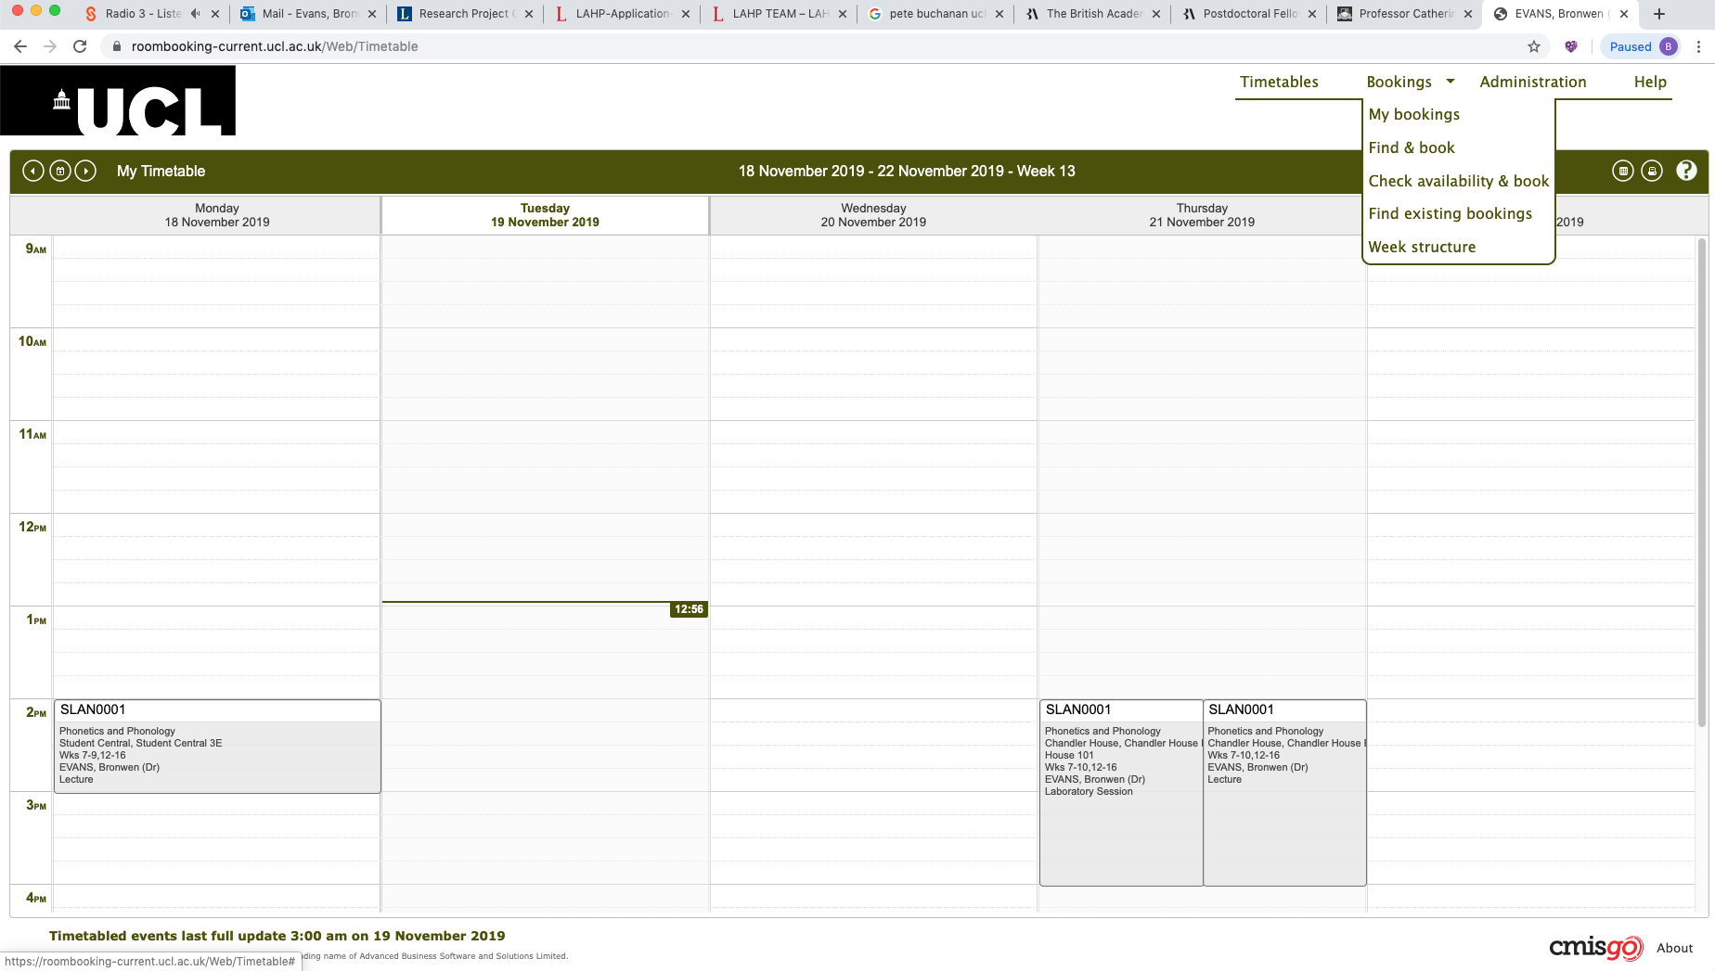

b. Fill in the dialogue box, exactly as below, and then click next;

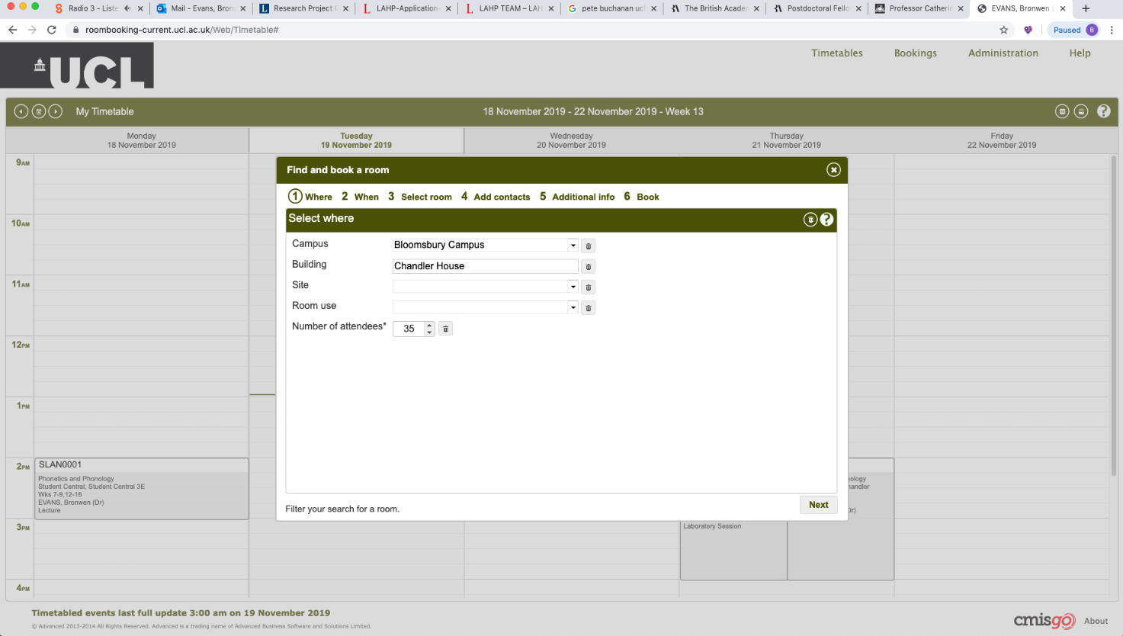

c. Select dates and times: you can select multiple dates and times. Click next

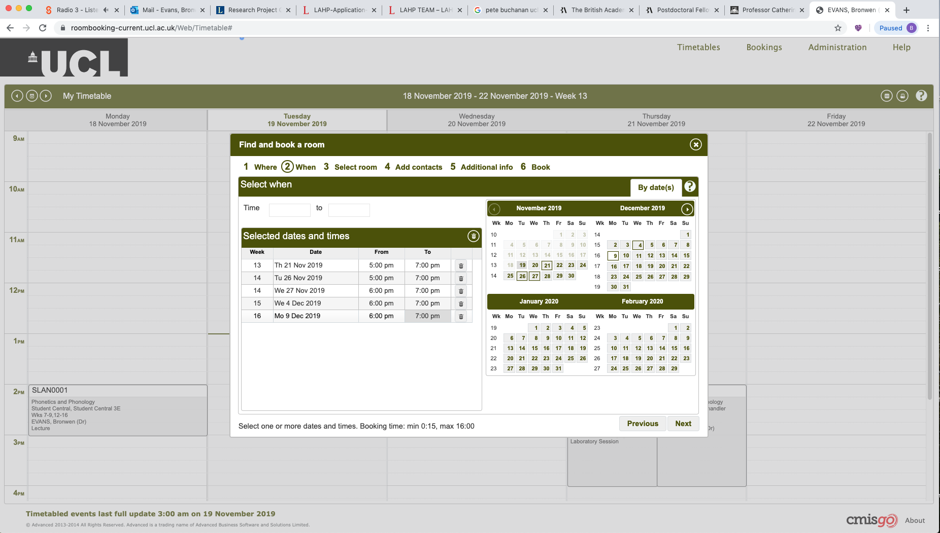

d. Assuming that the room is free, G15 will come up (see screenshot below). If G15 is not free for any of the dates you have listed, then it will not come up as an option. If you don’t see G15 listed as an option, then check your dates/times against the online bookings link in (1) and adjust.

Select G15 (highlighted as in screenshot below) and click next.

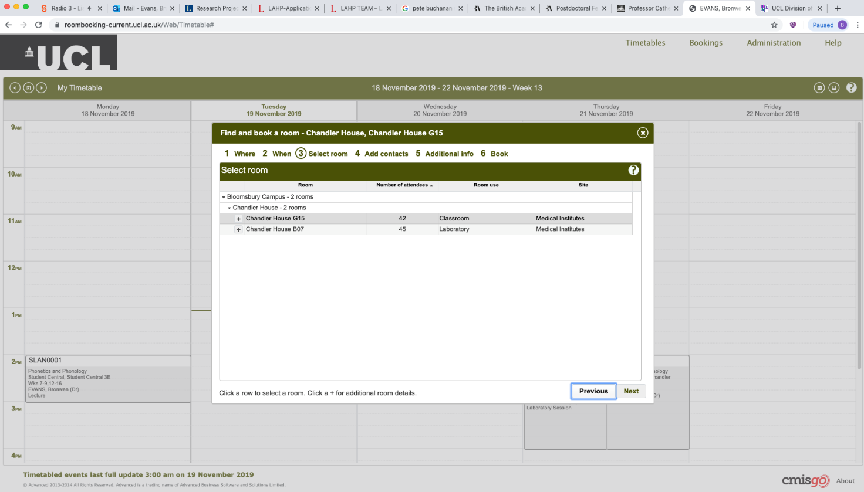

e. In the following dialogue boxes complete the information as follows;

Select the contact. Your name should be listed so select this. You can also add other names by typing their name in the box.

Additional Information - type N/A

Booking title: add UCL Chamber Music Club (see screenshot below) then click Book. Do not close your browser until you are directed to the confirmation page. You will also receive a confirmation email to your UCL email address.

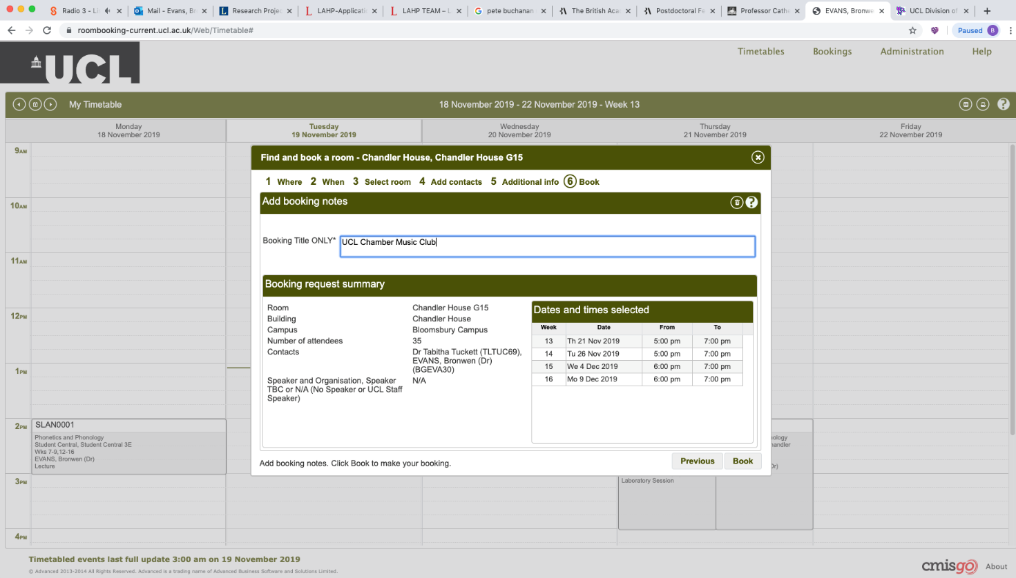

If you are a UCL student or former staff/student without a UCL user ID and password, please check room availability and then email Dr Bronwen Evans with your requested slot, bronwen.evans@ucl.ac.uk. Please try to allow at least 1 working day for your booking, i.e., for bookings on Monday, please email by lunchtime on Friday.

Please note that bookings cannot be made more than 28 days in advance.

Accessing the room:

Chandler House is swipe card entry only and you will need a valid UCL ID in order to access the building. If you do not have a UCL swipe card then you will need to show your UCL CMC membership card and sign in at the front desk and ask the security guard to let you through. Please note that you may be asked to show your membership card whilst using the room, so please make sure that you have this with you.

G15 is on the ground floor; on going through the barriers, carry straight on past the lift and stairs, and go through the set of double doors. G15 is the room facing you. If the doors are locked, ask the security guard on the front desk to open the room for you. The piano is currently unlocked.

Important

- If you use the room for a larger rehearsal and need to change the seating, please return the room to its original layout. Please note that the chairs in this room have flip tables attached to them. A small number of music stands are stored under the piano or at the back of the room.

- It is important to vacate the room promptly at the end of the final session of the day so that the room can be locked by the security guard.

