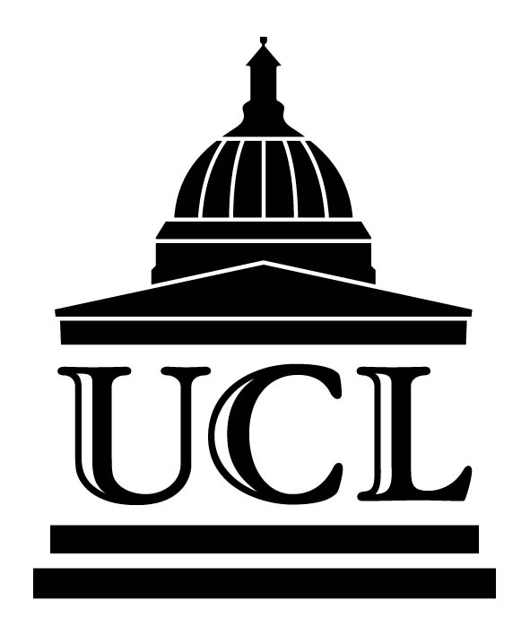 | UCL Chamber Music Club  Honorary President: Tamás Vásáry  A Concert of  Renaissance Music  6.00 pm, Tuesday 7 June 2005  Thomas Lewis Room  Rockefeller Building  (entrance in University Street) | 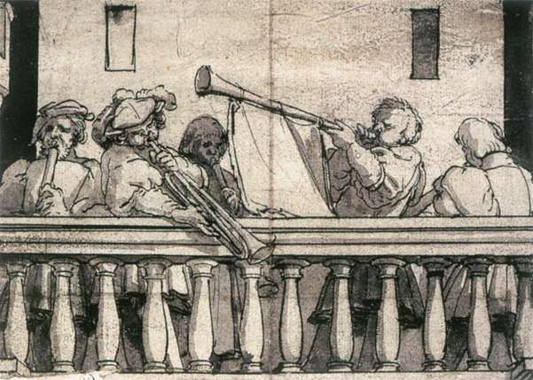
Sinfonia

La Padovana Lodovico Grossi da Viadana (c.1560 - 1627)
Southwark Waits (dir. Bernard Thomas)

Two Renaissance Motets for unaccompanied choir
O Vos Omnes Tomás Luis de Victoria (1548 –1611)
Super Flumina Babylonis Giovanni Pierluigi da Palestrina. (c.1526 - 1594)

UCL CMC Chamber Choir (dir. Chris Sherlaw-Johnson)

Venetian music for brass and wind
Derelinquat Impius Ascanio Trombetti (1544-1590)
Deus Qui Beatum Marcum Giovanni Gabrieli (1557-1612)
Renaissance music for recorders
by John Dowland, William Byrd, Claudio Monteverdi and Daniel Friderici

UCL CMC Recorder Ensemble: Annika Lindskog, John Minty,
Mary Pearce, Outi Jokiharju and Romany Kebar
From the Seventh Book of Madrigals by Claudio Monteverdi
Ohimè dov’e il mio ben and Chioma d’oro

Annika Lindskog, Jill House sopranos
John Lindon harpsichord

Finale
Canite Tuba Francisco Guerrero (1528-1599)
Beatus Vir Claudio Monteverdi (1567-1643)

UCL CMC Choir
Bronwen Evans, Michael Duchen violins
Sarah Bridle ‘cello Roger Beeson harpsichord
Southwark Waits
Entry is free -- All working at UCL or UCH are warmly invited
This is the Final Concert of Summer Term and will be followed by wine and refreshments
http://www.ucl.ac.uk/chamber-music/

