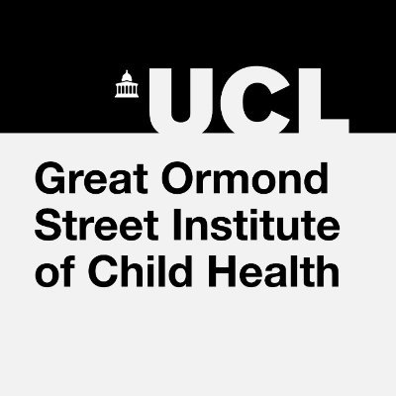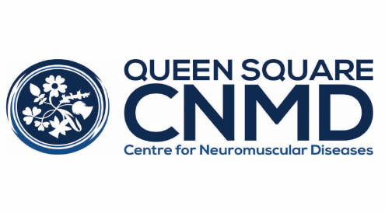
Sanofi and Roche have provided sponsorship for this meeting but have had no involvement in the agenda, educational content or the organisation of the meeting.

AGENDA
UPDATE IN NEUROMUSCULAR DISORDERS COURSE 2023
Date | Tuesday 2 - Thursday 4 May 2023
Venue | Clinical Neuroscience Lecture Theatre, Basement, 33 Queen Square, London WC1N 3BG
DAY 1 TUESDAY 2nd MAY
THEME: The floppy infant and updated diagnostics
09:30 - 10:00 | Registration and coffee
10:00 - 10.30 | Approach to diagnosis on the floppy infant | Dr Adnan Manzur
10:30 - 11:00 | Role of whole genomic sequencing in the floppy infant | Dr Anna Sarkozy
11:00 - 11:30 | Illustrative cases
11:30 - 12:00 | Break
THEME: Congenital myasthenic syndrome/channelopathies in infancy and muscle MRI
imaging
12:00 - 12:30 | Congenital myasthenic syndromes and skeletal channelopathies in infancy | Dr Pinki Munot
12:30 - 13:00 | Muscle MRI; a neuromuscular diagnosis - artificial intelligence in pattern recognition | Dr Luke Perry
13:00-14:00 | LUNCH
THEME: Corticosteroid in Duchenne muscular dystrophy
14:00 - 14:20 | Corticosteroid practice in DMD in the UK | Dr Giovanni Baranello
14:20 - 14:45 | Updating corticosteroid regimes in line with evidence | Dr Michela Guglieri
14:45 - 15:15 | Bone health implications and recommendations for DMD corticosteroid practice | Dr Claire Wood
15:15 - 15:30 | Panel discussion | Led by Giovanni Baranello
15:30 - 16:00 | Break
THEME: Cardiac management in DMD and myotonic dystrophy
16:00 - 16:30 | Update on cardioprotective therapies in DMD | Professor Michael Burch
16:30 - 17:00 | Cardiac management of paediatric myotonic dystrophy | Dr Elena Cervi

You are invited to a drink’s reception in the lecture theatre foyer after the meeting
DAY 2 WEDNESDAY 3rd MAY
THEME: Spinal Muscular Atrophy (SMA) type 1 and novel genetics treatments
09:00 – 09:45 | Onasemnogene zolgensma in SMA | Professor Eugenio Mercuri
09:45 – 10:15 | Biological basis of response to novel medication in SMA1 | Professor Francesco Muntoni
10:15 – 10:45 | Best management of "poor responders" to first line novel therapy Zolgensma /Nusinersen/ Risdiplam: Panel discussion | Chaired by Professor Francesco Muntoni
10:45 - 11:15 | Break
THEME: SMA type 2 and 3 in adults and novel treatments
11:15 – 12:00 | Nusinersen and Risdiplam in adults with SMA2 and SMA3 | Dr Channa Hewmadduma
12:00 – 12:30 | Goals and challenges in UK adult SMA practice: interactive discussion | Chaired by Dr Channa Hewmadduma
12:30 – 13:20 | LUNCH
THEME: Neuromuscular diseases in children / adults: dystrophy, metabolic, CMT, GBS
13:20 – 14:00 | Managing Duchenne's Muscular Dystrophy in adolescence and adults | Professor Ros Quinlivan
14:00 - 14:45 | Metabolic neuromuscular conditions seen in children and adults | Dr Elaine Murphy
14:45 - 15:30 | New insights in mitochondrial disease | Dr Rob Pitceathly
15:30 - 16:00 | Break
16:00 - 16:30 | Surgical management for CMT foot deformity | Mr Matthew Welck
16:30 - 17:00 | Update on Guillain Barre Syndrome | Professor Mike Lunn
DAY 3 THURSDAY 4th MAY
THEME: Neuropathies, FSH and channelopathies
09:00 - 09:30 | New technologies for diagnosis of inherited neuromuscular disorders | Dr Andrea Cortese
09:30 - 10:15 | Nutritional neuropathies | Dr Alex Rossor
10:15 - 11:00 | Neuromuscular complications of checkpoint inhibitors and other new cancer therapies | Dr Aisling Carr
11:00 - 11:30 | Break
11:30 - 12:15 | Emerging therapies for Facioscapulohumeral (FSH) dystrophy | Dr Enrico Bugiardini
12:15 - 13:00 | Update on channelopathies | Professor Mike Hanna
13:00 - 14:00 | LUNCH
THEME: MND, Mitochondrial diseases, MG and IBM
14:00 - 14:45 | Emerging therapies for Motor Neurone Disease | Professor Andrea Malaspina
14:45 - 15:15 | Update on myasthenia gravis | Dr Jennifer Spillane
15:15 – 15:45 | Inclusion body myopathy : where are we? | Professor Pedro Machado
15:45 – 16:00 | Closing comments | Professor Mary Reilly

