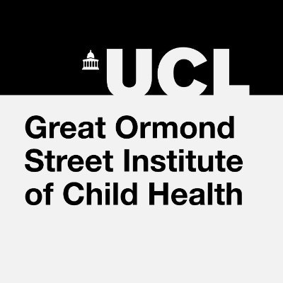 | 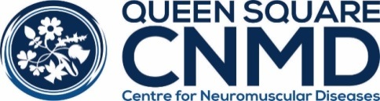
UPDATE IN NEUROMUSCULAR DISORDERS

Tuesday 7 – Thursday 9 May 2024

Clinical Neuroscience Lecture Theatre, Lower Ground
33 Queen Square, London WC1N 3BG

The Update in Neuromuscular Disorders covers a wide range of childhood and adult neuromuscular disorders with an emphasis on clinical issues, natural history studies, disease specific treatments and general management. This three-day course is designed for specialists with an interest in neuromuscular diseases. The first 1.5 days concentrates largely on paediatric neuromuscular disorders and the second 1.5 days on adult neuromuscular disorders.

The themes this year will be:
Paediatric: Congenital myopathies, Arthrogryposis, Duchenne Muscular Dystrophy, respiratory management in neuromuscular diseases, Spinal Muscular Atrophy (SMA) and childhood Myasthenia gravis.
Adult: Channelopathies, Nodal/paranodopathies, Limb girdle dystrophies, Metabolic myopathies, Mitochondrial diseases, Charcot Marie Tooth disease, peripheral nerve vasculitis, paraproteinaemic neuropathies, TTR amyloidosis, Motor Neurone disease and inflammatory myopathies
Click her to view the draft programme
Course organisers: Professor Mary Reilly and Professor Michael Hanna, Queen Square Centre for Neuromuscular Diseases, UCL Queen Square Institute of Neurology and the National Hospital for Neurology and Neurosurgery, UCLH Hospitals Foundation Trust, Professor Francesco Muntoni, Dr Adnan Manzur and Professor Giovanni Baronello, UCL Institute of Child Health and Great Ormond Street Hospital

On-line registration: F85 Neuromuscular Update Meeting 2024 | UCL Online Store
Costs for 2024  (Early bird) until 31 March 2024 | Day rate | Whole course
Consultants/pharma rates | £170 (£160) | £425 (£400)
Trainee rate (UK) | £80  (£70) | £200 (£180)
Trainee rate (non-UK) | £130 (£120) | £320 (£300)
Allied professionals (physios, nurses) | £110 (£100) | £275 (£250)
Course co-ordinator Jacky Bauer j.bauer@ucl.ac.uk 0044 203 448 8111
www.cnmd.ac.uk RCP and RCPCH CPD approval will be applied

