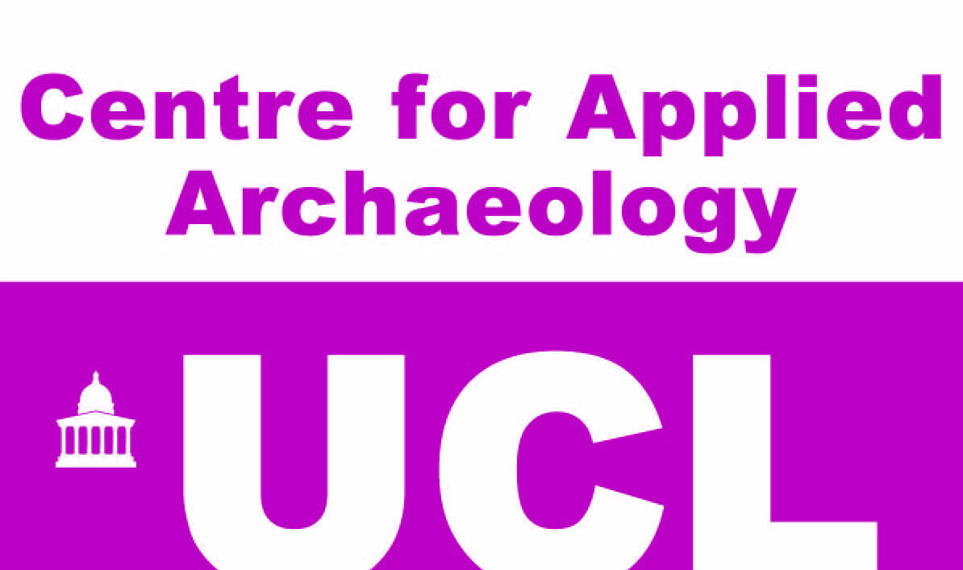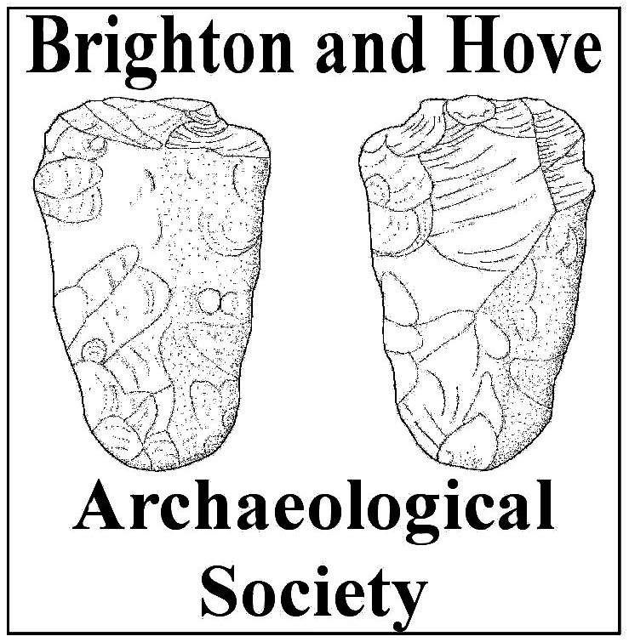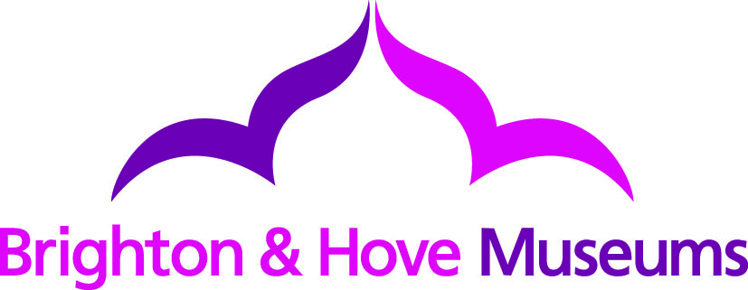

Whitehawk Camp Community Archaeology Project: Geophysical survey of Whitehawk Causewayed Enclosure reveals the 5,500 year old monument and suggests the presence of previously unknown archaeological features

A geophysical survey of Whitehawk Causewayed Enclosure, undertaken by the Centre for Applied Archaeology (CAA) and the Brighton and Hove Archaeological Society (BHAS), has revealed previously unknown archaeological features hidden beneath the ground. The work was undertaken as part of the Whitehawk Camp Community Archaeology Project which aims to connect Brighton's communities with the nationally important Whitehawk Causewayed Enclosure, the burial place of Brighton's first residents.

The team used a type of geophysical survey called magnetometry to ’map’ magnetic anomalies in the soil, rock and bedrock. The survey was undertaken to find out more about the extent and nature of this nationally significant Stone Age site and also, importantly, to help the project team to decide on the location of a community excavation set to take place on the site from 11th-29th August 2014.

The survey highlights the damage caused to the monument since it was listed as one of Sussex's first Scheduled Ancient Monuments in 1923. However, recent magnetic debris (such as disturbed soil containing ash or other burnt material) also served to highlight the presence of archaeological features. This debris infilled the top of the monument's ditches and depressions and provided a clear response when surveyed by the magnetometer. Whilst the archaeological deposits onsite are extremely important to research they have no intrinsic value and date from before the use of metal. The site is protected by law and unlicensed excavation or metal detecting could result in prosecution.

Excitingly, the survey detected several possible archaeological features, which could dramatically extend the size of the monument (currently the size of 8 football pitches) and/or provide further detail as to the lives of the Neolithic or Stone Age people who constructed it. The archaeological excavation during August will target these potential features and assess whether they relate to the monument.

Meanwhile, work on the archive of archaeological finds from the 1920s and 30s excavations has commenced this week at Brighton Museum and Art Gallery and we are hoping for some more archaeological revelations from the archives!

For further information and volunteering opportunities please visit http://www.ucl.ac.uk/caa/whitehawk-hlf or find us on Facebook 'Whitehawk Camp Community Archaeology Project' or Twitter @DigWhitehawk or Tumblr http://digwhitehawk.tumblr.com/

Notes to editors

The Whitehawk Camp Community Archaeology Project Partners

University College London - Centre for Applied Archaeology
The Centre for Applied Archaeology (CAA), and its professional arm Archaeology South-East (ASE), is part of the Institute of Archaeology, University College London and employs a team of over 70 professional archaeologists working out of offices in Portslade, London and Essex. As well as undertaking commercial work CAA aims to connect archaeologists in commercial practice, academic/research professionals and local communities in the shared goal of protecting and investigating our historic environment. CAA is committed to ethical and sustainable approaches, which build on and enhance the capacity of local communities to benefit from the historic and archaeological interest of the places they inhabit.

Brighton & Hove City Council - Royal Pavilion and Museums
The Royal Pavilion and Museums (RPM) brings together world class heritage, art and culture, with the iconic Royal Pavilion at its heart. It is one of the leading museums in the country, and one of only 16 granted Major Partner status by Arts Council England. RPM holds wide ranging, multi-themed collections, including a natural history collection designated of national importance, Ice Age, Neolithic and Bronze Age archaeology, and extensive local social, oral history and archival records. Over the past three years, the RPM has piloted new ways of working with audiences that have shown the enormous potential and appetite for genuine engagement. Building on this, one of the RPM’s key aims is to create contemporary, challenging exhibitions that engage and inspire, developed in collaboration with cultural partners, artists and community groups.

Brighton and Hove Archaeological Society
Brighton & Hove Archaeological Society, a registered charity, with a membership of 300, was founded in 1906, and through its long history has been a leader in the fields of archaeology and local history. The Society organises for its membership, a wide range of actives including lectures, walks and visits, and via its Field Unit, carries out excavation and post excavation work. It trains the members of the Field Unit to work up to professional standards. Their outreach activities include working with schools and local organisations from Brighton and Hove, and from East Sussex. They closely work with Brighton & Hove City Council, East Sussex County Council and Archaeology South-East; relationships which will stand them in good stead as a partner in this Project.

About the Heritage Lottery Fund
Using money raised through the National Lottery, the Heritage Lottery Fund (HLF) aims to make a lasting difference for heritage, people and communities across the UK and help build a resilient heritage economy. From museums, parks and historic places to archaeology, natural environment and cultural traditions, we invest in every part of our diverse heritage. HLF has supported almost 36,000 projects with more than £5.9bn across the UK. www.hlf.org.uk.

For further information, images and interviews, please contact
Jon Sygrave,
Project Manager
Archaeology South-East
j.sygrave@ucl.ac.uk
01273 426834

Images

Ed Start races to the finish line whilst surveying Whitehawk Camp with a Magnetometer (with thanks to Brighton Racecourse for access)



