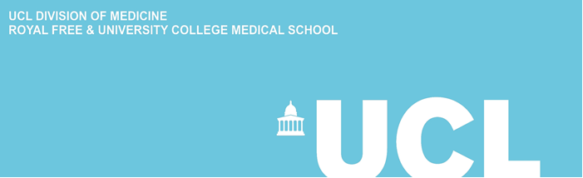
UCL INSTITUTE OF CARDIOVASCULAR SCIENCE

ICS CAREERS EVENT

Careers in Cardiovascular Science

Monday 18th November, 2019

Rayne Building, 2nd Floor Seminar Room (210),
5 University Street, London WC1E 6JF

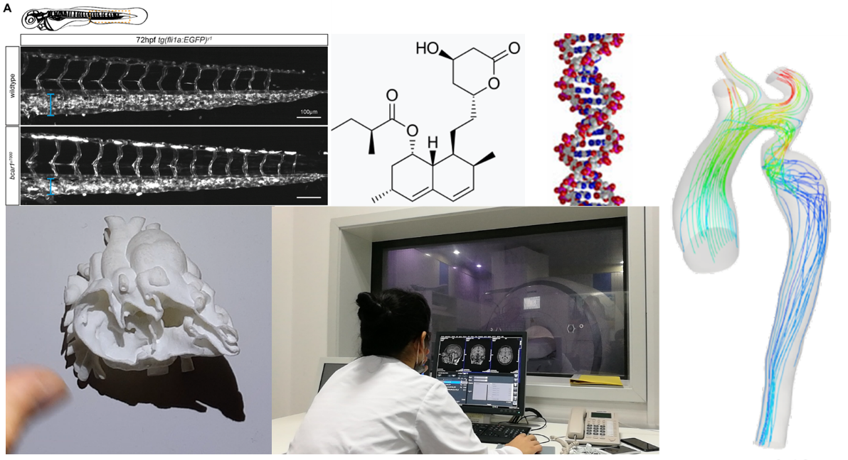

Institute of Cardiovascular Science (ICS): https://www.ucl.ac.uk/cardiovascular/
UCL Careers Service: http://www.ucl.ac.uk/careers/students
UCL Innovation & Enterprise: https://www.ucl.ac.uk/enterprise/students
Students’ Union UCL Volunteering: http://studentsunionucl.org/volunteering

A photographer will be taking images to use for promotional purposes that include display on our website, Twitter, and any other reasonable avenues. If you do not wish to be photographed, please email ann.walker@ucl.ac.uk or inform event staff upon your arrival.

13:00 | Dr. Ann Walker,  Associate Professor, Population Science and Experimental Medicine, ICS. | Introduction and welcome.
13:05 | Chairs:  Dr. Claudio Capelli, Senior Research Fellow, Children’s Cardiovascular Disease, ICS;  Ms. Vanessa Acquaah, BHF 4 year PhD Student, ICS (UCL MSc Alumnus).
13:10 | Ms. Jo Budd,  Career consultant,  UCL Careers. | What UCL Careers Service has to offer!  Advice on internships.
13:30 | Mr. John Braime,  Volunteering Partnerships Manager,  Volunteering Service, UCL. | Volunteering and employability.
13:45 | Dr. Parisa Samangouei,  Postdoctoral Research Fellow, Preclinical and Fundamental Science, ICS  (MSc Alumnus 2012-13,  UCL PhD Alumnus 2018). | MSc to PhD to Post Doc.
14.00 | Ms. Emma Cook,  Medical student MBBS, King’s College London,  GKT Medical School,  (MSc Alumnus 2017-18). | MSc to Medical School.
14:15 | Prof. Silvia Schievano,  Professor of Biomedical Engineering, Children’s Cardiovascular Disease, ICS. | Innovation and entrepreneurship in cardiovascular science: turning an academic idea into a biomedical device.
14:30 | Tea, refreshments and networking.
15:00 | Chairs:  Prof. Andrew Cook, Centre for Cardiac Morphology, Children’s Cardiovascular Disease, ICS;  Dr. Vanessa French, Postdoctoral Research Fellow, Preclinical and Fundamental Science, ICS.
15:05 | Prof. Sean Davidson,  Group Leader, The Hatter Cardiovascular Research Institute, Preclinical and Fundamental Science, ICS. | A career in research.
15:20 | Dr. Ayodipupo Oguntade,  Senior Registrar, University College Hospital, Ibadan, Nigeria, (MSc Alumnus 2018/19). Via Skype. | The MSc in a career as a Cardiologist.
15:35 | Dr. Alexandros Protonotarios,  Senior Clinical Research Associate, Clinical Science,  ICS. | From clinical medicine to an academic career.
15:50 | Dr. Paul Frankel,  Group Leader, Preclinical and Fundamental Science, ICS. | From Biotechnology to Start-ups and Research Group Leader.
16:10-17:00 | Drinks, snacks and networking.
v.2

