FACS Diva Quick Start Guide

All 3 flow cytometers – both Fortessa X20 and FACS Symphony – run on BD FACS Diva software.

Below is a quick start guide to set up an experiment using the Diva software.

**Start Up**

If you are first person to use the instrument, switch on the computer and make sure it is booted up into Windows 7.

Click on the icon labelled **regmcyto** on the right hand side of the screen

When prompted, type the password **“Facs2016”**.

NB Allow the computer to boot up fully so the workstation can connect with the cytometer.

Turn on the Cytometer on *via* the green button on the right hand side of the machine.

Open up the FACS DIVA software by double clicking on the icon on the desk top.

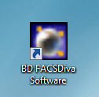

Next Log into your user area. **If you do not have one, we can assign one for you.**

**Creating an Experiment**

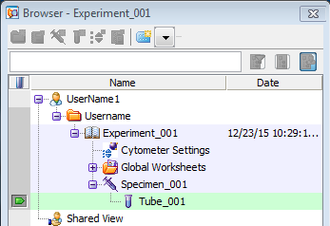

1. Right click on your username folder in the Browser window and select **New Experiment**.

The template window pops up, click OK to load a blank experiment.

2. Next, create a specimen - Right click on experiment and select **New Specimen** from the menu.

3. Expand the **Specimen** by clicking on the little “-”, changing it to “+”.

Double click on the tube so **Tube_001** appears. window goes green.

4. Click the tab in the margin and **make sure it turns green** so the **Cytometer window** is open.

**Setting up an Experiment**

Click on the **Parameter Tab** (arrowed) in the **Cytometer Window**:

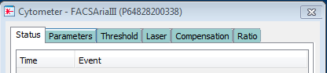

1. Tick the boxes in columns H (Height) and W (Width) for Forward and Side Scatter.

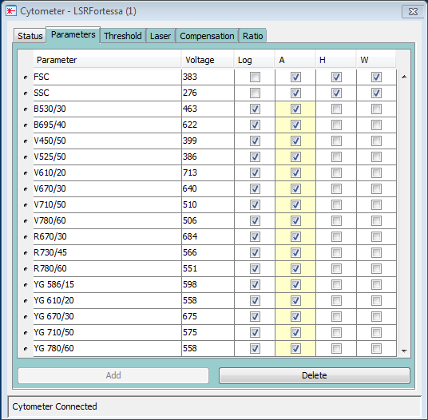

2. Then delete the Parameters that you are not using for you experiment by highlighting them blue (left click) and pressing the delete button in the Parameter window.

You can select multiple parameters by selecting one and clicking the next whilst holding the **Shift** button down.

Now looking at the **Worksheet** draw the plots to visualize and acquire your data. A typical worksheet layout is included below in the Gating section.

**Initial Gating**

Once the voltages have been set use the gating tools in the worksheet tool bar ensure removal of dead cells/cellular debris and doublets. A general gating layout and logic is shown below.

1. FSC-A vs SSC-A – Intact Cells.
2. FSC-A vs FSC-H – Doublet exclusion by Forward Scatter*.
3. SSC-A vs SSC-W – Doublet Exclusion by Side Scatter.

*Can be problematic with large cells.



**3**

**2**

**1**

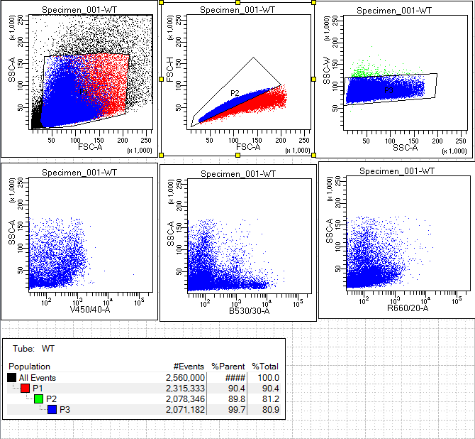

**Setting Voltages**

The voltages are in located in the cytometer window under the parameters tab. These can be changed using the small arrows next to the numbers of the slider that appears one you click on the parameter.

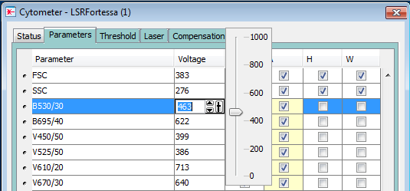

Using controls set the voltages for your FSC/SSC (or type in values into the Voltage field) and your fluorescent parameters ensuring positive populations do not go off scale and there is good resolution between your negative and positive populations.

**Acquiring Data**

Set your acquisition limits on the Acquisition dashboard shown below. Ensure you collect enough gated events to give an accurate representation of your samples. Usually 10-20,000 gated events is enough but for rare events (<1% of total) his number will need to be higher.

Right click on **Tube_001** and rename it with the name of the sample by right clicking on the mouse. Press **‘RUN’** on the cytometer and Press **Acquire Data** and then **Record Data** on the Acquisition Dashboard.

Once the sample is recorded press the **Next Tube** button and rename accordingly. Then place the sample on to the instrument and press acquire and record on the acquisition dashboard.

Repeat this process until all samples are recorded.

1. Click ‘Acquire Data’ to see events.

2. Click ‘Record Data’ to save events.

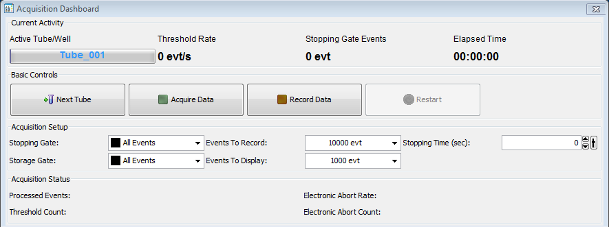

3. Adjust number to display more events.

**Exporting Data**

1. Open **ShareMounter** (the short cut icon is on the right hand screen, top right hand corner):

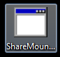

2. Enter your UCL User ID and your Password.

3. Click **‘Map Drives’**.

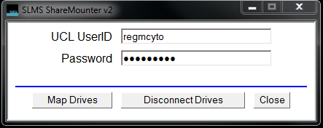

4. Click **‘OK’.**

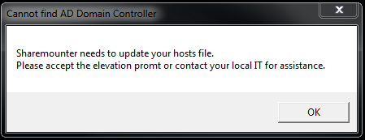

5. You now have access to your Home (N:) drive to transfer data:

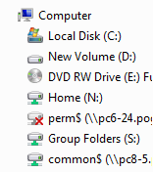

6. IMPORTANT: Once finished, re-open **ShareMounter** and select **‘Disconnect Drives’**. Otherwise the next user will have access to your Home (N:) drive:

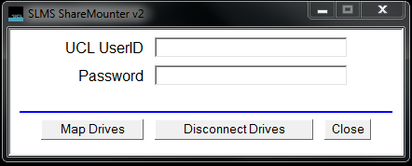

7. **DO NOT LOG OUT OF THE FACS Diva software as it can cause connectivity problems.**

**Cleaning**

It is important that everybody follows the cleaning procedure at the end of their booked session.

When using cleaning solutions **DO NOT OVERFILL FACS TUBES BEYOND THE MAXIMUM LEVEL AS THIS CAN POTENTIALLY DAMAGE THE INSTRUMENT.**

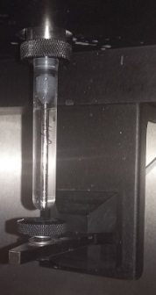

**Maximum Level**

1. FACS Rinse: 1 min arm to side and then 2 min arm closed.
2. FACS Clean (if PI or other DNA dye used): 1 min arm to side and the 2 min arm closed.
3. DI H2O: 1 min arm to side and then 2 min arm closed.
4. Ensure the event rate with the DI H2O is less than 20 events per second.

**NB Ensure the DI H2O is clean.**

1. Leave the tube of clean water on the SIP and turn the instrument on to **Stand By.**
2. Throw away any tubes and other detritus. Mop up any spillages.
3. **Please leave the work areas tidy and clean for the next user.**

**Fluidics Cart (Sheath Fluid and Waste)**

The instrument runs off sheath fluid and produces waste. If either of the boxes located on the FACS Flow cart beneath the instrument require attention an alarm will sound.

**You can check sheath levels visually via the cut windows on the tank boxes.**

You then have to either change the waste container to the spare located next to the instrument or refill the sheath from the container located near the instruments, next to the centrifuge labelled sheath.

**Be sure that the tank collars are in place when you reattach the fluidics lines.**

Press the reset button (to the left of the green lit On/Off switch).

**NB NEVER TURN OFF THE SHEATH TANK.**

ON/OFF Switch

**DO NOT TURN OFF!**

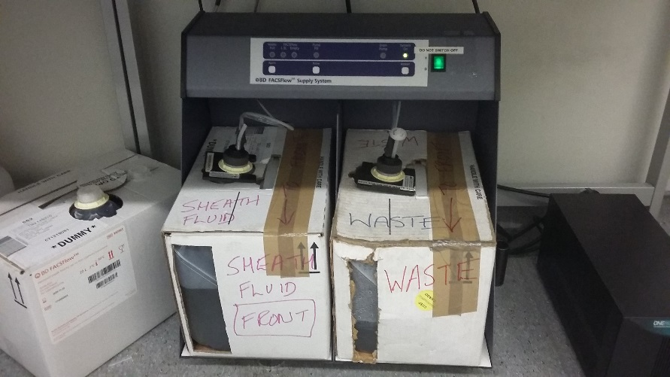

Reset button

Fault indicator

Tank collars

**Waste Tank**

**Sheath Tank**

**Last User Shut Down**

If you are the last user of the day, switch the Fortessa off using the green button on the right hand side of the cytometer and switch the computer off.

NB Make sure the computer is shutting down before leaving and does not require further action.

**If you are the last person booked for the day, IT IS ALSO YOUR RESPONSIBILITY TO SHUT THE RELEVANT INSTRUMENT DOWN OR LET THE PREVIOUS USER KNOW THAT YOU WILL NOT BE USING IT.**

Flow Cytometry Core Facility Instrument Booking

***For booking all instruments, you will need access to the Cancer Institute calendars (see below).***

***This can be done using either the UCL Office 365 Portal or via Microsoft Office 2013 Outlook.***

When booking the facility flow cytometers, **please**:

1. Be sure to book all your analysis appointments as far in advance as is possible.

2. Try to be punctual.

3. Do not overbook time slots as it prevents other users from accessing the instruments.

4. Plan your experiments accordingly rather than booking out longer than you actually need.

5. Likewise, try not to overrun into somebody else’s booking.

6. **Make any cancellations asap** if you know you are not going to use that slot.

7. Respect other users’ bookings of the facility instruments.

8. Let us know if there are problems with the calendars e.g. double bookings.

9. Clean the instruments thoroughly after use and leave the work areas clean and tidy.

10. If you are last user of the day, you are responsible to ensure that the instrument is shut down.

**NB All cell sorting needs to be booked through the core facility staff, preferably by email so we both have a record of the appointment.**

Remember to make a note the sorting/analysis appointment in your own Outlook calendar.

**Contacts:**

Will Day, Core Facility Manager [w.day@ucl.ac.uk](mailto:w.day@ucl.ac.uk)

George Morrow , Research Technician [g.morrow@ucl.ac.uk](mailto:g.morrow@ucl.ac.uk)

Barry Wilbourn, Research Technician [b.wilbourn@ucl.ac.uk](mailto:b.wilbourn@ucl.ac.uk)

**UCL Office 365 Portal Outlook Calendar**

1. Open your UCL Office 365 email online with a web browser.

2. Open the **Calendar** function.

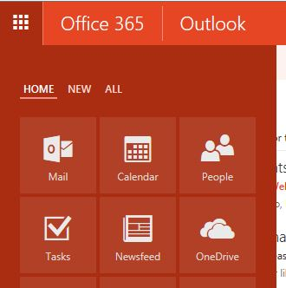

3. Click the **‘Add calendar’** tab.

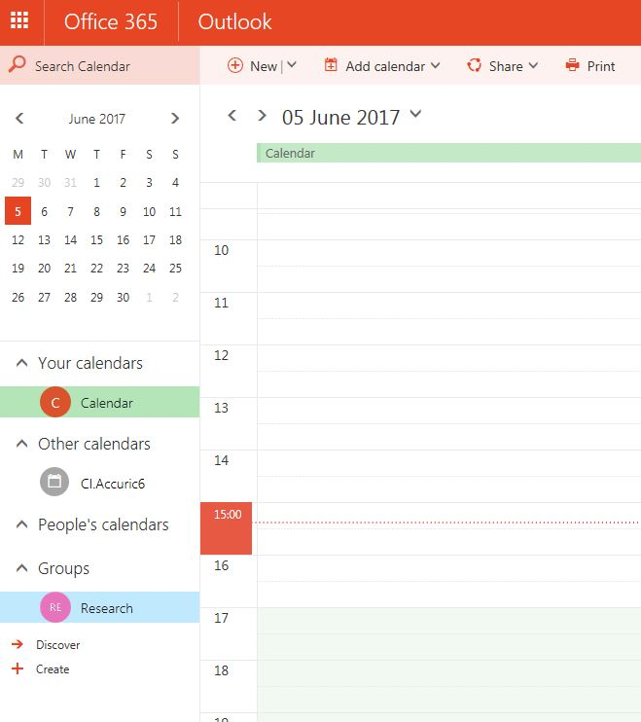

4. From the drop down menu select the **‘From directory’** option.

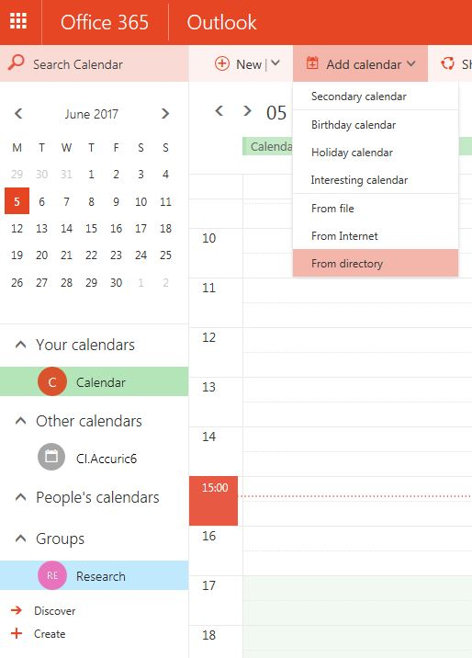

5. Type ‘**CI.Fortessa X20 Room 303’** and select **‘Open’** (the system will allow an autofill option so you don’t have to type the whole field). **NB Office 365 only allows you to add one calendar at a time.**

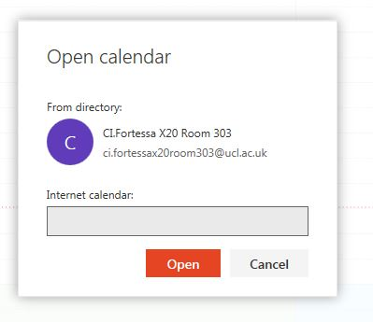

6. Repeat for the ‘**CI.Fortessa X20 B Room 303’** plus the ‘**~CI.Symphony Room 303’**.

7. You can also access the cell sorting calendar – ‘**CI.Aria III Room 304’** as **VIEW ONLY.**

**Please email us (copying all facility personnel into the email) for all sort requests.**

**Microsoft Office 2013**

1. Open Microsoft Office 2013 Outlook.

2. Go to the **Calendar** option in the bottom right hand corner of the Outlook screen.

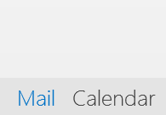

3. Click the **‘Open Calendar’** icon and select **‘From Address Book…’** from the pull down menu.

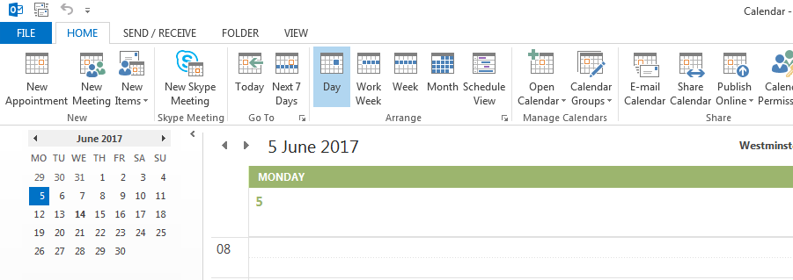

4. Type **‘CI.Forte’** in the search field and both Fortessa calendars will appear in the search box. Holding down the Ctrl key, select both **‘CI.Fortessa X20 B Room 303’** and **‘CI.Fortessa X20 Room 303’** calendars (red arrow).

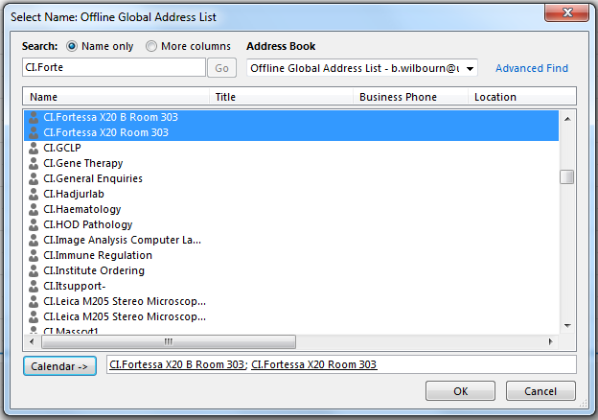

5. Press the **‘Calendar’** button (blue arrow) and then **‘OK’**.

6. Repeat for the **‘~CI.Symphony Room 303’** calendars if required.

7. You can also access the cell sorting calendar – **‘CI.Aria III Room 304’** as **VIEW ONLY.**

**NB A free slot on the sorter calendar doesn’t guarantee that the instrument is available.**

**Please email us (copying all facility personnel into the email) for all sort requests.**