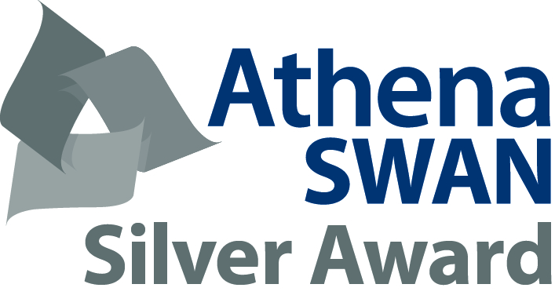

**UCL CANCER INSTITUTE**

**Excellence Needs Everyone**

**Cancer Institute Carers Fund**

A fund to support care costs beyond that required to meet the normal contracted requirements of the job.

**Background and Guidelines for the Fund**

As part of its set of Athena SWAN initiatives that aim to [advance gender equality: representation, progression and success for all staff](https://www.ecu.ac.uk/equality-charters/athena-swan/), and in support of a good work life balance; The Cancer Institute has ring-fenced £10,000 of funding per annum for 5 years to help support personnel to balance their work and caring commitments.

**Eligibility**

In recognition of the importance of exposure, recognition and networking in order to secure or maintain a position in all careers, the funding is primarily available to support staff (broadly defined as researchers, PhD students, teaching fellows, professional services and technical staff) with dependents to undertake activity which will enhance their work and career objectives.

Applications may be made to support care costs beyond that required to meet the normal contracted requirements of the job and may only be claimed in association with work activities undertaken outside of normal working patterns (including whilst on parental leave).

Applications can be made for a range of activities. Possible examples may include:

* Home-based childcare/eldercare expenses to enable conference / training course attendance
* Travel of a relative / other care provider to primary carer’s home to enable conference
* attendance / attendance at training
* Travel of children to a care provider who does not live in ‘home’ community
* Travel of a care provider to conference / training course location to care for the child
* Childcare costs at conference / training course location
* Conference travel and accommodation costs where not supported by other sources
* Funding for childcare costs to facilitate keeping in touch with work during maternity/paternity leave

**Process for Applications**

Staff who wish to apply must complete the application form and submit it to the HR Manager [m.rossini@ucl.ac.uk](mailto:m.rossini@ucl.ac.uk). Applications will be reviewed by the HR Manager and Institute Manager against the criteria and eligible claims will be assessed as they are received. It may not be possible to fund all applications received depending on the budget available. If a request for funding is refused there is no right to appeal. Priority will be given where there are no alternative sources of funding to support the proposal and / or to those who have not previously accessed the fund in the current financial year. Maximum claim is £500.

Anonymised information about all applications made to this scheme will be reviewed at approximately six monthly intervals by the Institute’s Athena SWAN Committee which meets monthly. Queries about the scheme should be directed to current co-chair(s) of the Cancer Institute Athena SWAN Committee.

Applications may be made to support care costs beyond that required to meet the normal contracted requirements of the job and may only be claimed in association with work activities undertaken outside of normal working patterns (e.g. childcare or eldercare costs while the primary carer attends a conference outside usual contracted hours).

All applicants should actively seek best value for money where it is practical and feasible and should justify the reasons for the proposed funding requested accordingly.

Please review the costs that may be claimed under the [UCL expenses policy](https://www.ucl.ac.uk/finance/policies-procedures/accordion-expenses/annex-5) and explain if these are not applicable. Under the strategic partnership of Research Councils UK (RCUK), each of the UK’s seven Research Councils below now allow childcare or caring responsibility costs to be claimed as allowable expenses if the costs are incurred for working outside normal working patterns.

Please provide as much information as possible to allow us to assess your application. The boxes in the form can be expanded and/or you could attach extra documents separately.

Please discuss your application with your line manager and include evidence of their support (signature or email).

**Cancer Institute Carers Fund – Application Form**

Completed forms should be returned to HR Manager [m.rossini@ucl.ac.uk](mailto:m.rossini@ucl.ac.uk)

If approval is given for a payment from the fund, payment will be made via a one off payment.

|  |  |  |
| --- | --- | --- |
| Name of Applicant |  | |
| Job Title / Role |  | |
| Please give details of the amount of funding being requested and what it is for. Please include date(s) and details of the event(s)  Please outline why this is the best value for money and why other potential options are not feasible. This should include assessment of childcare / eldercare options, auditable evidence of expected costs (quotes, receipts, booking confirmations), alternative sources of funding considered eg [Research Councils UK](https://www.ucl.ac.uk/finance/policies-procedures/accordion-expenses/annex-5) etc. Please give as much detail as possible. | | |
|  | | |
| Please explain how this activity will be of assistance to you in your work / your PI’s work / Cancer Institute priorities. | | |
|  | | |
| Applicant Signature | |  |
| Date | |  |
| Line Manager Signature / Attach email of support | |  |
| Date | |  |



**Excellence Needs Everyone**