Adding CI.Speedvac to Outlook calendar
- Open Outlook and go to “Calendar”
- Go to “Open Calendar” and select “From Address Book”
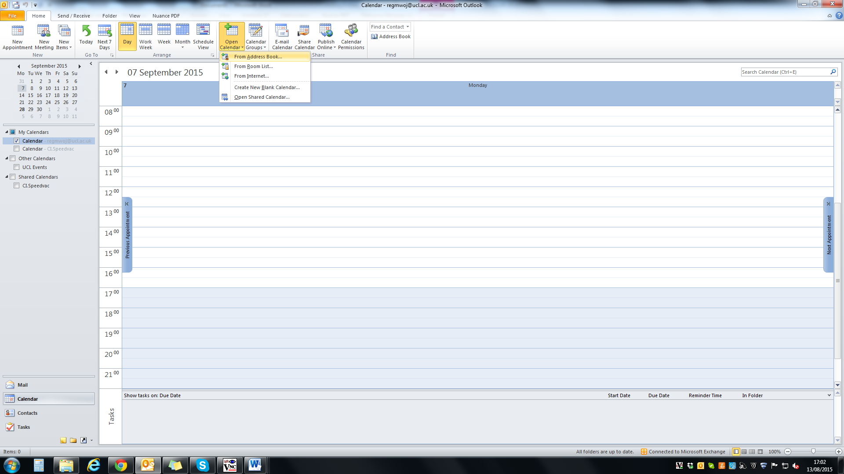
2.
1.
- Ensure that the Address Book is set to “Global Address List”
- Search for “CI.Speedvac”
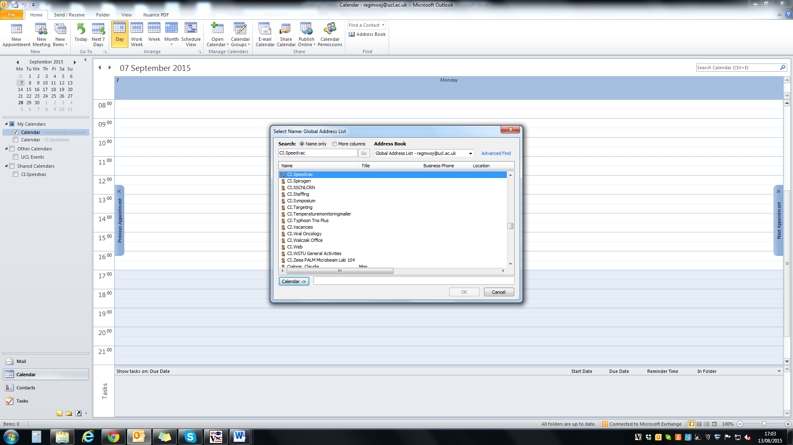
3.
4.
- Select it and add to your calendar
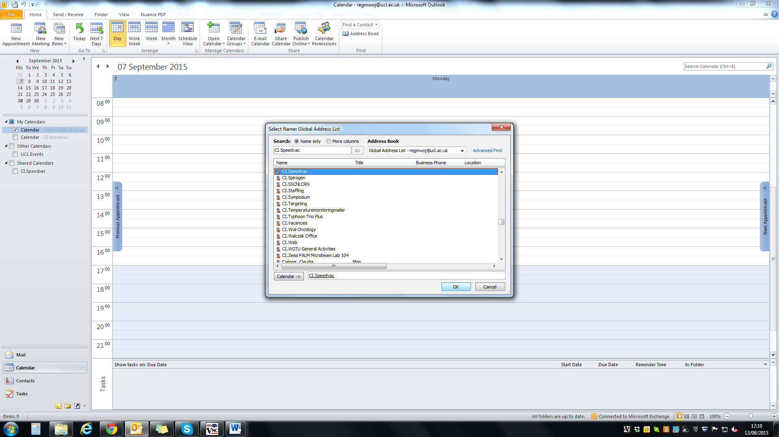
5.
- CI.Speedvac should now appear under “My Calendars” list
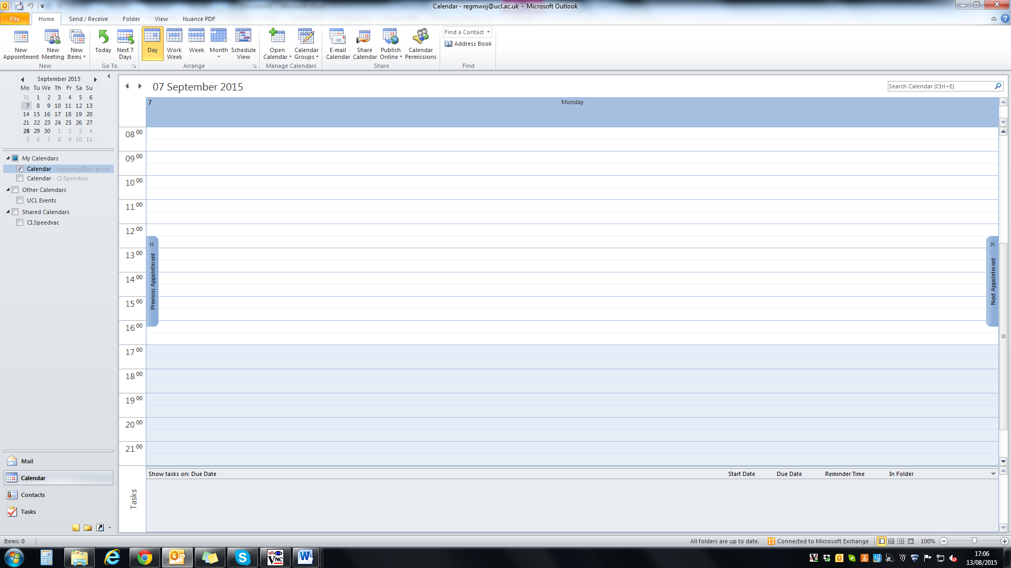
6.
- When booking the SpeedVac/Freeze Dryer please indicate the following:
  - Type of instrument: F for Freeze dryer, S for SpeedVac
  - Name and lab number
  - Brief description of solvents/buffers used containing names and concentrations of the chemicals
  - Number of samples
7a.
7b.
7c.
7d.
- To cancel your booking and report any issues related to the instruments please send an e-mail to ci.proteomicsresearch@ucl.ac.uk.

