Are there undeclared commercial ties between Prof. Mark Thomas and Living DNA
Khazar DNA Project by eelhaik / April 12, 2019 at 11:15AM
Here is a little something that no one wants you to know. Many population geneticists have ties with commercial companies. This is due to several reasons. One, it’s very hard to get money for research. Two, most of the population genetic research is really BS and no one wants to fund it. Three, PhD students cannot get a job in population genetics so they go to work for these companies. So far, nothing is wrong with that. Except that these academic links are almost NEVER reported in the scientific journals under the conflict of interest statement (you are welcome to check my papers). It usually gets ugly when one group attacks another group to support the financial interests of their company.
Recently, the UK gang consists of Mark Thomas; Adam Rutherford; and Debbi Kennett; with their new initiate Jennifer Raff, challenged the Primeval DNA Test that I developed. They do so with the pretence of caring about the public. I was not surprised it happened before to myself and others. Thomas has entire pages dedicated to trash competing companies.
Could it be that some of them are linked to a competing UK DNA company called Living DNA (here, here)? This website reported that Living DNA is working with Mark Thomas.
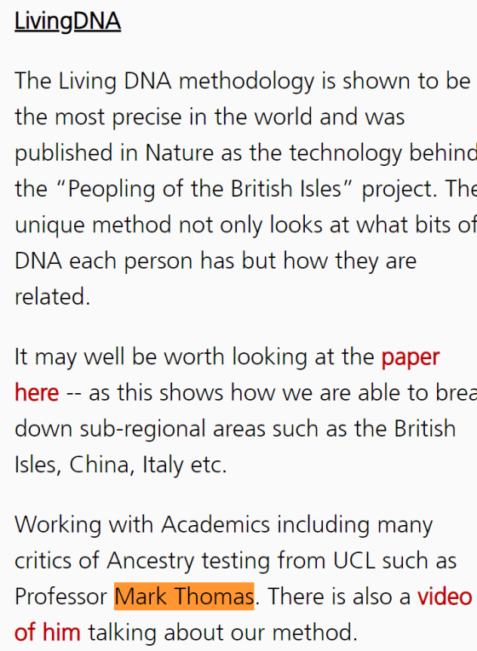
Here he is in a promotional video produced by Living DNA.
DAK note. The video was embedded on Elhaik’s blog post but can be found on Vimeo: https://vimeo.com/225527007/7fbc72d26f Can we embed it here?
Thomas’s former student (Gareth Hellental) works there too. Quite a few UK scientists consult this company. Thomas has never reported these relationships in his academic publications, as is required by scientific journals. Needless to say that he never declared his competing interests when challenging my work.
Debbie Kennett (an unemployed lady with a lot of free time) is promoting this company on her blog. Adam Rutherford uses public media tools to challenge competing entities with the pretence of caring about the public. None of them has ever criticized Living DNA.
So what is Living DNA? Basically, Living DNA specializes in one thing. Telling people that they are English. They do so by comparing them to modern-day people who claim to be English… do you see the problem with that? Since English are so diverse, almost everyone gets his money worth, some more than others. And right now, Living DNA looks like a Dinosaur compared to the Primeval DNA Test, because again, who cares about modern-day George and Harry? They do not represent the far past.
For this reason, one Jennifer Raff was asked to do a hit job. It wouldn’t work. You tried that before with GPS Origins. GPS Origins is now in every drug store in America and Wallmart.

