Antarctica and the strategic plan for biodiversity

Chown SL, Brooks CM, Terauds A, Le Bohec C, van Klaveren-Impagliazzo C, Whittington JD, Butchart SH, Coetzee BW, Collen B, […] McGeoch MA (2017) PLoS biology 15: e2001656

Despite their significant biodiversity, Antarctica and the Southern Ocean had never been assessed formally in the context of the Convention on Biological Diversity’s Strategic Plan for Biodiversity 2011-2020 and its 20 Aichi Targets.

With the assistance of the Government of the Principality of Monaco, and hosted by them in June 2015, a group of scientists experienced in Antarctic and Southern Ocean biodiversity and conservation, and in these fields more generally, produced just such an assessment.

Ben brought to the assessment and its subsequent write-up essential experience of the way such assessments had been made for diversity globally and for other regions. His sharp insights about the status and trends of terrestrial vertebrates globally proved especially helpful for Antarctic-wide comparisons.

Ben joined the 23-person team after a discussion with us and was soon at home among both familiar biodiversity colleagues and new Antarctic ones. He seemed to take both the dinner at Monte Carlo Casino and the conclusion of the assessment meeting by HSH Prince Albert II of Monaco in his stride – perhaps reflecting his strong view that biodiversity and its conservation outrank almost everything in their importance.

Ben will be remembered for his generous insights that have contributed to the conservation of the Antarctic and Southern Ocean biodiversity.

Professor Steven L Chown and Professor Melodie A McGeoch
Monash University, Melbourne Australia

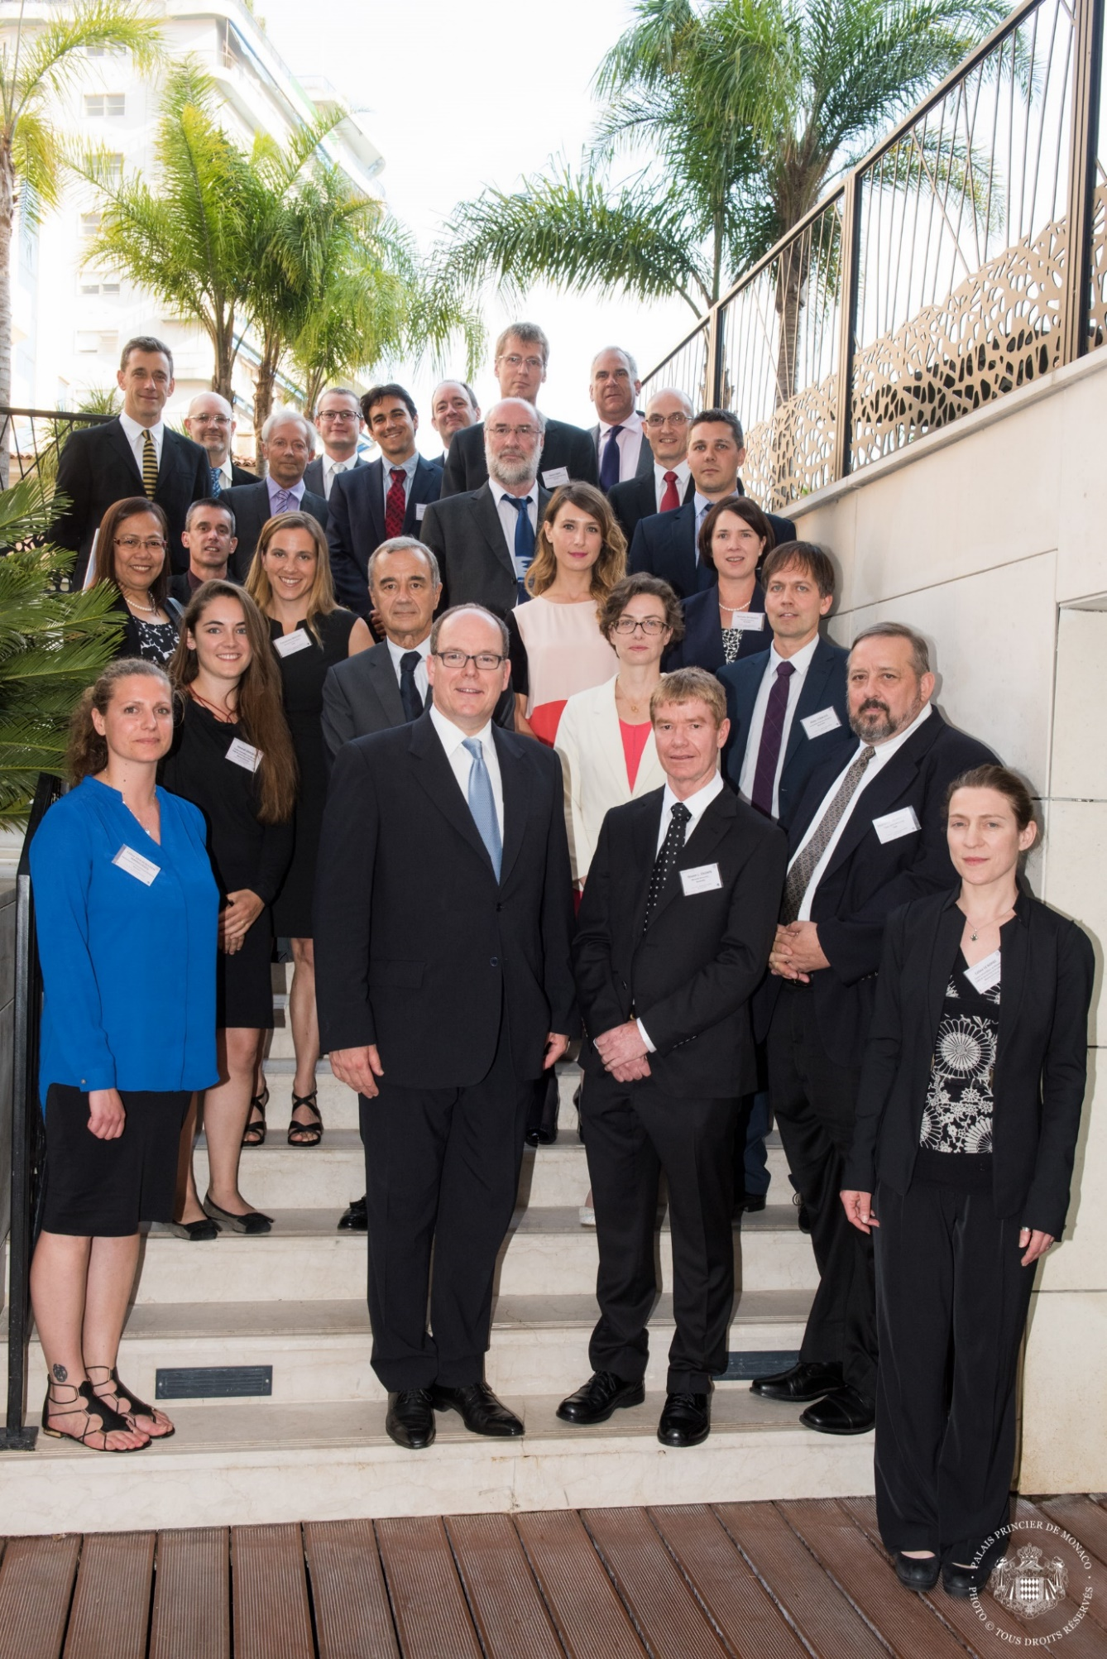
Ben, Steven Chown, Melodie McGeoch and team with HSH Prince Albert II of Monaco, June 2015

