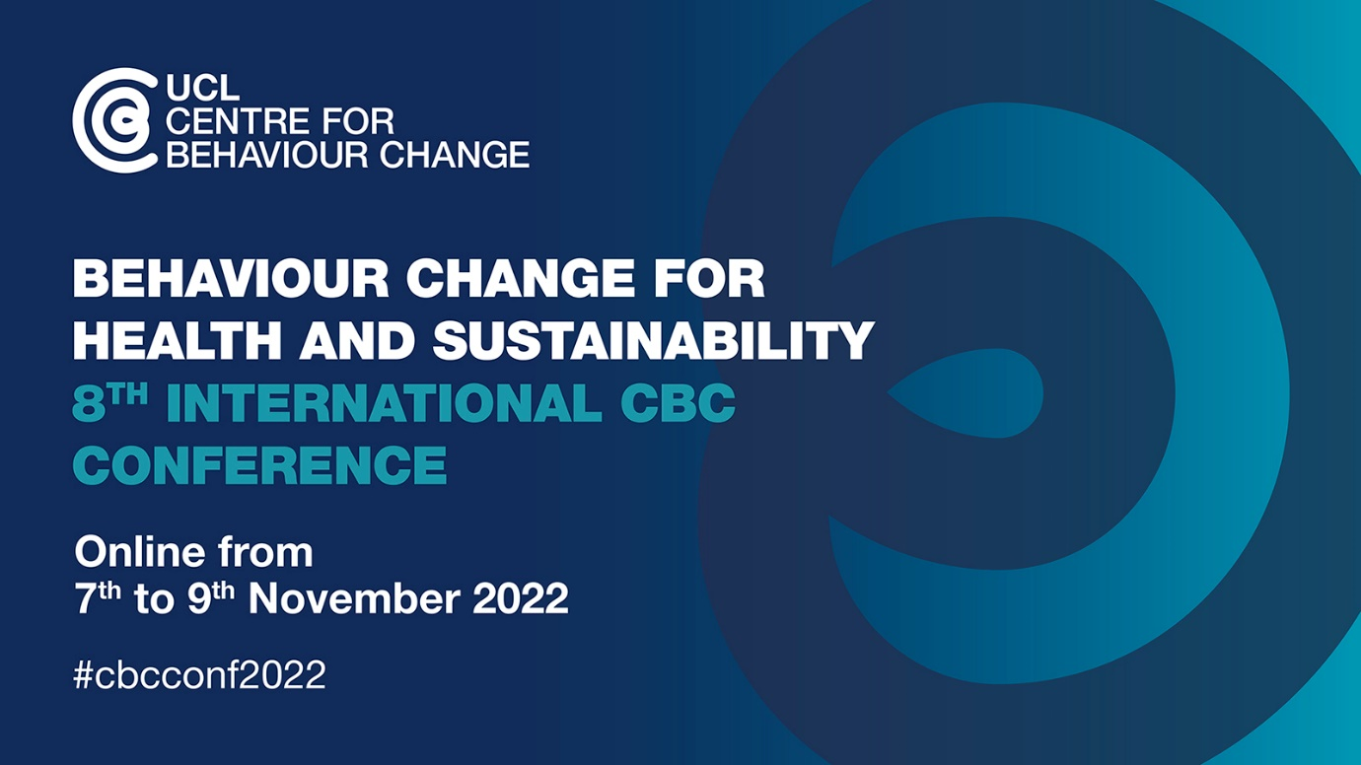

Post-conference workshop template

Post-conference workshops will be held on 10 November 2022.

Please complete this template with the details of your proposed workshop. You don’t need to have every detail of content/format worked out at this stage. Please just provide an outline of the focus of the workshop and what the audience would learn. This information will be used for the booking system. For selected workshops, there will be a free conference delegate place for up to two workshop facilitators.

An example outline for a previous workshop has been provided to help you fill in the template.
To submit a workshop proposal, fill out the Workshop Template and send to: behaviourchange@ucl.ac.uk

Title:
Facilitators:
Format:
Max number of participants:
Date: 10 November 2022
Time (start – end):
Learning objectives for the workshop:

Summary of the workshop (no more than 100 words, e.g. background to the topic, relevance to the issue of behaviour change for health and sustainability, what would participants learn, what value would the knowledge and skills learned bring to their careers or organisations?):

Example:

Title: Create behaviour change by designing effective digital interventions
Facilitators: Dr. Caroline Wood and Dr. Rosie Webster
Format: Half-day workshop
Max number of participants: 40
Time (start – end): 2-5pm
Learning objectives:

By taking part in this workshop participants will be able to:
- Describe the COM-B model of behaviour and the Behaviour Change Wheel (BCW) framework.
- Identify opportunities for applying COM-B and BCW within the development of digital interventions.
- Know how to integrate behaviour change techniques into the technological features of digital interventions.

What will the workshop focus on? What would the audience learn (no more than 100 words)?:

Models and frameworks of behaviour and behaviour change can be used to support the design of digital interventions to improve efficacy and support research. This workshop will introduce participants to the framework of the Behaviour Change Wheel and the Behaviour Change Techniques Taxonomy V1 and show how they have been used to design digital interventions. The course will be highly participatory with plenty of hands-on opportunities to help participants gain experience of applying the approach. There will be opportunities for participants to explore applying the framework and tools to their own projects with guidance from experienced researchers and practitioners.

If you have questions about workshops, please contact behaviourchange@ucl.ac.uk.

