The Bartlett School of Planning

GREEN POLICY
April 2015

Please see below some information on some initiatives we have in place to improve environmental sustainability. If you have any queries, or would like to join the School’s Green Action Team, please do not hesitate to contact the School’s Green Champion, Naomi Jones. For more information please see http://www.ucl.ac.uk/greenucl

Contents
RECYCLING 2
BINS 2
Mixed recycling 2
Food waste 2
Non-recyclable waste 2
Batteries 2
Used printer cartridges 2
Mobile phones and other electrical equipment 2
Used postage stamps 3
Furniture and equipment 3
Paper 3
ENERGY USE 3
Computers and lights 3
Air conditioning and heating 3
TRAVEL 4
Flights 4
Cycling 4
Video conferencing 4
WATER 4
Drinking water 4

RECYCLING

BINS

There are three types of bins:

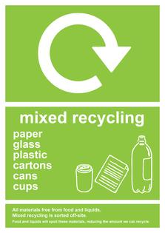
Mixed recycling

This is for EVERYTHING except food and contaminated waste.
All paper, plastics, glass, used paper towels – most things can go into mixed recycling.

If in doubt – please put the item into this bin.

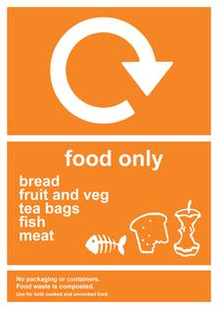
Food waste

All food should go into the food waste bins. This includes tea bags and coffee filters.

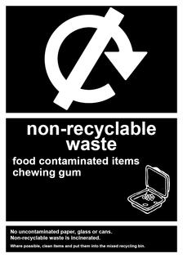
Non-recyclable waste

This is only for items which are contaminated with food, chewing gum, and non-recyclable plastic such as crisp packets.

If possible please wash out recyclable items – put food into the food waste bin and then the washed item into mixed recycling.

Batteries

Please put all used batteries into the box in the Planning Office for recycling.

Used printer cartridges

Please give used printer cartridges to the Planning Office. All parts of the cartridges are recycled or reused.

Mobile phones and other electrical equipment

Please put any electrical equipment you are no longer using into the box in the Planning Office. We will send it on to be recycled and raise money for charity. If you have a preferred charity please let the office know. Old mobile phones both working and broken, tablets, PDA's, iPods and digital cameras can all be recycled.

Used postage stamps

Please tear/cut used postage stamps off the envelope leaving about a cm of paper around the edge of the stamp, and put them in the box next to the fifth floor pigeonholes in Central House.
All stamps are sent to the RNIB, which raises money through resale to stamp dealers.

Furniture and equipment

Please inform the Planning Office of any furniture or equipment that you no longer need. We try to reuse as much as possible on the WarpIt website. When furniture is broken and reuse is not possible, we recycle metal furniture.

Paper

All staff and students are strongly encouraged not to print whenever possible. Avoid printing out whole publications or long documents. Store files on the public folder and use PCs, laptops or tablets to reference them.

When organising meetings, lectures or seminars, please ask individuals whether they require hard copies before printing.

Please help to reduce our paper use by taking double-sided copies wherever possible. Instructions are displayed next to all shared copiers and printers. If you have your own printer, make sure it is set to print double-sided as default.

Please put any one-sided non-confidential print outs in the box in the office - this will be reused rather than recycled. We also reuse all envelopes – please return them to the office.

ENERGY USE

Computers and lights

All staff and students are asked to be vigilant about turning off lights, computers, monitors and printers in their own offices as well as turning off lights in meeting rooms once they have finished.

To set your computer to go to sleep mode automatically, in Windows open the Control Panel, and choose “System and Security” then “Power Options”

On a Mac, go to the Apple menu, select System Preferences and then Energy Saver.

All equipment MUST be switched off over weekends and college closures.

Air conditioning and heating

All rooms have a temperature sensor to control the heaters and air conditioning units. These should be set between 19 and 22 degrees only, or 24 degrees in the summer if the windows are open.

Portable heaters should be used only if the heating units are not functioning. If you are using a Portable heater you must inform the office so they can ask maintenance to fix the heating.

TRAVEL

Flights

Domestic air travel must be avoided unless absolutely necessary. Staff and students are also encouraged to use trains rather than flying when travelling to Europe.

Student field trips should use train travel such as the Eurostar when traveling to Europe whenever possible. Student field trips within the UK should be train or bus only.

Cycling

The nearest cycle racks to Central House can be seen on this map:
http://www.ucl.ac.uk/cycling/maps-and-facilities

Video conferencing

UCL has teleconference and video-conferencing facilities that can be used as an alternative to travelling to meetings. Please contact Naomi Jones for more information, and to book these facilities.

WATER

It is estimated that a dripping tap can waste up to 15 litres of water a day (which is just under just under 5.5 tonnes per year).

Please turn off all taps when not in use, and report any dripping taps or leaks immediately to the Planning Office.

Drinking water

Water filters can be found in the 5th and 6th floor kitchens, providing free drinking water for all staff and students.

