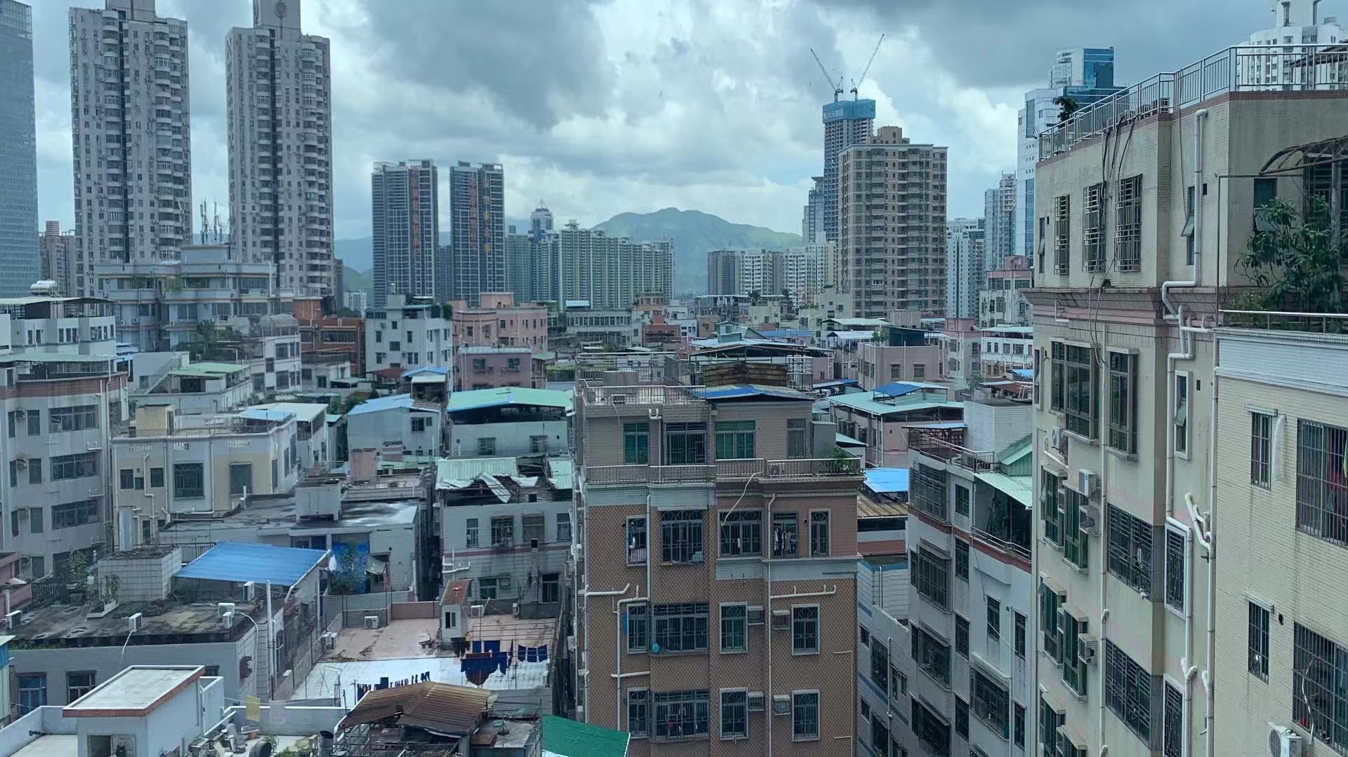
CPRG Online Event

12:00 – 13:00 (UK)
24th February 2021

Zoom Meeting ID
942 2107 5019
https://ucl.zoom.us/j/94221075019
、

Remaking Inclusive sustainability:
a spatial-temporal dimension

CHINA PLANNING RESEARCH GROUP EVENT

Speaker: Prof. Xiaoling ZHANG

Department of Public Policy,

City University of Hong Kong

Abstract:
The sustainability research field draws upon scholarly attempts from multiple academic corners. The kaleidoscope nature of the “field” of sustainability science has worried researchers and practitioners at different scales in recent decades. It is therefore important to raise the fundamental questions regarding what is meant by the field of sustainable science, e.g.,

1 How to remake inclusive sustainability (IS) for individuals, places and regions across time? How to quantify IS for diversifying and targeting coping strategies?
2 How is sustainable city challenged? In what ways? Under what conditions? Locally and globally?
– a relational and multi-scalar approach

This presentation attempts to contribute to the ongoing debate by interrogating these questions. It will elaborate on the major types of inquiries undertaken, the topical areas examined, and research methodologies employed in the field. After reviewing three strands of thoughts, I intend to formulate a relational, integrative framework to remake inclusive sustainability as a concept. The main practical contribution of this paper is to provide a potential policy tool-box for synthetic and solution-based inquiry for SDGs at both global and local scales.

Professor Xiaoling Zhang’s research focuses on sustainability science and resource management and economics, and political economics of environmental studies and energy studies. She also works predominantly with macro-level dynamics in sustainable urbanization, regional and neighborhood change, urban socio-spatial restructuring, informal and formal policy regime, governance and the interactions between them. She now serves as Associate Editor for npj (Nature Partner journals) urban sustainability; She is leading the Smart & Sustainable City lab at CityU.
For future China Planning Research Group event notices, join: http://eepurl.com/-L-l9

