Junior Wac Arts Questionnaire

Which year are you in at school? (Please tick)
Year 1 | Year 2 | Year 3 | Year 4 | Year 5 | Year 6 | Year 7 | Year 8 | Year 9 | Year 10

What class are you in? (Please tick)
Dance | Drama | Music Tech | Digi-Arts | Singing | Percussion

- I learn new things in the class. (Please tick)
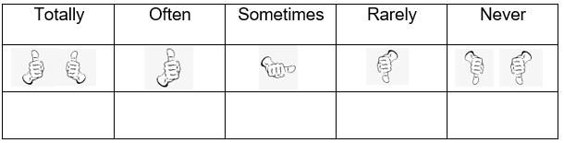

- I enjoy sharing ideas at Wac Arts.

- The class helps me to get better at what I do.

- I feel close to the people I meet at Wac Arts.

- People that I see at Wac Arts respect me.

- Together, we create exciting things at Wac Arts.

- I feel that people at Wac Arts are happy to have me here.

- I think I make a difference when I come to Wac Arts.

- I am able to make up my mind about things when I come to Wac Arts.

- People listen to my ideas when I come to Wac Arts.

- I think I learn how to make the world better when I am at Wac Arts.

- I have fun when I come to Wac Arts.

- When I come to Wac Arts I feel… (please tick all the answers you agree with)
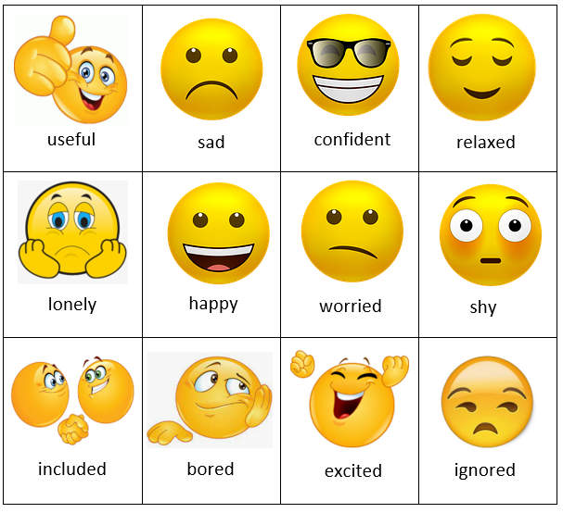

- I have made friends at Wac Arts.
Yes | Not sure | No

15. What have you learnt in the class?

16. What would you like to learn?

17. Are there any classes that you would like to do at Junior Wac Arts that we don’t currently deliver?

