Guide to the MSc Light and Lighting virtual open day

Thank you for signing up to the MSc Light and Lighting virtual open day will take place from 14:00-15:00 GMT on Friday 16th March 2018. The event will be taking place on WebEx, a web conferencing tool. Please follow the instructions below to access WebEx and take part in the open day.
If you have any questions about the open day please contact Majida Haque at majida.haque@ucl.ac.uk

Before the event

Download the WebEx plug-in
You do not need to install software to use WebEx, however a plug-in is required. It is strongly recommended that you download the WebEx plug-in and complete the following diagnostic test a day before joining the event.

To carry out the test open a browser window, and go to: http://www.webex.com/test-meeting.html
Enter your name and email address and click join. Follow the instructions on the screen to download the WebEx plug-in.

What you will need
To join the event you will need access to a computer with good internet connection, and headphones. Please see the following webpage for the minimum system requirements for WebEx: https://support.webex.com/MyAccountWeb/knowledgeBase.do?articleId=WBX4830

Log in to the event
To log in to the event please paste the following link into your browser https://bseer.webex.com/bseer/onstage/g.php?MTID=ef568b3bb12ece900cc06a52ed626e062. The event password is light
Please enter your first name, last name and email address and click Join Now (see Figure 1).

Figure 1 (example)
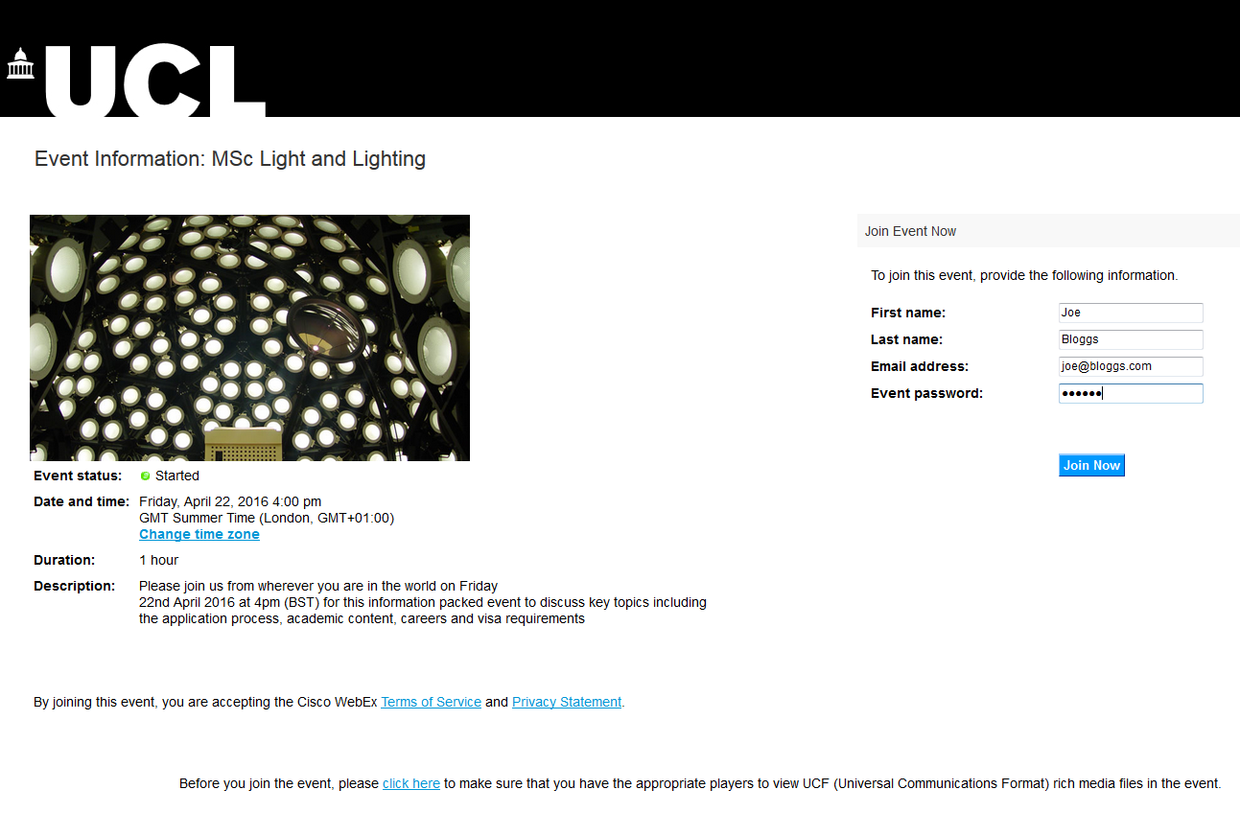

Connecting to audio
After logging in you may be asked if you would like to join an Integrated Voice Conference. If you see the window pictured in Figure 2 please click Yes.
Figure 2
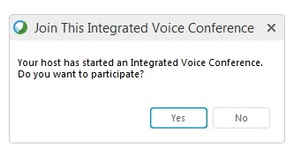

You may be asked to test your computer audio. If you see the window pictured in Figure 3 please ensure that the correct audio device is selected before clicking OK.
You will not be required to use a microphone at this event. If you receive an error message regarding your microphone connection please ignore this.
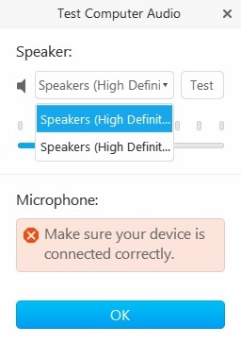
Figure 3

How to activate our webcam screen and chat with us

View our webcam output
At the virtual open day you will be able to see us through our webcam screen.

At the beginning of the virtual open day the MSc Light and Lighting Course Director will give a short presentation. To view our webcam output alongside the presentation please click on the Participants button at the top of the screen (Figure 4, Box 1). You may also need to click on the drop-down Participants button (Figure 4, Box 2).

Chat with us
At any point in the event please feel free to ask us questions by typing them into the chat box. To ask us questions during the presentation please open the chat box using the Chat buttons pictured in Boxes 3 and 4 in Figure 4.

After the presentation – go full screen!
After the short presentation please change the view to full screen, as by doing so you will be able to type in the chat box and view our webcam output simultaneously. To change the view to full-screen mode hover your cursor above our webcam screen and click the button pictured in Box 5 in Figure 4.

Please see Figure 5 for the full-screen view. To activate the chat-box in full-screen mode hover your cursor at the top of your screen and click the Chat button in the upper bar. Once the Chat pop-up is open you may drag it anywhere on the page.

Figure 4

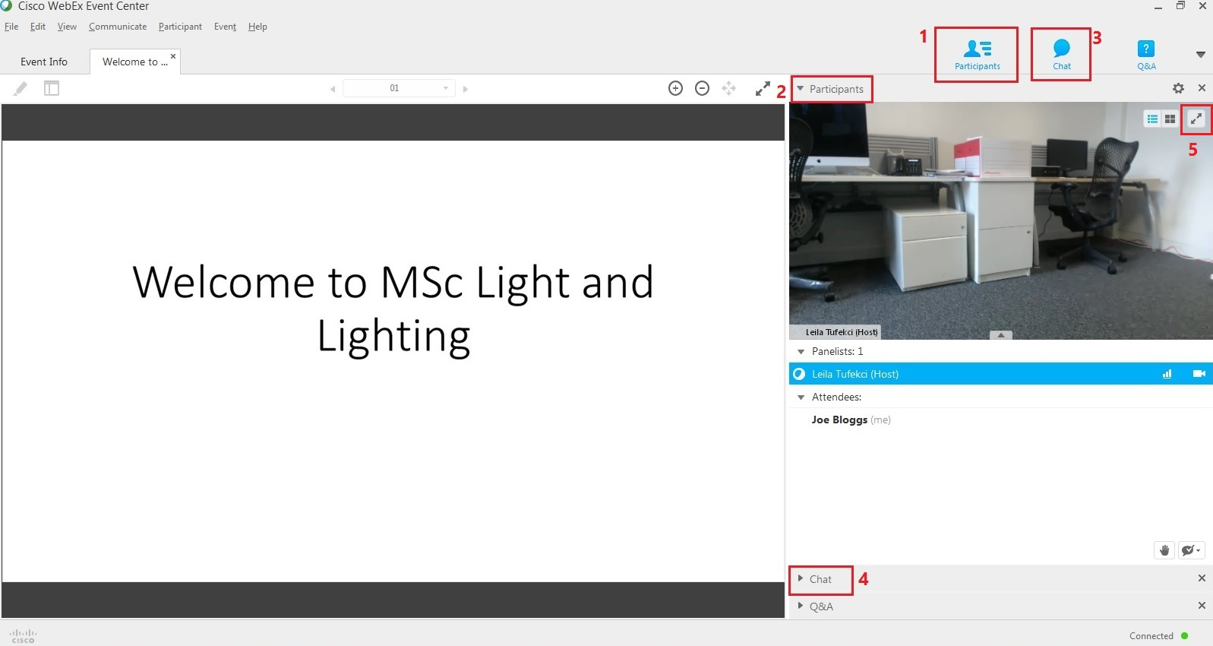

Figure 5

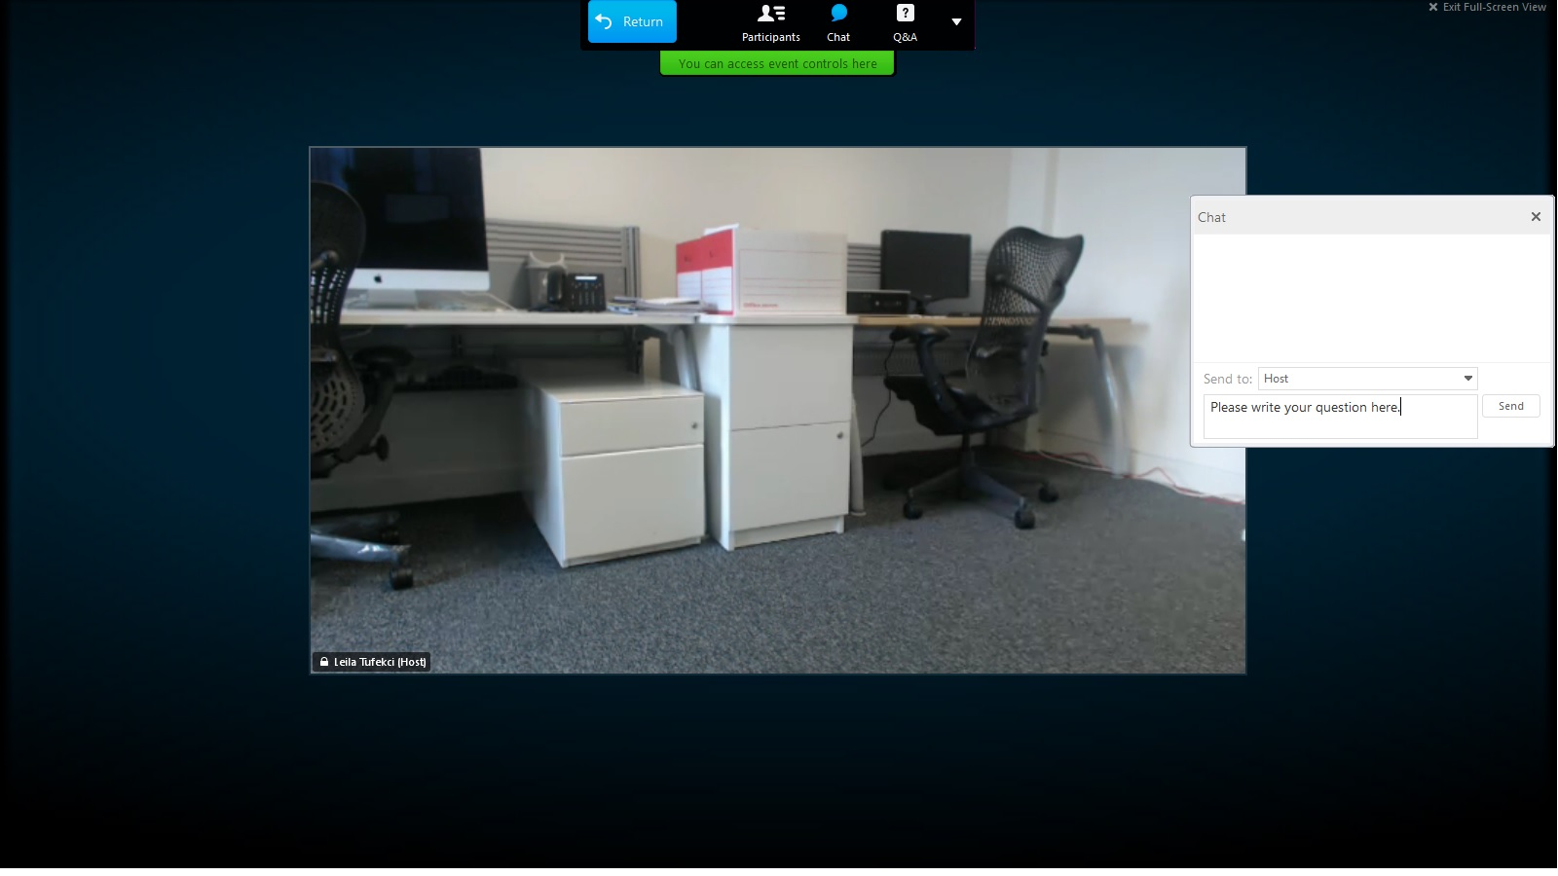

We hope you enjoy the event!

