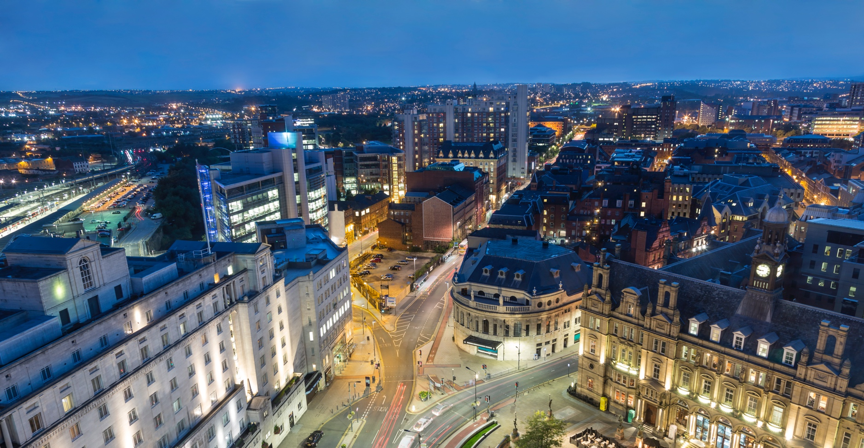

Energy in Buildings and Communities Research and Innovation

Invitation to an international workshop
1st June 2018
Westminster Conference Centre, 1 Victoria Street, London SW1H 0ET

The Department for Business, Energy & Industrial Strategy (BEIS) and University College London (UCL) extend an open invitation to a free international workshop on Research and Innovation in Energy in Buildings and Communities. The workshop will showcase current international research and innovation projects in the field and it will present opportunities to become involved in future research programmes.

The workshop will benefit researchers, designers, planners, builders, developers and product manufacturers and suppliers active in developing and researching low energy buildings and communities. An outline programme is provided overleaf.

For your free ticket register here.

The workshop is organised under the auspices of the International Energy Agency’s Technology Collaboration Programme for Energy in Buildings and Communities (IEA-EBC). For further information on the IEA-EBC please visit the website.

Outline Workshop Agenda
10.00 | Registration | Tea and coffee provided on arrival
10.50 | Welcome | From BEIS and UCL
11.00 | Introduction | Introduction to UK involvement in IEA programmes (BEIS)  Introduction to the operation of IEA-EBC (UCL)
11.20 | Projects | Explaining the work and output of example present research projects
12.20 | Strategic Plan | Presentation of the draft 5 year strategic plan for the IEA-EBC focusing on the objectives and proposed fields of research.
14.40 | Funding opportunities | EPSRC presentation
13.00 | Lunch
14.00 | Review  (breakout groups) | An opportunity to review the objectives and the proposed fields of research presented in the draft strategic plan, text their relevance to the UK context and provide feedback.
15.00 | Summary of reviews | Presentation of feedback from review groups
15.20 | Tea & coffee
15.40 | UK involvement  (breakout groups) | Discussion of participants interests in current and possible future IEA-EBC projects, with the opportunity to put forward concepts and ideas for new projects.
16.40 | Conclusions | Drawing together of discussions and recording actions for feedback on the strategic plan, involvement in current projects, proposals for new projects and future meetings.
V3

