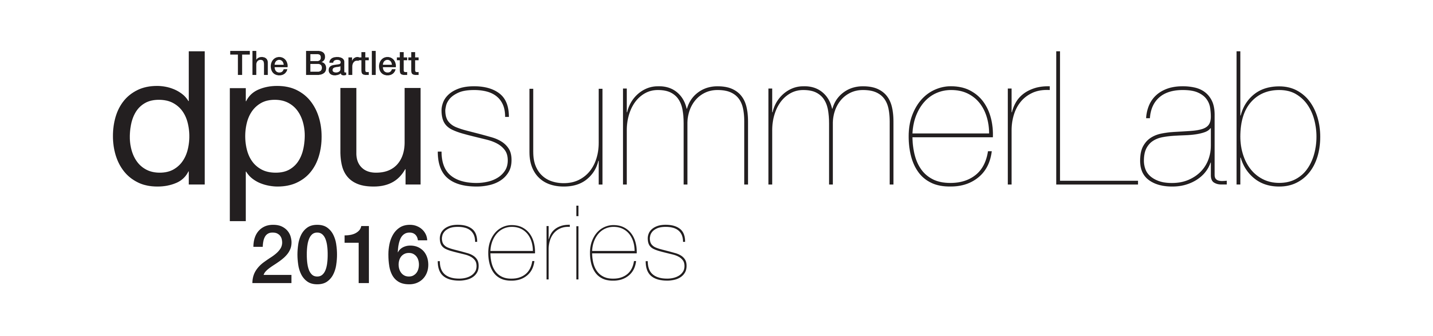

APPLICATION FORM (Please complete this form in BLOCK CAPITALS.)

Please submit this form along with your CV and letter of motivation via email to dpusummerlab@ucl.ac.uk by Monday 4 July. You may wish to submit a design portfolio along with your application, however, please note, this is not mandatory. Please ensure the attachment is in PDF format and does not exceed 5MB.

Once accepted to the DPU SummerLab, we will contact you with further logistics details and a link to the online payment form for the fee. To guarantee your place, the total payment for all workshops must be made by Monday 11 July 2016.

Fees
The international participation fee for each workshop is £400. If you are applying for more than one workshop, the fee is reduced to £300 per applicant. For currently enrolled DPU students and DPU alumni the fee is £300. We also offer group discounts. If you wish to submit a group application (five people or more), please use the ‘group application form’ instead (you can find this on the DPU summerLab website, ‘Application and fees’ section).

Please note these fees do not include travel or accommodation, though advice and local information will be provided. Participants are responsible for making their own visa arrangements if they require one, to which the DPU can provide proof of workshop registration if needed.

- I wish to apply for the following DPU summerLab 2016 workshops
(Please tick the appropriate destination and continue on the next page):
__
San Juan Reactivating Dispersed Urbanisms 29 August - 3 September 2016
Beirut Riverside Ecologies and Contested Waterscapes 5 - 10 September 2016
__
Palermo Emergent Migrant Topographies 5 - 10 September 2016
__
Ljubljana Disputing Empty Landscapes 12 - 16 September 2016
__
Barcelona Conflicting Diversities 19 - 23 September 2016
__
London Heritage in Transformation 19 – 23 September 2016
__

2. Are you a current DPU student or Alumni? ___YES ___NO (please tick as appropriate)

3. Surname or Family Name: 4. Title (Dr, Ms, Mrs, Mr etc.):
4. First Name or Given Name(s):
5. Place of birth: 6. Date Of Birth:
7. Nationality:
8. Address for correspondence:
9. Telephone number (day-time):
10. Email:

11. Insurance:
You will need to have your own medical / travel insurance to cover you for the full duration of the DPU summerLab workshop. Please give proof of this here if available now, (attach a separate document or photocopy if needed) or arrange to purchase insurance before the DPU summerLab. You will not be allowed to participate without proof of insurance.

12. Applicant’s Signature:
The DPU reserves the right to amend in any way the facilities or activities for which participants have enrolled. Participants shall have no claim against the DPU in respect to any alteration made to the DPU summerLab. If the applicant has paid the deposit and should withdraw for any reason after the full payment deadline, the DPU reserves the right to retain 10% of the total to cover administration cost. The DPU reserves the right to retain up to 50% of the total if the withdrawal occurs in the last 14 days prior to the beginning of the workshop. If the number of desired participants for any DPU summerLab workshop is not met, the DPU reserves the right to cancel that workshop. Only in this instance will participants receive a full refund (paid participants will also be given the option to choose a place on another workshop). If the full fee is not paid by the payment deadline stated above, the DPU reserves the right to remove the participant from the workshop.

Data Protection Act 1998: I agree to DPU processing personal data contained on this form or any other data which DPU may obtain from me or other people or organisations whilst I am applying for admission. I agree to the processing of such data for any purpose connected with my studies or my health and safety whilst on DPU premises or for any legitimate purpose.

To the best of my knowledge the information on this application is accurate and complete. Please sign and date that you have read and understood all of the above conditions:

Signed: Date:

