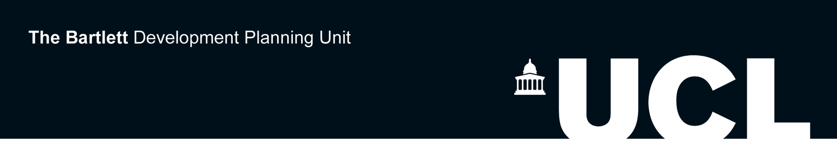

DPU summerLab Bar Elias, Beqaa, Lebanon
Public realm and spaces of refuge

RELIEF Centre Sponsorship

The RELIEF Centre is a transdisciplinary research collaboration that focuses on one of the world’s pressing challenges of the moment: how to build a prosperous and inclusive future for communities affected by mass displacement. The sponsorship will cover the successful applicants’ participation fees and accommodation.

APPLICATION FORM (Please complete this form in BLOCK CAPITALS.)

Please submit this form along with your CV and letter of motivation via email to dpusummerlab@ucl.ac.uk and info@catalyticaction.org by Friday 3rd August 2018, at 23.59. You may wish to submit a design portfolio along with your application. However, please note, this is not mandatory. Please ensure the attachment is in PDF format and does not exceed 10MB in size.

Once your application is received we will undergo a selection process and contact the shortlisted applicants to schedule an interview.

SELECTION CRITERIA
Importantly:

- Arabic must be the applicant’s first language;
- the applicant must be fluent in English language.

Please notice the ones above are essential selection criteria, exceptions cannot be made. Professional experience in the humanitarian sector is desirable.

PERSONAL DATA

1. Surname or Family Name: 2. Title (Dr, Ms, Mrs, Mr etc.):

2. First Name or Given Name(s):

3. Place of birth: 4. Date of Birth:

5. Nationality:

6. Address for correspondence:

7. Telephone number (day-time):

8. Email:

9. Insurance:
You will need to have your own medical / travel insurance to cover you for the full duration of the DPU summerLab workshop. Please give proof of this here if available now (attach a separate document or photocopy if needed) or arrange to purchase insurance before the DPU summerLab programme will start. You will not be allowed to participate without proof of insurance.

10. Applicant’s Signature:

The DPU reserves the right to amend in any way the facilities or activities for which participants have enrolled. Participants shall have no claim against the DPU in respect to any alteration made to the DPU summerLab programme. Should an applicant not pay the full fee by the payment deadline stated above, the DPU reserves the right to remove the applicant from the workshop. If the applicant has paid the deposit and should withdraw for any reason after the full payment deadline, the DPU reserves the right to retain 10% of the total to cover administration cost. The DPU reserves the right to retain up to 50% of the total if the withdrawal occurs in the last 14 days prior to the beginning of the workshop. If the number of desired paid participants for any DPU summerLab workshop is not met, the DPU reserves the right to cancel that workshop. Only in this instance will participants receive a full refund (paid participants will also be given the option to choose a place on another workshop). Please note DPU will not refund travel and accommodation expenses, therefore participants are strongly advised against purchasing travel tickets and booking accommodation prior to receiving an email from the DPU summerLab team, confirming the activation of the workshop. This email will be sent out after the general application deadline stated above.

Data Protection Act 1998: I agree to DPU processing personal data contained on this form or any other data which DPU may obtain from me or other people or organisations whilst I am applying for admission. I agree to the processing of such data for any purpose connected with my studies or my health and safety whilst on DPU premises or for any legitimate purpose.

To the best of my knowledge the information on this application is accurate and complete. Please sign and date that you have read and understood all of the above conditions:

Signed: Date:

