AnthroSchools Homework Resource

Curriculum and Exam Board: A-Level AQA
Subject: Psychology
Topic: 4.3.3 Gender (BSRI)

Resource Tasks

- Read and annotate psychological study about the application of the BSRI to a Brazilian population
- Reflect and answer questions about the article you have read

Learning Outcomes
Students will be able to critically examine key psychological studies
Students will develop an understanding of the cultural variations in gender and the application of the BSRI in a wider context

Key Skills Developed in Resources

- Understand scientific language
- Critically examine key psychological studies and theories
- Application of aspects of research methodology to psychological studies

Task 1: The Bem Sex Role Inventory

The BSRI (Bem Sex Role Inventory) is a scale used to measure the prevalence of masculine, feminine and neutral traits in an individual. The individual rates how relevant each trait is to them on a seven-point scale and these scores are classified as masculine, feminine, androgynous or undifferentiated (Flanagan et al. (2016))

Your first task is to read and take notes on the extract below drawn from the open-access article titled,

“Gender differences: Examination of the 12-item Bem Sex Role Inventory (BSRI-12) in an older Brazilian Population”
by Carver et al. (2013, Plos One)

Abstract

Objectives
Although gender is often acknowledged as a determinant of health, measuring its components, other than biological sex, is uncommon. The Bem Sex Role Inventory (BSRI) quantifies self-attribution of traits, indicative of gender roles. The BSRI has been used with participants across cultures and countries, but rarely in an older population in Brazil, as we have done in this study. Our primary objective was to determine whether the BSRI-12 can be used to explore gender in an older Brazilian population.

Methods
The BSRI was completed by volunteer participants, all community dwelling adults aged 65+ living in Natal, Brazil.to examine the underlying gender roles of feminine, masculine, androgynous and undifferentiated, and to validate the BSRI in older adults in Brazil.

Results
The 278 participants, (80 men, 198 women) were 65–99 years old (average 73.6 for men, 74.7 for women). Age difference between the groups was not significant.

Conclusions
Although the BSRI-12 appears to be a valid indicator of gender among elderly Brazilians, the gender roles identified in the BSRI-12 did not correlate with being male or female.

Introduction
Many researchers use the terms sex and gender interchangeably. However, sex is defined physiologically whereas gender is a cultural construct that includes social and psychological factors. Gender is linked to roles and behaviours expected of men and women in a particular culture at a specific time and may be influenced by education and socioeconomic status. Sex and gender roles are “intertwined; they influence each other in a network of constant reciprocal changing processes”, however, it is possible to measure them separately. This research examines the ability of a short version of the Bem Sex Role Inventory (BSRI) to assess gender role in a sample of older Brazilian adults.

Defining Gender Roles
Gender is an understudied area in health research, particularly among older adults. When it is considered, the most commonly used and repeatedly validated measure of gender roles is the Bem Sex Role Inventory (BSRI) developed 4 decades ago. Sandra Bem categorized instrumental traits including taking the lead, being aggressive, competitive, dominant, self-reliant, and athletic as masculine; while feminine role characteristics were considered expressive and included compassion, affection, sympathy, warmth, and being yielding.
Bem was the first to conceptualize gender roles as something other than exclusively masculine and feminine, defining a third role, androgyny, that combined both masculine and feminine traits and a fourth category, undifferentiated, describing people whose scores on both masculine and feminine traits were low. She hypothesized that “many individuals might be "androgynous"; that is, they might be both masculine and feminine, both assertive and yielding, both instrumental and expressive—depending on the situational appropriateness of these various behaviours”. Androgynous men and women were postulated to be adaptive and therefore more likely to have better mental health and higher competence. Some psychologists dispute the androgyny model while others assert that androgyny exists but reflects a developmental change.
The original BSRI included 60 dichotomous items divided into 3 subscales (Masculinity, Femininity, and Neutral) of 20 items each. A personality characteristic was categorized as feminine if it was independently judged, using a 7-point scale, by both females and males to be significantly more desirable for women than for men and vice versa for masculine characteristics.
Shorter versions of the BSRI are common. A 12 item Spanish version of the BSRI (BSRI-12) was created and included the items: gentle, sympathetic, leadership abilities, acts as a leader, dominant, tender, warm, affectionate, strong personality, defend own beliefs, sensitive to other’s need, and makes decision easily. This version demonstrated strong psychometric properties, in some cases better than the original 60 item BSRI.
The BSRI-12 has been used more recently, with students ranging in age from 12 to 15 years and found reasonable reliability.
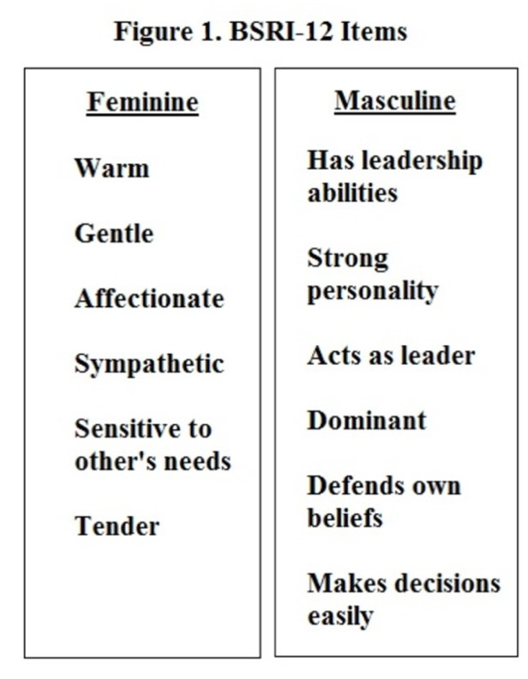
Figure 1
BSRI-12 Items

Gender Role Classification
The methods used to classify participants’ scores into gender role vary and can impact the gender role classification. Generally, classification is done using participants’ scores on the masculine and feminine scales. A common method for classifying scores on the BSRI into gender roles is to split the sample using the medians from Bem’s original normative samples. This means comparing participants’ scores to the median scores on the masculine and feminine scales.

International use of BSRI
The full 60 item and the short versions of the BSRI appear to be valid across geography and culture. The BSRI has been used, for example, in Zimbabwe, Japan, and China with good validity and reliability when a few items were removed to improve cultural fit. Although the Bem Sex Role Inventory has some history of reliability and validity in Brazil, to the best of our knowledge neither the full nor the 12 item BSRI has been evaluated among older Brazilians.

Gender and Aging
Gender is often overlooked in studies of aging populations. When it is considered, the BSRI appears to be the measure of choice. For both men and women, gender identity is less rigid among older individuals. In the few studies that looked at gender roles within aging populations, findings suggest that gender roles and biological sex may not be related. One study found that with aging, women’s masculinity, but not their androgyny, scores increase. Another study also suggested that women embrace instrumental traits as they age. For both men and women, gender identity is less rigid among older individuals. Finding that BSRI scores were not clearly masculine, feminine or androgynous among seniors, researchers hypothesized that this result reflected the idea of complex gender roles, rather than gender as a dichotomous construct.
Given the limited research on gender and older adults our primary objective was to determine whether the BSRI-12 can be used to explore gender in an older Brazilian population.
Our original hypothesis was that a greater proportion of males would be classified in the masculine/instrumental category and a larger proportion of females would be classified as feminine/expressive.

Methods

Participants
Three hundred participants were randomly sampled from among community dwelling adults (older than 64 years) living in Natal, the capital of the province Rio Grande do Norte, Brazil. Two hundred and seventy-eight individuals (93%, 80 men, 198 women) agreed to participate in the study.
Socio-demographic factors
Information including age, sex, and marital status was collected for each participant. In addition, socioeconomic status (SES) of participants was assessed via level of education and satisfaction with income.

Classification into Gender Roles
In the literature there are multiple methods for classifying people into gender roles. The most common method uses the median split. The median split method was used to classify the gender roles of these participants. First the median for the whole sample was established for both the masculine and the feminine scales. Then individual scores for each participant on the femininity scale and the masculinity scale were calculated and compared to the median (scores that fell at the median were classified as “high” rather than “low” scores). If the individual’s mean score was below the median on both the feminine and masculine scales, he/she was classified as undifferentiated. If the individual’s mean scores on both the masculine and feminine scales were equal to or above the median that individual was classified as androgynous. Those people who were equal to or higher than the median on the feminine scale and lower on the masculine scale were classified as feminine. Finally, those who were equal to or higher than the median on the masculine scale and lower on the feminine scale were classified as masculine (see Figure 2).
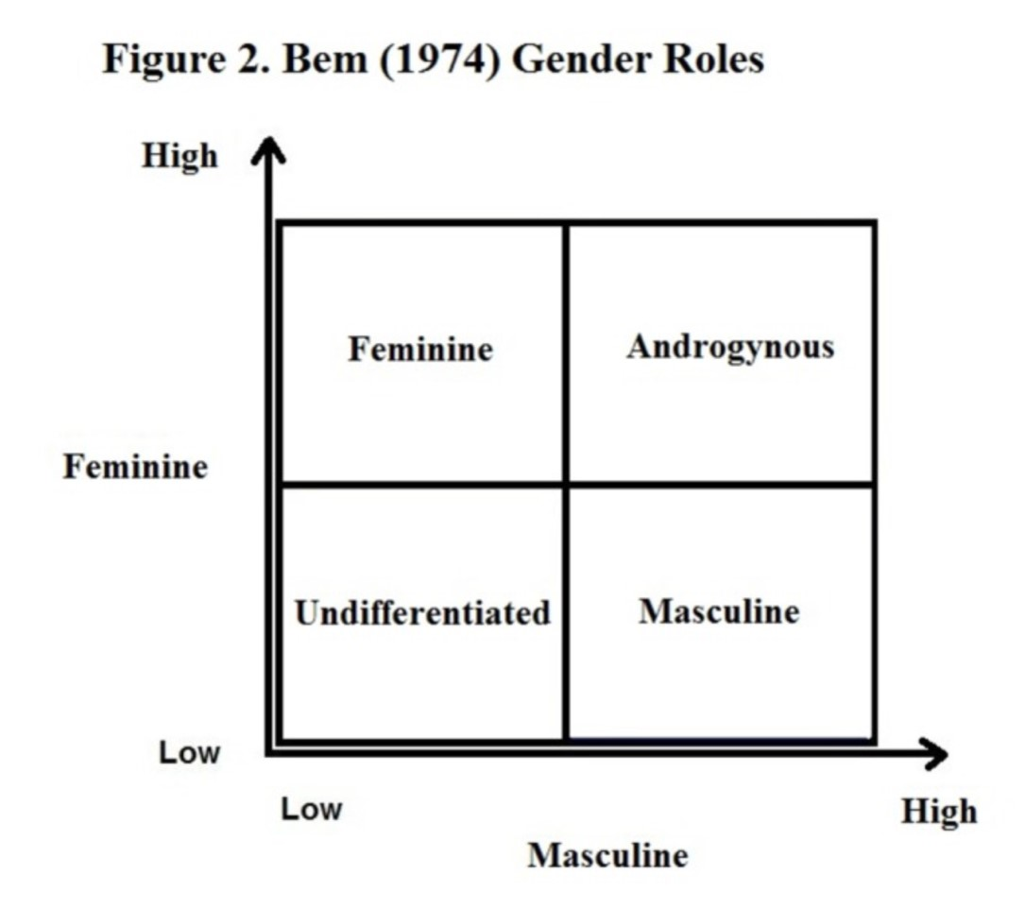
Figure 2
Bem (1974) Gender Roles

Results

The Bem androgyny model was the conceptual base for constructing four gender role groups. Using a median split: among men, 18% (n=14) were categorized as masculine, 32% (n=26) were androgynous (high in both masculine and feminine items), 16% (n=13) were categorized as feminine and 34% (n=27) were undifferentiated. For women, 20% (n=40) were classified as feminine, 19% (n=37) were masculine, 34% (n=67) were androgynous and 26% (n=52) were undifferentiated. Most importantly, perceived gender roles did not differ significantly by sex, suggesting that biological sex is a different entity than gender.

Table 4
Gender roles across biological sexes

Gender role group | Male sex (%) | Female sex (%)
Undifferentiated | 27 (34) | 52 (26)
Masculine | 14 (18) | 37 (19)
Feminine | 13 (16) | 40 (20)
Androgynous | 26 (32) | 67 (34)
Missing |  | 2 (1)
Total | 80 (100) | 198 (100)

There was no significant difference between males scores and female scores

In summary, our factor analysis showed that, in this population, the BSRI-12 differentiated two factors, corresponding to feminine and masculine scales. Contrary to our predictions, gender role classification did not reflect biological sex. In fact, a higher percentage of both males and females were classified as either androgynous or undifferentiated than those classified in traditional gender roles of masculine and feminine. Furthermore, the lack of association between biological sex and gender roles indicates that sex and gender roles are different entities in this population.

Discussion

Asking about, and including measures of gender roles among an older, non-English speaking population is surprisingly rare in health outcomes research. Perhaps this is because translating the concepts in the inventory is not simple and straightforward, but it may also speak to assumptions that seniors are either unaffected by gender roles or that they all ascribe to the same roles. If research is to acknowledge and account for gender as a social determinant of health, then measuring gender roles is a key component of such research. Gender, however, is not fixed or static but varies across time and place making repeated validation of measures such as the BSRI necessary as characteristics of any population studied vary.

It would appear that the gender role differentiation power of BSRI-12 was not as strong statistically in our research as in a number of earlier studies. This may because there were only twelve items to score, or because of the content of the list of items on the BSRI-12. It may be that over the decades and with changes in gender roles the BSRI will require modification to better reflect social expectations of men and women. This is in keeping with the fluid and contextual nature of gender, itself.

Our original hypothesis was that a greater proportion of males would be classified in the masculine/instrumental category and a larger proportion of females would be classified as feminine/expressive. This was not the case. Similar to other researchers studying older adults, we found little overlap between biological sex and gender roles; that is, men were not significantly more likely to be masculine than were women. In fact, a smaller percentage of males and females fell into the traditional gender roles of masculine and feminine than into the androgynous and undifferentiated categories. In this sample of older Brazilians, we found that more men (32%) and women (34%) were androgynous than masculine (men 18%; women 19%).

The lack of differentiation according to physiological sex between gender roles may have been due to the translation of the instrument, classification method or the low education and socioeconomic status of our participants. Perhaps the BSRI-12 does not describe masculinity and femininity in ways that fit the context of our study population. On the other hand, and in keeping with other research, this lack of congruency between biological sex and gender roles may indicate that each is an independent contributor to who a person is and, potentially, to well-being; and that measuring both constructs will add explanatory value in social determinants research. Despite frequent assumptions that the elderly are more traditional than younger people, the lack of overlap between sex and gender roles in this older population from a relatively traditional culture suggests that with aging, gender roles may actually become less stereotypic and rigid, even in a more traditional and less egalitarian society.

Conclusion

To deepen the meaning of biological sex and address how or whether aspects of gender are determinants of health requires including measures of gender equalities, constraints and expectations in quantitative research. The BSRI is one such measure that, despite its age, remains valid, and adds meaning not captured by the simple dichotomous classification of sex. It does require revalidation when used with new study populations.

Among a relatively socioeconomically deprived population of Brazilian seniors the BSRI-12 may have measured aspects of gender not encompassed by the construct of sex. Research on education, SES and gender may reveal the extent to which socioeconomic deprivation impacts gender. Using only sex in research automatically dichotomizes a population. Including the BSRI-12 as a measure of gender roles among this group of older Brazilian adults suggests convergence rather than division between men and women. The BSRI-12 appears to have meaning across contexts and age groups, and to be a valid measure of one aspect of gender among this older, low socioeconomic status, Brazilian population.

Task 2: Answer questions about the text
Now that you have read and annotate the above text, answer the following questions about it.

(Approx. 25 minutes)
- What does the Bem Sex Role Inventory measure?
- How might the self-attribution of traits affect the internal validity of the BSRI?
- Why is it important to measure the applicability of the BSRI in different cultures?
- Explain what is meant by the term ‘androgynous’.
- What did the results of this study show about the relationship between sex and gender in Brazil?

