AnthroSchools Homework Resource

Curriculum and Exam Board: A-level AQA
Subject: Psychology
Topic: 4.3.1 Attachment

Resource Tasks

- Read and annotate academic article about fathers’ involvement and child socioemotional behaviour
- Analyse the article and answer questions

Learning outcomes
Students will be able to critically examine key psychological studies

Students will develop an understanding of the cultural variations in attachment in a wider context
Students will expand their knowledge of the role of the father

Key Skills Developed in Resource

- Understand scientific language
- Critically examine key psychological studies
- Application of aspects of research methodology to psychological studies
- Application of psychological theories to real-world contexts

Task 1: Read and annotate article about fathers’ involvement and child socioemotional behaviour

Schaffer and Emerson (1964) studied infant attachments and produced a stage theory for the development of attachment. They also found that fathers were much less likely to become primary attachment figures than mothers.

The following, taken from an article that investigates the correlation between father involvement and child socioemotional behaviour, expands on the role of the father as a caregiver.

Read the text (35 minutes), taking notes and then proceed to the next task.

Fathers’ Involvement: Correlates and Consequences for Child Socioemotional Behaviour in the United Kingdom
McMunn et al. (2015, Journal of Family Issues)

Fathers’ Involvement: Trends and Correlates
While traditional social norms privileging the breadwinner role in defining fatherhood have waned, there is not currently a great amount of evidence to demonstrate actual behavioural change on the part of fathers. One study found the ratio of the amount of fathers’ time to mothers’ time spent in child care increased across all primary child care activities among married couples in the United States between the mid-1960s and the late 1990s. On the other hand, a time-use study in France and the Netherlands found that “new fatherhood” was an image that was not founded on real practice among men in terms of time spent in domestic labor and parenting. Additionally, while fathers may be more involved in their children’s lives than previous generations of fathers, evidence suggests that women remain largely responsible for child care and domestic life.
Levels of fathers’ involvement are not homogenous across society. For example, as gender norms continue to identify men as household providers, and time is a finite resource, we might expect fathers’ involvement with their children to diminish with increasing hours spent in paid work. However, evidence suggests that working mothers safeguard time spent with their children, despite increased hours spent in paid work, and a recent U.S. study showed that work hours were not strongly related to fathers’ involvement. Within couples, parental time may be conceptualized as a household-level resource. The evidence regarding whether fathers become more involved in parenting to offset longer work hours among their wives or partners is mixed, as is that on fathers’ involvement in relation to their own educational attainment or financial resources. Some studies suggest that fathers in professional occupations are able to be more involved with their children due to having more control over their work schedules, but other studies suggest the opposite.

Fathers’ Involvement and Children’s Socioemotional Behaviour
Fathers’ increasing involvement may work to strengthen family life, particularly against the current backdrop of busy working parents. Fathers’ involvement may benefit children directly, in terms of increased quantity of parental attention, and indirectly through improvements in mothers’ well-being, due to sharing the responsibility of parenting, and/or through more harmonious relationships within the household, which have been linked with more equal sharing of caregiving responsibilities. Social learning theory would suggest that increased interaction with fathers provides children with an additional opportunity to learn social skills, as well as an additional source of emotional and instrumental support.
Evidence supports the hypothesis that fathers’ more frequent participation in child-related activities has significant beneficial effects on children’s cognitive, linguistic, and socioemotional development across early childhood independent of mothers’ involvement or household financial resources.
Parent–child reading has been identified as a form of parental involvement that is particularly important for cognitive development and school readiness and has been shown to be more strongly related to learning outcomes than parental play or warmth. However, many studies of parental reading focus specifically on mother–child reading and very little is known about father–child reading. In addition, while parent–child reading has been linked with a variety of measures of school readiness, achievement, and cognitive development, the potential impact of parent–child reading on behavioural development has not been investigated.

This Study
We hypothesize that fathers’ reading with their child will have significant beneficial cross-sectional and longitudinal effects on children’s socioemotional behaviour, independent of the effects of mothers’ reading and any effects of previous child behaviour on parental reading.

Method

Data
The Millennium Cohort Study (MCS) is a prospective study of children born in the United Kingdom at the start of the new millennium. The original cohort consisted of 18,819 children born between September 2000 and January 2002. In total, there have been five waves of data collection of which the first four, at ages of 9 months, and 3, 5, and 7 years, are used here.

Results

Involvement in Parenting Activities: Comparing Mothers and Fathers by Child Gender
Table 1 shows the proportion of fathers and mothers who participate in various activities with their children (several times per week or more) at age 5 and at age 7 separately by the gender of the child. At age 5, fathers were significantly more likely than mothers to play physical games with their children. Otherwise, mothers were significantly more likely than fathers to participate in each of the activities with their 5-year-old children at least several times per week. Reading was the most prevalent activity for both parents, with 81% of mothers and 49% of fathers reading to their 5-year-old at least several times per week. When their children were 7 years old, fathers were more likely than mothers to play games with their child at least several times per week and a little over a fifth of both mothers and fathers told their children stories at least several times per week. On the other hand, mothers were significantly more likely than fathers to read, do artistic activities, and take their child to the playground at least several times per week.
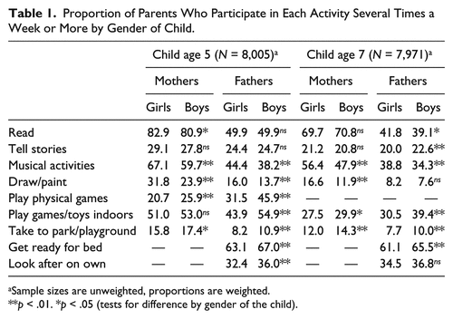
Looking at the gender of the child, both mothers and fathers were significantly more likely to participate in artistic activities at least several times per week with daughters than with sons. When children were 5 years old, 32% of mothers of daughters drew or painted at least several times per week compared with 24% of mothers of sons. This relationship persisted when children were 7 years old. When cohort members were 5 years old, both mothers and father were significantly more likely to play physical games at least several time per week with sons (46% of fathers and 26% of mothers) than with daughters (32% and 21%, respectively). In addition, fathers of sons were significantly more likely than fathers of daughters to play games, go to the park, put their child to bed, and look after their child on their own at least several times per week. Reading and telling stories to or with children did not differ by the gender of the child as greatly as participation in artistic or physical activities did.

Correlates of Fathers’ Reading
Table 2 shows the proportion of fathers who read to their child at least several times per week by fathers’ characteristics. The likelihood of fathers reading to their children at least several times per week increased with father’s educational qualifications, ranging from 28% among fathers who had no educational qualifications to over half of fathers with postgraduate degrees.

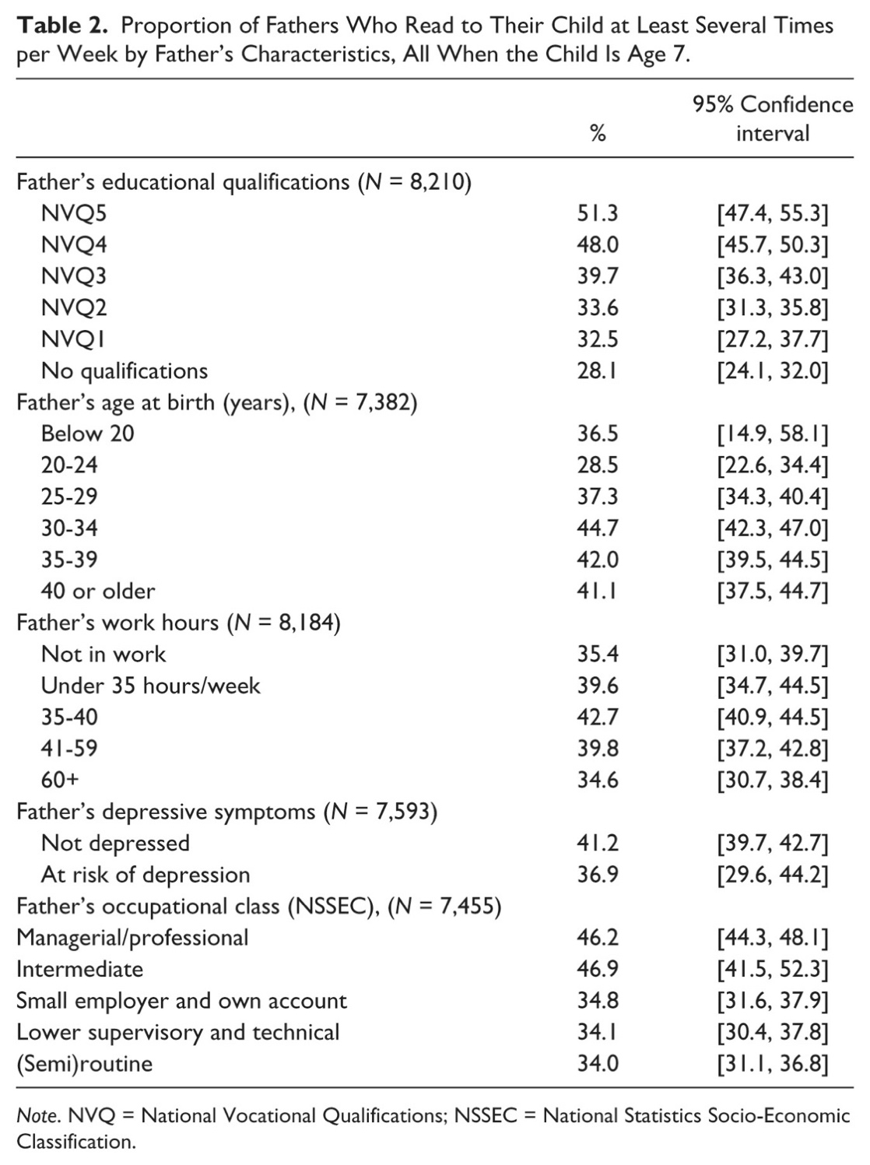

Relationships Between Fathers’ Reading and Child Socioemotional Behaviour
This study also analysed the relationship between fathers’ reading and child socioemotional behaviour when children were 9 months, 3, 5, and 7 years old. The father’s involvement in reading to their children was compared with the child’s socioemotional behaviour at each age to find the correlation between the two variables.
It found that father’s involvement at 9 months predicted better socioemotional behaviour at age 3, although father’s reading was not significantly associated with child behaviour at any age after accounting for each of the mother’s, father’s, and household characteristics
Mother’s reading at age 3 was significantly associated with improved socioemotional behaviour at both age 3 and age 5 even after accounting for concurrent reading at age 5 and previous socioemotional behaviour. Children’s socioemotional behaviour at age 3 significantly predicted mother’s reading at age 5; the more behavioural difficulties children had at age 3, the less frequently their mother read with them at age 5. Child socioemotional behaviour at age 3 significantly predicted child socioemotional behaviour at age 5, which significantly predicted behaviour at age 7.

Discussion
This study examined longitudinal relationships between parents’ reading and children’s socioemotional behaviour between infancy and age 7. We found no significant association between fathers’ reading and child socioemotional behaviour. However, fathers’ involvement in infancy significantly predicted better socioemotional behaviour at age 3, although the relationship was not strong. These results suggest that early father involvement may have a small but significant part to play in the prevention of child socioemotional difficulties, when taken within the broader familial context. Nevertheless, this small contribution may be long-lasting as child socioemotional behaviour at ages 3, 5, and 7 is strongly and significantly correlated, so even a relatively small impact in the early years may help set children up on a positive trajectory. There is previous evidence to suggest that father’s involvement with their children in infancy has longer term impacts, predicting improved hormonal reactivity, behaviour, and mental health at school age and self-worth in adolescence.
Our work suggests that mothers’ reading with children has a greater impact than fathers’ reading on children’s behaviour, all else being equal. Frequency of mother’s reading at age 3 was significantly associated with better socioemotional behaviour scores for children at age 3, and at age 5. The greater strength of the relationship between mothers’ reading and child behaviour, in comparison with fathers’ reading, may be partly due the beneficial effects of fathers’ reading being drowned out by that of mothers. We have seen that mothers are more likely than fathers to be frequent readers, and that fathers who are frequent readers are more likely to live in households in which mothers are also frequent readers. Also, prior to including mother’s reading in the model, father’s reading at age 3 was significantly associated with children’s behaviour at age 3.
This study has also shown that fathers’ involvement in reading with their children is socially patterned. Fathers with higher levels of education and income, those in more advantaged occupations and those who are older than 30 years of age are more likely to read with their children frequently. Therefore, children whose fathers read with them are also more likely to live in environments that are more socially and economically advantaged.
Time availability also appears to be an important correlate of fathers’ involvement. Fathers who worked longer than a 40-hour week were less likely to read with their child frequently, as were fathers in male-breadwinner households and those living with greater numbers of children. It seems that time works as a household resource as well, with fathers in dual-earner households and those where mothers worked longer hours more likely to read frequently with their child.
In conclusion, this is the first study to examine longitudinal relationships between fathers’ involvement and child behaviour up to age 7 in the U.K. context. From a policy perspective, our analysis suggests that policies and workplace practices that enable fathers to spend time with their children at very early ages may be important for children’s subsequent development. The ongoing imbalance between mothers and fathers in their involvement with their school aged children as documented by this study suggests a continuing need for such policies and practices. While it is important to maintain fathers’ links with paid employment for a variety of reasons, including its positive influence on children’s well-being independent of socioeconomic factors, fathers in the United Kingdom remain much less likely than mothers to take their entitled paternity or parental leave or to reduce their hours after the birth of a child. After paternity leave entitlement in the United Kingdom was extended to up to 26 weeks in 2011, only 0.6% of eligible fathers took up the additional entitlement. This study suggests the need for a greater focus on supporting fathers in the important contribution they can make particularly in their children’s earliest years.

Task 2: Answer Questions about the text (25 minutes)

- Did this study use primary or secondary data? Explain the benefits and limitations of this.

- Schaffer and Emerson (1964) found that fathers were less likely to be primary attachment figures than mothers, how might the results from this study support or challenge their conclusion?

- Why might fathers be less likely to be primary attachment figures?

- Evaluate the use of a longitudinal study

- Explain how social learning theory would suggest that increased time spent with fathers could aid children to learn social skills

- Only the quantity of the fathers’ interactions with their children were measured, explain how this could affect the internal validity of the study

Learning Outcomes
- Students will be able to critically examine key psychological studies
- Students will develop an understanding of the cultural variations in attachment in a wider context

Key Skills
- Understand scientific language
- Critically examine key psychological studies
- Application of aspects of research methodology to psychological studies
- Application of psychological theories to real-world contexts

