AnthroSchools Homework Resource

Curriculum and Exam Board: A-level, AQA
A-level History (AQA) Curriculum Section 2S
- Part Two: Modern Britain, 1979-2007.
  - Section: The impact of Thatcherism, 1979–1987,
- Main assessment objectives
  - AO2: Analyse and evaluate appropriate source material, primary and/or contemporary to the period, within its historical context.
Subject: History
Topic: The Falklands War
Resource Tasks

- Territory and borders as anthropological concepts
- Departing from Anglo-centric narratives
- The US-UK Special Relationship

Learning outcomes
- Students can start to think critically about concepts like land ownership, territory and borders. Students will be introduced to more complex topics such as colonialism and anthropological terms like ethnocentrism. This will also help in acquiring an understanding of different identities within society and an appreciation of aspects such as social, cultural, religious and ethnic diversity, as appropriate.

Students will depart from purely Euro and Anglo-centric accounts and sources. This will help students to incorporate different perspectives into their historical analysis, resulting in broad evaluation of appropriate source material, primary and/or contemporary to the period, within its historical context.

Students will engage critically with media propaganda, and consider how it can be valuable as a historical source. In turn they will develop the ability to ask relevant and significant questions about the past and to research them.

Key Skills Developed in Resources

- Engaging with diverse source material, including newspaper cartoons, historical and anthropological texts.
- Critical questioning of information and sources, in order to acquire an understanding of the nature of historical study, for example that history is concerned with judgements based on available evidence and that historical judgements are provisional.
- Developing the use and understanding of historical terms, concepts and skills, while also being introduced to new anthropological terminology.
- Evaluation and analysis of unfamiliar historical perspectives and an understanding of the interrelation between different historical concepts.

Task 1: Territory and Border

This task has two main aims. In this task you will…

- Analyse and evaluate two brief excerpts from anthropological texts about territory and borders.

- Investigate and assess new anthropological concepts such as ethnocentrism.

Step 1: Read the below excerpts

Read the following excerpts which analyse the concepts of territory and border from an anthropological perspective.

Source 1: ‘When we speak of territory in anthropological terms, we understand it as the space of a certain society, social structure, group or institution, that is, as socially controlled and projected limits. Space, thus constituted as territory, expresses a relation of power: by controlling the territory this society establishes its power over itself, its groups, material resources and also in relation to other societies.’

Societies “against” and “in” the State, Andrey Cordeiro Ferreira

Source 2: ‘Borders are both a philosophical category as well as fundamental social phenomena.’

Selected conceptual issues in border studies, Vladimir Kolossov and James Scott

Step 2: Answer the following questions

Answer the following questions about these excerpts based on your understanding of the concepts ‘territory’ and ‘border’.

Consider how the above excerpts compare and contrast with the approaches taken to the Falklands War by the UK and Argentinian governments.

- How do these excerpts add to or change your view on borders and territory? (50 words)

- In Source 1, Ferreira states that control of territory allows a state to establish "its power over itself". What does Ferreira means by this statement? (50 words)

- In Source 2, Kolossov states that borders are 'fundamental social phenomena'. Why do you think he uses the word 'fundamental'? (50 words)

Task 2: Departing from Anglo-centric narratives

This task has two main aims. In this resource you will…

- Investigate the Falklands War from the Argentinean perspective, especially in regard to claims over land.

- Consider the role of media and propaganda in wartimes.

Step 1: Read the following quote and look at the attached image

Source 1: ‘Ethnocentrism is the term anthropologists use to describe the opinion that one’s own way of life is natural or correct… Another example of ethnocentrism is colonialism. Colonialism can be defined as cultural domination with enforced social change.’
Ethnocentrism, Lumen Learning

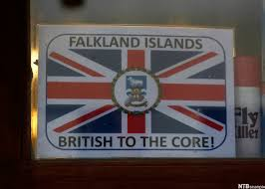
A window poster in support of Britain’s claim to the Falkland Island
Source: CC-BY-NC-ND-4.0 Photographer: Marcos Brindicci, http://www.scanpix.no

Step 2: Answer the following questions

Territory claims and land disputes are an age-old tale intrinsic to the development of humanity and culture. However, the age of Empires, imperialism and colonial rule had unprecedented and often destructive effects across the globe. The Falkland Islands are considered a British overseas territory rather than a colony.

    - What do you think the differences between a territory and colony are? (50 words)

    - At the time of the war, the Falkland Islands were considered a British Crown Colony rather than an overseas territory by the British public. Why do you think this was? (50 words)

Task 3: The US-UK Special Relationship and the Falklands

This task has two main aims. In this task you will…

- Describe and analyse a cartoon

- Answer questions about the role of media and propaganda in war

Step 1: Describe and Analyse at the Below Cartoon

Look at the Argentinian cartoon below, depicting the relationship between Margaret Thatcher and Ronald Reagan during the Falklands War.
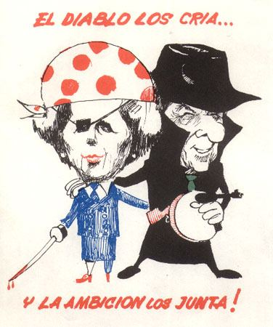
Translation: the devil breeds them… and the ambition brings them together!

Source: Malvinas-Falklands_Propaganda_Flyer_29_(438824577).jpg ‎(376 × 450 pixels, file size: 32 KB, MIME type: image/jpeg)

- Briefly describe the cartoon (50 words)

- Now analyse the cartoon (100 words)

  - What does this depiction of Thatcher and Reagan, in this Argentinian propaganda flyer, say about the ‘special relationship’ between the UK and the USA and how it is perceived by others?

  - In answering this question consider concepts such as territory and staking a claim to land. Consider the representations and choices of characterization depicted

Step 2: Answer Questions about the Role of Media in War

- What is the role of local media during times of war? (100 words) Continue on a separate sheet if you need to.

- How valuable is media propaganda to a historian? (100 words) Continue on a separate sheet if you need to.

Learning Outcomes Achieved from Resource

- Acquired an understanding of different identities within society and an appreciation of aspects such as social, cultural, religious and ethnic diversity, as appropriate.
- Introduced to new anthropological terminology and how it relates to historical analysis.
- Incorporated different perspectives into their historical analysis, resulting in broad evaluation of appropriate source material, primary and/or contemporary to the period, within its historical context.
- Developed the ability to ask relevant and significant questions about the past and to research them.

Key Skills Developed through Resource

- Ability to engage with diverse source material.
- Critical questioning of these sources, in order to acquire an understanding of the nature of historical study, for example that history is concerned with judgements based on available evidence and that historical judgements are provisional.
- Evaluation and analysis of unfamiliar historical perspectives and an understanding of the interrelation between different historical concepts.

