AnthroSchools Homework Resource
Curriculum and Exam Board: A-level AQA
Subject: Geography
Topic: 3.2.5 Resource Security (3.2.5.3 Water Security)
Case Study: Dakota Access Pipeline

Resource Tasks
- Research the Dakota Access Pipeline conflict
- Write an essay about the incident as an example of local water conflict and resource conflict

Learning outcomes
Students will understand the concept of water security
Students will understand the relationship between the physical environment and human activity,

Through a case study, students will develop knowledge and understanding of
- Water source
- Distribution networks
- Sustainability issues
- Geopolitics
- Conflict and its resolution
- Students will understand the concept of water security
Students will understand the relationship between the physical environment and human activity

Key Skills Developed in Resources
- Research skills
- Developing extended and analytical writing skills.
- Conducting independent research tasks.
- Core skills (application, analysis, deduction and comprehension)
- Application of a theory to a specific context

CONTENT WARNING: Please note, independent research into this event will reveal instances of discrimination and violence against the proteste

Task 1: Research the Case Study
Estimated Time: 45-60 minutes
In this task, you must conduct independent research into the 2016 development of the Dakota Access Pipeline at Standing Rock and the ensuing controversy around it. Make sure that you take notes to answer the questions in the next task.
You should try to understand all perspectives but make sure to take a particular interest in the conflict from the perspective of the Sioux Tribe.

Summary of Case Study
Source: BBC News Online “Dakota Access Pipeline: Judge suspends use of key oil link”. https://www.bbc.co.uk/news/world-us-canada-53317852
The $3.7bn (£2.8bn) 1,200 mile-(1,900km) long pipeline, completed in 2017, can transport some 570,000 barrels of crude oil a day across four states, from North Dakota to a terminal in Illinois, where it can be shipped to refineries.
Supporters of the pipeline, owned by Energy Transfer, argue it provides a more cost-effective, efficient means of transporting crude, rather than shipping barrels by train.
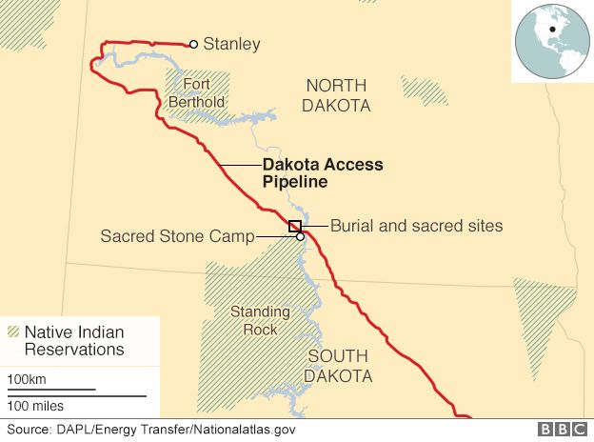
But the Standing Rock Sioux and their supporters argued the project - which passed just north of the tribe's reservation - would contaminate drinking water and damage sacred burial sites.

Potential Places to Gather Further Information about the Issue
Short Documentary
- ‘The Fight for Standing Rock’:
News Articles
- The Guardian 2016: https://www.theguardian.com/us-news/2016/nov/03/north-dakota-access-oil-pipeline-protests-explainer
- The Guardian 2019: https://www.theguardian.com/commentisfree/2019/nov/15/dakota-access-pipeline-standing-rock
Native American Perspectives
- https://americanindian.si.edu/nk360/plains-treaties/dapl
- https://lastrealindians.com/news/2016/11/10/nov-10-2016-dakota-access-llc-announces-plan-to-drill-under-missouri-river?rq=Dakota%20Access

Task 2: Write an Essay
Estimated Time: 1-1.5 hours
Having conducted independent research, you must now write an essay (1200-1500 words) that discusses the incident as an example of water conflict and proposes a resolution.
Consider the following questions
- How did the proposed development of the pipeline impact the water supply on Standing Rock Indian Reservation?
- How did the Sioux tribe react to this development? And why?
- How did the proposed development of the pipeline impact the water supply on Standing Rock Indian Reservation?
- In what ways do the Sioux tribe and the US government see the issue differently?

