University College/Royal Free London Medical School

University College, Royal Free and Whittington Hospitals

MBBS
Module B
Year 4

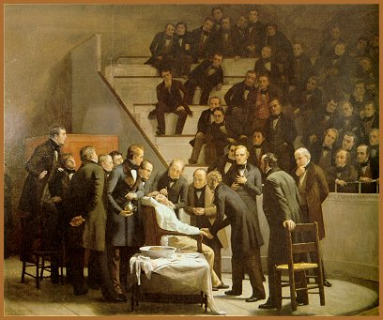
16th October 1846. The operating theatre, Massachussetts General Hospital.
Surgeon John Collins Warren removing a tumour from Gilbert Abbot's jaw under the first public Ether anaesthesia delivered by William Morton.

Anaesthesia, Pain and Perioperative Medicine
Student Workbook

Dr Rob Stephens, UCLH
Dr Basil Almahdi, Whittington
Dr Jane Lowery, Royal Free

Contents Page

Introduction, syllabus and objectives 3

Chapter 1 Pre-operative patient: Cardiac & Respiratory Systems 6

Chapter 2 Pre-operative patient: Other systems 15

Chapter 3 Intra- operative care 19

Chapter 4 Post- operative care 27

Chapter 5 Assessing and managing post-operative pain 36

Chapter 6 Body fluids and compartments, Blood 44

Chapter 7 Intravenous fluid therapy 48

Chapter 8 Patient safety, risk and recovery 60

Chapter 9 Assessing Acutely ill patients 67

Chapter 10 Critical Care 72

Appendix

1.The Prescribing Highway Code 76

2. Guidelines ALS, BLS, 80

3. ECG made easier 82

Introduction

Welcome to the anaesthetic department teaching in perioperative care. We want to prepare you for finals and your first Foundation year by developing specific knowledge and skills which directly apply to the clinical setting. We will draw upon your existing knowledge of physiology, pharmacology and basic science, emphasising clinical application of basic principles.

Each section of the booklet contains relevant core knowledge and a few questions and clinical case scenarios to do if you have time. These require you to put your factual knowledge into practice. They will be the basis of discussions during some of your tutorial sessions.

Resources
- This Booklet
- Articles on our UCL Website
- Our SBA Podcast series on our YouTube site
- The practical procedures book- on the website
- Knowledge gained when you come to theatre, pain rounds.

Assessment
Your assessment will be in 2 parts:
- Coming to theatre + Logbook in your allocated group weeks
- End of year exams

Practical Skills
Come to theatre/preassessment/pain rounds in your allocated ‘off’ week. This will provide amazing opportunities to practice practical procedures in your year 4 booklet in theatres including cannulation, catheterisation and IV drug administration. This would be under direct observation with constructive feedback by anaesthetists. We encourage you to make the most of this unique opportunity. Do be proactive- if you're not getting things done, try moving to an adjacent theatre or texting the admon person/lead!

Feedback
We want your feedback- we’re always looking to improve!. Do tell/email us- we can do something about it!

Covid 19
In this strange socially-distanced era we find ourselves, we’ve had to adapt our teaching – as you’ve had to adapt your life.
We’ll have
- Information packs emailed to you to go through before the blackboard tutoroals
- 7 Blackboard 4:30-5:30 tutorials- all recorded
- A Forum to ask questions on Moodle
- Days to come into Theatres etc on your ‘Off’ weeks

Do take care and pay attention to the safety briefings- for you and anyone who comes into contact with you. Try not to worry – you are all in the same boat… learn a few things each day and you’ll do real well.

Syllabus Outline

We have taken this from
- GMC- our interpretation of ‘Outcomes for Doctors’
- The Royal College of Anaesthetists Undergraduate Framework
- The Anaesthesia / Perioperative Medicine teachers at RFH, UCLH & Whittington
The content / detail is in
- the teaching booklet
- the podcasts
- the Single Best Answers series
- the tutorials
Preoperative: Basic assessment of cardiac and respiratory disease. Important tests to perform before surgery. Cardiovascular drugs to stop and continue. Ways to improve / 'optimise' / prepare patients before surgery.

Intraoperative: An outline of the drugs for providing anaesthesia, with mechanisms. Options for airway management. The basic sequence of events during surgical anaesthesia. Intraoperative Monitoring. Basic physiology as applied to breathing during surgery, cardiovascular, bleeding and fluid challenges.

Postoperative: Classification, knowledge, prevention and treatment of common postoperative complications.

Pain: The options for systemic and regional analgesia, with common side effects

Fluids: Body fluid compartments. The types of intravenous fluids given: composition, why, how much, side effects. Physiology and compensation for hypovolaemia. Transfusing blood and products: side effects.

The Critically Ill Patient: How to approach an acutely ill ward patient: the first 30 minutes. DR ABC. Sepsis, sepsis 6 and qSOFA.

Oxygen: Physiology pertinent to arterial oxygenation, the use of oxygen to correct hypoxaemia, the different oxygen masks and their uses / limitations. Shunts, deadspace & Cardiac output.

Practical Procedures: laid out in the 'procedures book' on line.
WHO Checklist+ Putting on preoperative monitoring in the Anaesthesia Room
Cannulation, IVI fluid bag and drip set up using a 3-way tap
Open & draw up drug from glass ampoule, Draw up antibiotics
Guedel /Oro-pharyngeal airway / self-inflating bag & mask / Chin lift - neck tilt - jaw thrust Connecting up self inflating bag – connections
Oxygen masks – types and options
Drug chart: write up analgesia / Fluids / antiemetics for major surgery
Connect up/turn on Oxygen cylinder

Tutorial 1
Key issues to learn from the tutorials
Chapter 1 Pre-operative patient: Cardiac & Respiratory Systems
Walking up 1 flight of stairs without symptoms- a key fitness measure
dysrythmias/cardiac failure/ Ischaemic Ht Diease before surgery is a big deal
Carry on most drugs especially β blockers
But stop ACE inhibitors / Consider stopping Anticoagulants
Great caution re stopping any anticoagulation in those with coronary stents

Chapter 2 Pre-operative patient: Other systems
NBM guidelines - 2 hrs fluid /6 hours food
Diabetic drugs & insulin what to do
FBC, U & E, other preop bloods

Tutorial 2
Chapter 3 Intra- operative care
Classic drugs of Anaesthesia: Hypnosis/Analgesia/ Neuromuscular Paralysis
MAP = CO x SVR - 2 basic causes of hypotension
‘Anaesthesia causes hypotension’
Basic airway management Mask ventilation vs supra vs infraglottic airways

Tutorial 3
Chapter 4 Post- operative care and Complications
LMWH timing
Classifying complications- local/systemic & immediate/early/late
Enhanced recovery- the concept and some elements
Ways to prescribe oxygen + antiemetics

Tutorial 4
Chapter 5 Assessing & managing postoperative pain
Classifying Analgesia- Local / regional / systemic (ladder)
Common analgesics: side effects, routes and doses
Spinals and Epidurals
Paracetamol, NSAID + Opioid 'rules' doses and timings

Tutorial 5
Chapter 6 Body fluid compartments, Fluids and Blood Products
Intra/extra cellular, interstitial and vascular compartments
Crystalloids/colloids/ blood products: types, contents, uses
Anaemia preop- the options
Side effects of blood transfusion

Chapter 7 Intravenous fluid therapy
NICE ward guidelines: Assessment, Resuscitation, Routine Maintenance Replacement Redistribution
The physiology of bleeding and the stress response: Autonomic / Immune/ Endocrine / RAS

Tutorial 6
Chapter 8 Patient safety, risk and recovery
WHO safe surgery checklist components
The risk of surgeriy vs the risk of alternatives
Consent-capacity + informed consent
Calculating risk: ASA, SORT & POSSUM

Tutorial 7
Chapter 9 Assessing Acutely ill patients
DR ABCDE first few minutes
'Do Not Attempt to Resuscitate' - what it means/doesn't mean

Chapter 10 Critical Care
Why go to Critical Care- indications
What can be done there - CVS RS GI Liver Renal Neuro
Sepsis, sepsis 6 and qSOFA
Issues in Critical Care

Chapter 1 Pre-operative Patient:
Cardiac and Respiratory Systems

Objectives

- How and why a patient must be optimised prior to anaesthesia
- The implications of medical conditions for anaesthesia
- The relevance and interpretation of investigations
- How and why a patient is prepared for theatre

Pre-operative tests
- Tests should inform patients making decisions and the consenting process – the patient thinking/knowing about their operation
- You should always think “what will I do if this is test normal/abnormal. Would it alter anything I do next or say to the patient?”
- Patient’s activities of daily living (ADL) gives an important indication of their physical reserve.
- Tests must detect relevant contitions that can be altered/optimised before the physiological challenges of the perioperative period.
- Tests required vary according to the condition of the patient and the type of surgery they are scheduled to undergo.
- ‘Major surgery’ (chest, abdomen, pelvis, vascular) especially with major ‘comorbidities’– the risk of the surgery needs to be considered vs the risk of NOT having the surgery.

Many fit and healthy patients are now operated on as day cases. Patients who come into hospital for their surgery are increasingly those with complex medical histories as well as requiring a surgery. Managing these patients safely through their anaesthetic is a matter of team-work between the surgeons, anaesthetists, the general practitioner, nurses and many other healthcare professionals.

General Factors
Anaesthetists use to decide whether to investigate the heart before surgery:

Urgency of Surgery Emergency / Urgent / Scheduled / Elective
Severity of Surgery Peripheral (eg hand) vs body cavtiy
Patients’ Exercise Capacity 1 flight continuously without SOB?
Patients Comorbidities More is worse!

Anaesthetists are involved in most branches of acute medicine, including:
- many imaging procedures: MRI & CT scans, angiography and angioplasty
- radiotherapy to children under anaesthesia
- cardiologists do DC cardioversions under anaesthesia
- some gastroscopies / other complex endoscopies and bronchoscopies
- women in labour requiring anaesthesia and analgesia
It is important that you understand the risks and can explain what will happen to a patient under anaesthesia.

1. Cardiovascular System CVS

Cardiovascular disease is the commonest co-morbidity in surgical patients.
- Inform the anaesthetist of any significant / symptomatic CVS disease.
- Anasthesia stresses the cardiovascular system
- How much activity the patient can usually do without significant shortness of breath or chest pain? ADL/’METS’ (Metabolic Equivilant of Task):
Can they walk up 1 flight of stairs continually?
How else can you quantify ‘work” – can they carry shopping etc?
Hard to assess this in patients with hip/knee disease

Cardiac Failure – limits the ability of the heart to respond under stress during anaesthesia / surgery. More dangerous than Ischaemic Heart Disease.
Ischaemic Heart Disease - Patients with unstable angina or recent MI are at increased risk of a peri-operative MI which has a mortality of >30%: they should be carefully assessed and optimised pre-operatively. Unfortunately revascularisation before non-cardiac surgery (CABG/ Angioplasty/coronary stents does little to reduce mortality.

Hypertension – Persistent uncontrolled hypertension (> 180-200 mmHg / 100-110 mmHg) should probably be treated for a month or more before elective surgery due to the increased cardiovascular risk.
Cardiac Dysrhythmias – Atrial fibrillation should have a well-controlled rate i.e.<100bpm. Other dysrhythmias should be discussed with the anaesthetist.

Intravascular fluid status – Patients with hypovolaemia need immediate resuscitation. Patients who have been starved, had prolonged nasogastric drainage, nausea, vomiting, or those who have undergone ‘bowel prep’ may become significantly hypovolaemic in the peri-operative period.

Valvular heart disease – Murmurs detected on physical examination may need investigation with echocardiogram. Aortic stenosis in particular can lead to significant perioperative risk.
- ECG - in patients aged > 55yrs because of the risk of silent MI in this age group.
- ECG - in anybody with cardiac symptoms or signs, including hypertensive patients
• Anti-anginal and anti-hypertensive medication should be continued except ACE inhibitors

A cardiopulmonary exercise test gives information about fitness. The patient exercises on a cycle ergometer whilst gas exchange at the mouth is measured to determine oxygen uptake- VO₂, and carbon dioxide production- VCO₂, A low peak VO₂, low VO₂ at the ‘anaerobic threshold’ and a high VE/VCO₂ (the amount of breathing you have to do to breathe off 1L of CO₂) is associted with a poor outcome.

2. Respiratory system

Anaesthesia and surgery reduce lung function. Patients must be optimised to ensure that they have the respiratory reserve to cope with the physiological demands of surgery. This is especially true of patients undergoing upper abdominal surgery, which has a greater impact on respiratory function.

• Shortness of Breath (SOB) - If at rest shows severe respiratory compromise.
• Activity - How far can they walk without getting breathless?
- Can they manage a flight of stairs without breathessness/chest pain?
• Wheeze / Asthma - Well-controlled asthma which has never required hospital admission does not present significant anaesthetic difficulties. Patients who have had multiple hospital admissions with breathing difficulties may cause problems.

The new development of an acute upper or lower respiratory tract infection, or acute bronchospasm may require postponement of elective surgery. Ask the patient if they are as well as they can be? This is a good indicator of whether they may need to be optimised!
Routine pre-operative investigations and management
• A chest x-ray is not required pre-operatively for anaesthetic assessment unless there is a clinical indication, or the patient is having thoracic surgery.
• Asthmatics should have a peak expiratory flow rate (PEFR) done and bronchodilators should be continued pre/post -operatively.
• COPD patients may need physiotherapy both pre- and post-operatively

For more information please see articles at
www.ucl.ac.uk/anaesthesia/StudentsandTrainees/students

- Podcast on UCL Anaesthesia’s site:
  - Preoperative Assessment
  - Introduction to Cardiopulmonary Exercise (‘CPET’) Testing

Case Studies - Chapter 1

Problem 1

Mrs Elizabeth Brown is a 50-year-old housewife. She is scheduled to have her varicose veins stripped on the list this afternoon. The nurses have admitted her to the ward, and they have taken her blood pressure on admission and 1 hour later. Her TPR chart is shown opposite. She is not on any medication. Her mother had a stroke at the age of 75, and her brother had a small heart attack last year at the age of 55.

A What are the issues?

B What investigations should be performed?

C Should the patient have surgery now? Please explain your answer.

D What is the most appropriate way to manage this patient.
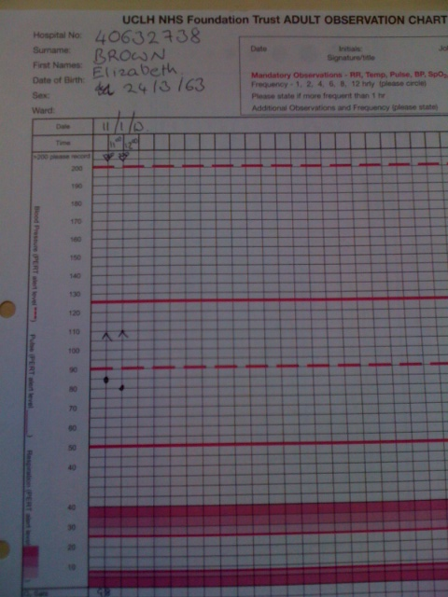

Problem 2

Mr Eric Rogers is a 65 -year old man, who presents at a pre-assessment clinic before having his right inguinal hernia repaired. He complains of a productive cough that is present most of the time. He smokes 20 cigarettes a day and has done for 40 years. At present he is producing green sputum, and is slightly breathless as he walks into the room. He is very anxious to have his operation. His lung function tests are shown below.

A What are the questions/issues with Mr Rogers?

B What tests should be carried out?

C How would you manage this patient?

D Should the patient have surgery now? Please explain your answer.

Peak expiratory flow rate 215 l/min 53% predicted
FEV₁ 1.6 litres 61 % predicted
FVC 3.2 litres 72% predicted
FEV₁/FVC 50%

Post bronchodilator:

PEFR 290 L/min
FEV₁ 1.8 litres
FVC 3.0 litres

Problem 3

Mr Jai Ravinder is 55 years old and has a 9-month history of intermittent right upper quadrant abdominal pain. He has gallstones on ultrasound, and is scheduled for elective laparoscopic cholecystectomy. He has not been seen by the surgeons for 5 months. On taking his history, he tells you that he was in another hospital 2 months ago with chest pain which he still gets sometimes. He was in CCU and was told he had had a mild heart attack.

His ECG is shown opposite.

A What are the questions/issues with Mr Evans care?

B What does this ECG show? Why might this be significant?

C What action should be taken?

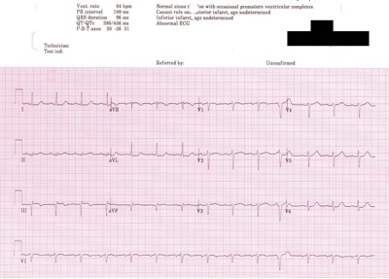

Problem 4

Mrs Nellie Jones is admitted on the day of a total hip replacement. She is limited in her movements by the pain in her hip but has noticed she is increasingly short of breath on even mild activity in the last few months and her ankles swell during the day. On examining her you find that her pulse is irregular. Her ECG is shown opposite.

A What does the ECG show?

B How should this patient be managed?

Nellie Jones Pre op ECG

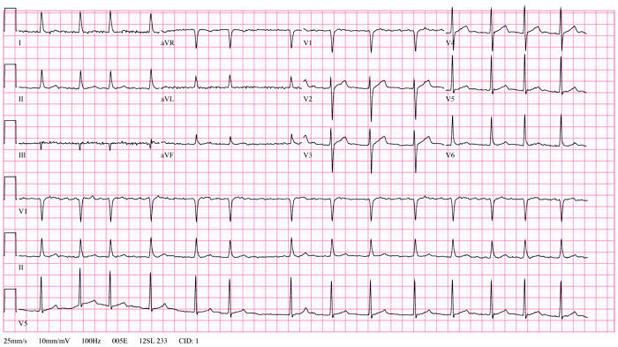

Problem 5

Miss Evelyn White is 70 years old. She comes to the pre-assessment clinic as she is due to come in on the morning of surgery for a wide local excision of a breast carcinoma. On listening to her chest you hear a previously undocumented systolic murmur in the aortic area.

Her ECG is shown opposite.

A What does the ECG show? Why might this be significant?

B How should this patient be managed?

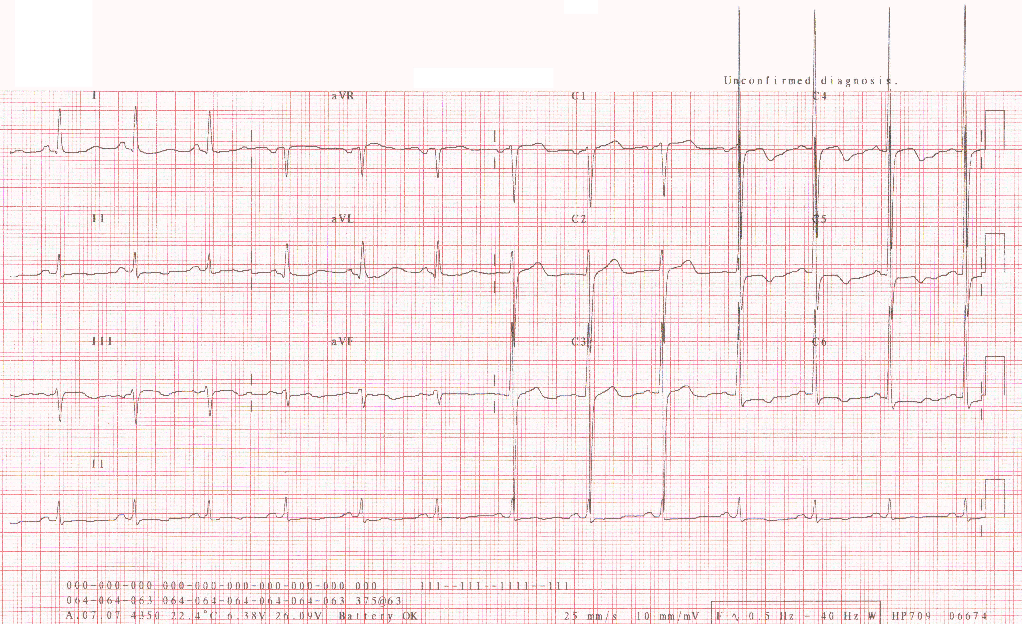
Chapter 2 The Pre-operative Patient:
Other Systems

1. Gastrointestinal Symptoms
- Hiatus Hernia – Symptomatic hiatus hernia increases the risk of regurgitation and aspiration of stomach contents at induction of anaesthesia. The anaesthetist should be forewarned and the patient should be started on an H2 receptor antagonist or a proton pump inhibitor and metoclopramide pre- operatively.

2. Renal/Hepatic Dysfunction

- U&Es – large fluid shifts in the peri-operative period may be detrimental to renal function.

- LFTs – must be done on any patient with a history of jaundice or hepatic dysfunction. Also do a coagulation screen and platelet count.

Advice should be sought from the anaesthetist if the patient is known to have renal or hepatic dysfunction. Dehydration must be avoided in these patients; they may need pre-operative i.v. fluids.

3. Central Nervous System

- TIA/Stroke – these patients are at risk of further cerebrovascular events perioperatively.

Additional pre-operative investigations are performed according to the clinical indications. The need for advanced investigations should be discussed preoperatively with the anaesthetist.

4. Endocrine Abnormalities

- Diabetes Mellitus – Patients with diabetes should be scheduled at the start of the operating list whenever possible. 2 hourly blood glucose analysis must be arranged. An ECG, and urea and electrolyte analysis are necessary. The anaesthetist must be informed in order to decide on an appropriate peri-operative diabetic regime.

5. Haematology/Coagulation

- FBC - A full blood count is required for all patients whose surgery presents a risk of substantial blood loss. Knowledge of the expected blood loss determines whether the patient needs to be fully cross matched or for the patient’s blood group to be determined and serum saved for rapid cross-matching if required (Group & save). In most hospitals there is a cross match or group and save schedule (the MBOS), which tells you which to perform and if appropriate how many units to cross match. If in doubt discuss with the surgeon and/or anaesthetist.

- Anaemia – the cause should be determined, and if clinically appropriate the anaemia should be corrected pre-operatively. In some circumstances (e.g. chronic renal failure) it may not be appropriate to correct anaemia. There is an increasing reluctance to transfuse patients pre-operatively, due to infection risks: it is best to discuss pre-operative transfusion with the surgeon and/or anaesthetist.

- Coagulopathies – should be investigated, and often require specialist help from haematologists.

- VTE (Venous thromboembolism) prophylaxis Must be considered in the following :

- Prolonged surgery
- Abdominal/pelvic surgery
- Prolonged bedrest
- Obese
- Oncological surgery

Prophylaxis may involve thromboembolic deterrent stockings (TEDS) +/- subcutaneous heparin. There maybe a local hospital policy if not discuss prophylaxis with the surgeon and or anaesthetist.

- Sickle-cell testing - is required on all patients of Afro-Caribbean, east Indian and central south American descent. A simple 'sickledex' screening test determines whether or not the patient carries any sickle Hb. If positive, haemoglobin electrophoresis is performed to determine the exact diagnosis.

6. General Pre-operative Preparation

General anaesthesia suppresses the cough and gag reflexes, and reduces the competence of the lower oesophageal sphincter, therefore all adult patients should be starved of solids for 6 hours. Drinks of water may be allowed up to 2 hours pre-operatively in elective surgery. Small children undergoing elective surgery may be allowed milky drinks or breast milk 4 hours pre-operatively, and water up to 2 hours pre-operatively.

Antibiotic prophylaxis should be discussed with the surgical team. Patients with heart valve pathology may need antibiotic prophylaxis against bacteria endocarditis, discuss this with surgeon and/or anaesthetist.

Review the patient's medications. Check for drugs, which may be stopped pre-operatively e.g. aspirin (unless there is a cardiac stent) and for those that should be continued e.g. β-blockers

For more information please see articles at
www.ucl.ac.uk/anaesthesia/StudentsandTrainees/students
- Articles
  - ‘How to do: Blood Transfusion’
Having read Chapter 2 you should be able to answer these questions:

1. If the full blood count reveals a low Hb, name 3 things that the anaesthetist must consider.

2. What is meant by the terms ‘Group&Save’ and ‘Cross-match’?

3. What factors in the past medical history may influence the need for a pre- operative ECG?

4. List the main risk factors for venous thrombo-embolism.

5. Why is it important to inform the anaesthetist of a symptomatic hiatus hernia ?

Case Studies – Chapter 2

Problem 1

Mr Courtney Vickers is admitted for a cyctoscopy and trans urethural resection of a bladder tumour. He has had many anaesthetics in the past, but since his last one three months ago he has had 2 Transient Ischaemic Attacks (TIAs)

A What should be done?

Problem 2

Mrs Packman has been under the renal physicians for many years and coincidentally she has been found to have an infrarenal aneurysm.
She is scheduled to have it treated with an endovascular stent . She is anxious about her kidneys getting worse.

A How can she be reassured?

B What precautions can be taken to reduce the risk to the kidneys?

Problem 3

Joe Parks is a 10 -year old boy who has come for pre-clerking for an elective circumcision in the day surgery unit. He weighs 25 Kg and looks unwell. His mother tells you that he has started to wet the bed at night, yet he says he is always thirsty. He has lost weight recently.

Qn: What should be done?
Chapter 3
Intra- operative Care

When you have worked through this section you should understand

• The physiological changes that occur during unconsciousness
• How to recognise the signs of an obstructed airway and the signs of apnoea
• How to manage the airway of an unconscious patient
• To understand the need for sedation or anaesthesia

Anaesthesia
From the Greek- an-, "not/without" and aesthētos, "perceptible/ able to feel"

general anaesthesia a drug induced reversible state of unconsciousness
‘Triad’ of drugs: Hypnotic, Analgesia, Neuromuscular Paralysis
three stages: induction, maintenance and emergence
regional anaesthesia, nerve transmission is blocked, and
the patient may stay awake or be sedated/anaesthetised as well

1. Decreased consciousness in the peri-operative period

In general, there are many causes of unconsciousness:
Primary Neurological Head trauma, Fit,
Cardiovascular Cerebrovascular accident
Drugs Anaesthesia, drugs overdosage
Metabolic Hypoglycaemia

Whilst the primary cause and its management are being established, unconscious patients all require special attention to specific aspects of their care.
During your time in theatre you will see the theatre staff do various things to the patient. Observe what they do and see how it relates to the following:

The unconscious patient has:

DR Danger ? Response
A Reduced or no airway protective reflexes
+/- airway obstruction
Reduced /No cough reflexes

B Respiratory depression

C Reduced peripheral vascular tone (BP = CO x SVR)

D Reduced oesophageal sphincter tone & reduced gastric motility
Inability to swallow
Reduced or absent movement in response to painful stimuli
Reduced or absent corneal reflexes
Decreased ability to regulate body temperature
Inability to alter posture, Inability to call for help

Hypoglycaemia is the easiest cause of unconsciousness to treat and also the easiest to miss. Always check a blood sugar.

2. Respiratory consequences of surgery and anaesthesia

Anaesthesia (or unconsciousness) cause
- reduced respiratory drive
- a fall in functional residual capacity-
- decreased mucocilliary clearance/cough
- reduced laryngeal competence
All of which predispose to the development of post-operative chest infections, hence the importance of deep breathing exercises.

Patients at high risk of respiratory complications :

COPD
DR
A Airway
B Breathing
C Circulation
Obese
Upper abdominal surgery
Prolonged bed rest
Long surgery
Elderly
Smokers

Airway obstruction

You may see acute airway obstruction post-operatively - or in a patient with a decreased conscious level from any cause. The tongue and soft palate falling back against posterior pharyngeal wall cause airway obstruction in the unconscious patient.

Signs of airway obstruction

Increased respiratory efforts
Tracheal tug
Intercostal recession
Cyanosis- after a few minutes
Stridor
Tachycardia initially, leading to a terminal bradycardia
Cardiac arrest

Beware : These signs may not be obvious in a patient with decreased respiratory drive.

LOOK
LISTEN
FEEL

Signs of Apnoea

- Absent chest movements
- No breath sounds
- No evidence of airflow e.g. misting of oxygen mask.

Signs of Respiratory Distress

- Increased respiratory rate
- Increased heart rate
- Signs of CO₂ retention (sweating, tremor, ↑BP)
- Abnormal respiratory pattern

Management
Head tilt
Chin lift
Jaw thrust
You must become proficient at the basic airway manoeuvres

Opening and clearing the airway

Open mouth and look for foreign bodies
Use a Yankauer sucker to clear secretions, vomit, etc.
Oropharyngeal airway insertion

Trauma and the Airway

In suspected trauma- danger of c-spine damage from boney or ligament injury.
In suspected trauma- danger of c-spine damage from boney or ligament injury
Keep the head/neck still and only perform Jaw thrust!

Administration of oxygen

In the patient with no respiratory drive, once the airway is established you should administer high concentration oxygen. In theatre, this will be taught using bag-valve-mask technique. This is easier as a two-handed technique. On the wards you will be using a Laerdal mask. The technique is the same as the bag-valve-mask.

If there is evidence of respiratory drive with adequate respiration rate >8, you should give high concentration oxygen via a mask with a reservoir bag attached.

Recognising airway obstruction and being able to employ basic airway skills to oxygenate the patient is the most important skill for you to learn. IT SAVES LIVES!

Oxygen Therapy

During anaesthesia, patients receive a minimum of 30% oxygen, and many will need additional oxygen for several hours following surgery. All patients who are receiving intravenous opioid analgesia should have supplementary oxygen.

Oxygen should be prescrobed to aim for a set SaO₂ value, (unless an emergency).
In the following patients, oxygen therapy may be required for several days:
- following prolonged abdominal or thoracic surgery
- obese patients
- patients with sepsis or hypovolaemic shock
- patients with pre-existing respiratory compromise
- patients receiving IV opioids

Explore different forms of O₂ therapy- from less to more invasive
- Nasal specs/ cannulae 1-3L / minute
- Variable flow, Hudson Mask up to 15L/min = c50-60% oxygen
- Venturi mask- different FiO₂ + coloured mask attachments 24/28/35/40/60%
- Face Mask with non-rebreathe bag
- CPAP mask or hood- tight fitting
- Differing airways - LMA / COETT ('intubation')
- Advanced ventilation - oscillator, ECMO etc

Pulse oximetry

This is a non-invasive technique to measure the percentage of arterial haemoglobin oxygen saturation. It is extremely useful as long as you know its limitations.

- performs poorly on poorly perfused peripheries (hypoperfusion, cold fingers)
- need to see a reliable wave form
- due to the sigmoid shape of the oxygen dissociation curve, the lower alarm limit should be set to 94%
- you should always be aware of the % Oxygen the patient is on
- it measures oxygenation not ventilation
- can read falsely high in the presence of carboxyhaemoglobin

For more information please see articles at
www.ucl.ac.uk/anaesthesia/StudentsandTrainees/students
- Articles
  - An introduction to Anaesthesia
  - The Airway’ and ‘How to manage Airway obstruction’
  - ‘Oxygen delivery and consumption’
- Podcast on UCL Anaesthesia’s site
  - An introduction to Anaesthesia
  - Acute Airway Obstruction

Having read Chapter 3 you should be able to answer these questions :

- What are the important factors in looking after an unconscious patient? How do we manage the patient in the light of these factors while he/she is unconscious?

2. How would you recognize airway obstruction?

3. How does urinary catheterisation assist in the management of a hypovolaemic patient?

- How is deep sedation different from conscious sedation?

Case Studies – Chapter 3

Problem 1

Ada Hotah is a 40 year old woman who was admitted with abdominal pain and suspected appendicitis. You are called to see her as she is unwell. When you arrive, you find that she is lethargic and seems slightly confused. Her oral temperature is 38.5, heart rate is 135/min, BP 90/60 mmHg, respiratory rate 25/min. Her abdomen is tense and rigid and painful on palpation. She is scheduled for an urgent appendicectomy.

A What do you think is happening?

B What do you think are the problems facing the anaesthetist?

Problem 2

Mr Aleksander Hogan, a 82 year old man, has been admitted to the Acute Admissions Unit overnight. You are the FY1 and in the handover you learn that he has been scheduled for an emergency laparotomy. He is vomiting faecal fluid. His blood pressure is 80/45 and his heart rate is 123.

A What should be done ?

Problem 3

Mr Dennis Tanks, a 31 year old banker has just emerged from a restaurant where he ate a large meal 3 course with quite a lot of wine, as he had been entertaining…

Failing to check the traffic, he was run over by a white van. He sustained a fractured mandible, widespread soft tissue injuries, and a supracondylar fracture of his left humerus.

He weighs 105kg and is 1.75m in height

A What are the issues requiring consideration by the anaesthetist?

B What difference would it make to his perioperative care when he
informed the staff he was a Jehovah’s witness?

Problem 4

Miss Alice Williams, an independent and active 91 year old lady had a fall at home where she lives alone, just before going to bed at night. Unfortunately, unable to get up, she lay there until the arrival of her daughter the following morning. She sustained an intertrochanteric fractured neck of femur.

Normally she takes bisoprolol 2.5mg od and lisinopril 5mg od for essential hypertension, as well as a simvastatin 20mg od and occasional paracetamol for pain resulting from osteoarthritis.

A What are the challenges in managing this patient?

B What factors need consideration when planning her perioperative care?

C When should she go to theatre ideally?

D How can she be consented if appearing to be confused?

Chapter 4
Post- operative care

When you have worked through this section you should understand

• How to manage common post-operative problems.

1. Cardiovascular Instability in the post-operative period

Blood Pressure

When considering blood pressure, it is important to know what the normal value is for that patient. A patient may have a pressure of 100/70, which would seem adequate until you discover that their normal pressure is 165/95; on the other hand, the patient may normally have a blood pressure of 110/80 and this would be with in their normal range. Blood pressure tends to increase with increasing age.

Hypotension

Post-operatively, the main causes of low blood pressure are:
- Residual Anaesthesia - immediately after surgry
- Hypovolaemia (see section 5 on body fluids)
- Sepsis: In sepsis, the systemic vascular resistance is very low due to vasodilatiaion and the blood pressure is low. This results in warm peripheries, in contrast to the cool peripheries seen in hypovolaemic shock.

The first line management of hypotension is a combination of oxygen administration and an intravenous fluid challenge.

Hypertension

Post-operatively, blood pressure can be raised for a variety of reasons:

- Pain
- Anxiety, Shivering
- CO₂ retention
- Pre-exisiting hypertension
- Withdrawal of antihypertensive drugs eg didn't take them before surgery

The Recovery Room

In Recovery there is 1:1 nurse to patient ratio and the following are monitored:

- Respiratory rate
- Pulse rate
- Pulse oximetry
- Blood pressure
- Urine output
- Temperature (which may be low, if measures to keep the patient warm are not taken, or high: a sign of sepsis)
- Mental state i.e.checking that the patient is not confused.
- Pain

These observations are continued on the wards. The trend of observations over time is much easier to interpret than a single set of observations.

“THE TREND IS YOUR FRIEND” !

Patients at high risk of developing post-operative complications may be electively admitted to the high-dependency unit (HDU) or intensive care unit (ITU).

Post-operative problem checklist

CVS Hypotension / Shock Hypovolaemia (dehydration / bleeding)
Sepsis
Cardiac failure / ischaemic heart disease

Myocardial ischaemia Underlying ischaemic heart disease
Tachycardia
Severe hypoxaemia
Hypotension

RS Hypoxaemia Airway obstruction
Respiratory depression
Respiratory failure
Hypostatic pneumonia
Pulmonary atelectasis
Aspiration pneumonia
Pulmonary embolism
GI Nausea and vomiting

GU Oliguria Dehydration / Hypovolaemia
Acute renal failure
Urinary retention / obstruction

NS Pain
Confusion Hypoxaemia
Alcohol withdrawal
Opioids / sedative drugs
Sepsis / infection
Hypovotension

Hypothermia, fever, sepsis pressure area necrosis
As a FY1 trainee, it will be your responsibility to look out for the early signs of these problems

Post operative Nausea and Vomiting 'PONV'

This is common after surgery and can be very distressing for the patient. Risk factors for nausea and vomiting have been identified:

- Pain/anxiety
- Age/sex (young>old, female>male)
- Type of surgery (especially surgery to breast/bowel/uterus/middle ear) and movement
- Use of opioid drugs
- History of previous postoperative nausea and vomiting or motion sickness
- Dehydration

There are a number of drugs available to treat PONV. They work via different receptors in the nausea and vomiting pathway.

No one drug is effective in all patients.

A rational approach to treating PONV is:
- Cyclizine
- 5HT3 antagonist if no response to cyclizine within 30 minutes
- Dopamine antagonist if no response to 5HT3 antagonist within 30
minutes.

Metoclopramide is a prokinetic agent and is less used in post operative nausea and vomiting.
Dexamethasone is frequently given once perioperatively for its antiemetic property

Group Drug

Antihistamines Cyclizine
5Hydroxytryptamine antagonists Ondansetron, Granisetron
Dopamine antagonist Prochlorperazine, Metoclopramide
Steroids Dexamethasone

For more information please see articles at
www.ucl.ac.uk/anaesthesia/StudentsandTrainees/students
- Articles
  - ‘Hypotension’
  - Postoperative complications
- Podcasts
  - Hypoxia
  - Recognising the Critically Ill Patient
Case Studies - Chapter 4

Problem 1

Ted Anson is in the recovery room. He has just come out of theatre after a laparotomy. The recovery nurse asks you to look at him because she is anxious that despite good respiratory efforts, he has a loud inspiratory stridor.

A List 5 potential reasons for his stridor

B Explain how you would examine a patient with airway obstructi

Problem 2

You are asked to see Mr Roger Whitely who has returned from the operating theatre 30 minutes ago after an elective inguinal hernia repair. The nurses are worried about him because he is unrousable and is having difficulty breathing. His anaesthetic chart is shown below.

A What should be done?

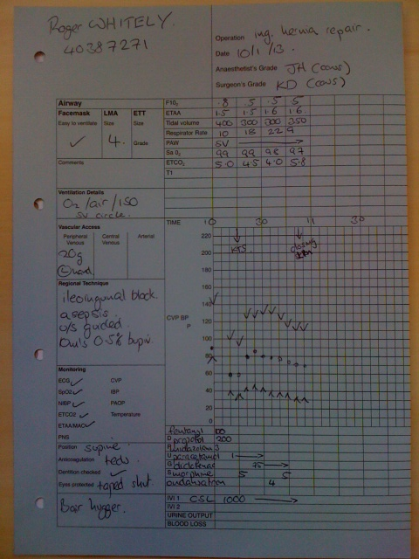
Patient 3

Mr Johnson has returned from the operating theatre after a laparotomy for bowel obstruction 3 hours ago. The nurses are worried because his vital signs are deteriorating. His postoperative TPR chart is shown opposite.

A How should this patient be managed?

B What fluids should be administered and why?

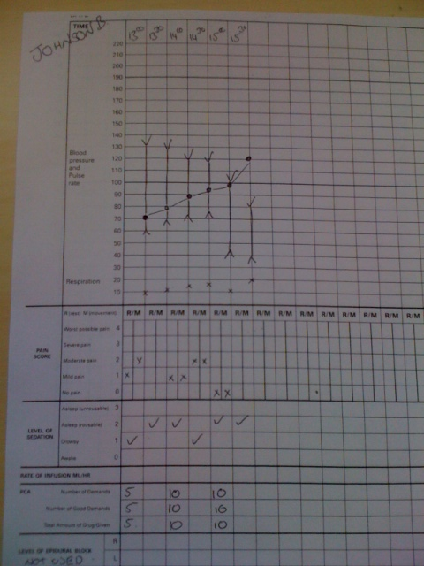
Problem 4

Mr Anatol Kranz is a 65-year-old man who has been living rough for some time. He is admitted and operated on for debridement of a leg ulcer. He becomes confused and aggressive in the night.

A Give 3 possible causes for his confusion and aggressiveness

B What investigations will you order?

C How should this patient be managed?

Problem 5

Mr Jan Barker has undergone a haemorrhoidectomy. On returning to the ward he complains of numbness and tingling in his left foot.

A What is happening?

B What should be done?

Problem 6

The nurses ask you to look at David Cole who has returned from theatre 6 hours ago. He had a right nephrectomy, and has been well until two hours ago. He has difficulty breathing and his arterial pulse is very faint. You get given a chest X-Ray that was done in recovery.

A What has happened?

B What should be done?

Chest X Ray

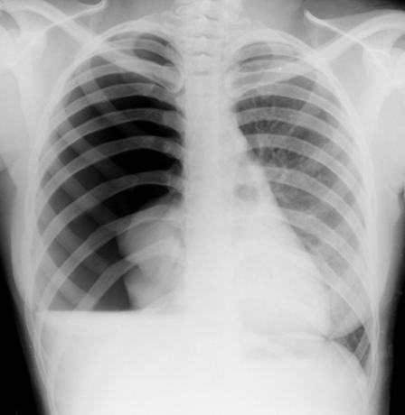

Problem 7

You are called by the ward nurse to see Mrs Savitri Singh, a 34 year old patient. She is on a PCA after her breast surgery. She is not using her PCA because of severe nausea.

What can be done?
Chapter 5
Assessing & managing postoperative pain

Pain must be treated for fundamental humanitarian reasons and because of its detrimental physiological effects. Patients may be in pain because of their disease state, or as a result of the operation / investigation they have undergone.

Pain can be measured in several ways. The common clinical method is to use a simple numerical pain score i.e. VRS (Verbal Rating Score) out of 4 or 10. You could alternatively ask “out of 10, with 0 being no pain and 10 being the worst imaginable how much pain are you in”? Ideally patients have 1-2 or less out of 10.

Pain scores, part of the routine observations are useful in deciding whether analgesia is effective. They are taken for pain at rest and on movement. Sedation score and respiratory rate are essential to monitor the effects of opioids.

In nearly all hospitals there is a specialist pain team who can be consulted for advice. As a FY1 you will be expected to prescribe analgesia for your patients and consult the pain team as necessary. A useful guide is the analgesic ladder below.

Analgesia can be
- Psychological- eg explanation, kindness
- Physical eg cold compress, rubbing, splinting a fracture
- Local eg to skin wound
- Regional eg spinal/epidural or blocking a specific nerve
- Systemic- see below- the ladder

A version of....The Systemic Analgesic Ladder
Simple analgesia... NSAID..... Weak Opioid ...Strong Opioid
Remember post operative pain should normally start bad and get better.

Therefore, strong analgesic drugs (+Simple analgesia + NSAID) are required in the very early stages: they are replaced over time by weaker ones. The analgesic ladder is turned upside down- ie you stop the strongest first, leaving less strong analgesics. If pain suddenly increases after a period of improvement, there maybe other causes why this has happened- these should usually be investigated urgently.

When approaching a patient in pain consider the following:

- What is the cause of the pain? - is it expected / in proportion?
- Could something else be going on eg full bladder / stomach
- Can anything be done to remove or decrease the cause?
- How severe is the pain?
- Which drugs are most suitable to treat the pain?
- What factors in the patient may affect your choice of analgesic drugs?
- What route of administration should be used?
- Are they already on simple / NSAID / opioids?- think about each

Using Analgesic Drugs

Pain is managed using a multimodal pattern of drug administration. Synergy between different groups of drugs allows the use of smaller doses of each, thereby minimising side effects.
Simple analgesia NSAID Weak opioid Strong opioid
Paracetamol ibprofen dihydrocoedine morphine
diclofenac tramadol diamorphine
keterolac fentanyl
Oxycodone

Mode of administration: After surgery analgesia can be given intravenously, subcutaneously or intramuscularly until the patient can absorb oral medications. For this period patients with pain receive morphine. Ibuprofen is often avoided at this time. Paracetamol can be given intravenously or as suppositories to reduce the need for opioids.

Patient Controlled intravenous Analgesia (PCA): Patients are able to give themselves 1mg of morphine by pressing a button. If patients are given PCA or epidural analgesia, it is most important not to prescribe any other opioids as this can cause serious respiratory depression. Fentanyl / Oxycodone can also be used.

Oral analgesia: As soon as oral intake commences, the patient can be started on regular paracetamol 1 g every 6 hours, and if there are no contraindications, regular doses of a Non Steroidal Anti-Inflammatory Drugs (NSAID) such as ibuprofen 400mg three times a day. Consider side effects.
NSAIDS should not be given by intra muscular injection as this causes pain and may result in a sterile abscess.

As the patient’s pain improves and they require less opioids, they can be given oral opioids in the form of oramorph (a liquid) or ‘sevredol’ (tablet) on the ‘as required’ side of the prescription chart.

REMEMBER: Acute pain is still under treated in hospitals!

Dihydrocodeine can be used as so called ‘step down analgesia’. When prescribing dihydrocodeine, monitor its effectiveness and if necessary change to an alternative drug. In this case tramadol, a drug with actions via opioid receptors and 5HT receptors could be used. Codeine is metabolised to morphine in the liver-about 25% of the population do not produce the enzyme that metabolises codeine and in these people it is ineffective. Patients are usually discharged home with analgesia. Write up regular paracetamol and NSAIDS. Patients who require stronger analgesia may need a moderately strong opioid in addition. There are a number preparations on the market which combine paracetamol and codeine (eg Co-Codamol). These are convenient, as the patient only has to swallow one tablet, but it is difficult to adjust the analgesia, and better results can often be obtained by giving regular paracetamol 6 hourly, and then NSAID +/- opioid.
Specialist analgesic techniques

You should discuss these with an anaesthetist.

- Patient controlled analgesia (PCA) - Morphine / Fentanyl / Oxycodone
- Epidural anaesthesia / analgesia
- Ultrasound guided plexus or nerve blocks
- Local anaesthetic techniques
- Anjunct drugs such as Gabapentin, Amitryptiline + Ketamine

Non Acute Pain / Chronic Pain
Chronic pain is a common, serious and causes real disability. Many population surveys have shown up to 30% of the population has chronic pain.

Chronic Post-surgical Pain (CPSP)

You may well be aware of chronic pain after amputation leading to phantom limb pain, but there are a number of surgical procedures where ongoing pain is more common. Badly treated acute pain may lead to chronic pain eg after a mastectomy,
inguinal hernia, amputation or a thoracotomy.

It is important to have acute pain well treated to reduce the severity of this pain.

Acute pain from surgery in patients with chronic opioid-use

You have to accept that this group of patients have already an altered pain perception and can be more sensitive to pain. Their baseline use of opioids has to be taken into account and their overall use is often significantly increased ie they need to have more. Remember to always use the pain scores to measure pain and to assess your treatment.

For more information please see articles at
www.ucl.ac.uk/anaesthesia/StudentsandTrainees/students
- Articles
  - ‘How to look after an epidural on the Ward’
  - ‘How to prescribe Perioperative Analgesia’
  - ‘Introduction to Pain Pathways and Mechanisms’
  - ‘Introduction to Pain Pathways’
- Podcast on UCL Anaesthesia’s site:
  - Prescribing Analgesia for the Surgical Patient
  - Postoperative Analgesia
  - An Introduction to Pain Pathways and Mechanisms
Having read Chapters 5 you should be able to answer these questions :

1. How would you assess a patients’ pain?

2. When prescribing an opioid, what additional drugs should be prescribed?

3. In which patients should NSAIDs be avoided?

4. What are the ‘pros and cons’ of PCA?

Case studies - Chapters 5

Problem 1

Mr Jon Ross , a 74 year old, is scheduled for an elective inguinal hernia repair. He is very anxious about the pain he may feel post operatively.

What can you tell him about the methods of analgesia he may receive

Problem 2

Mr Charlie Darwin is scheduled to have a right hemicolectomy. He is not keen on an epidural for post-operative pain relief, but asks you to explain to him what Patient Controlled Analgesia is.

Explain to a Tutor, as if he/she were Mr Brown, what advantages and disadvantages of PCA there are.

Expect some searching questions from Mr Brown, he is very well informed.

Problem 3

Victoria Sekibo is on an intravenous infusion of morphine. She has a respiratory rate of 6 but she is 98% saturated on the pulse oximeter.

A How should this patient be managed?

Problem 4

Ian Armstrong is a 25 -year old who has had an arthroscopic meniscectomy. He is a day case, and is waiting to go home. You are asked to prescribe some analgesia for him to take home.

A What information should you establish before you prescribe?

B Write your prescription on the ‘TTA’ (To Take Away) drug chart below.

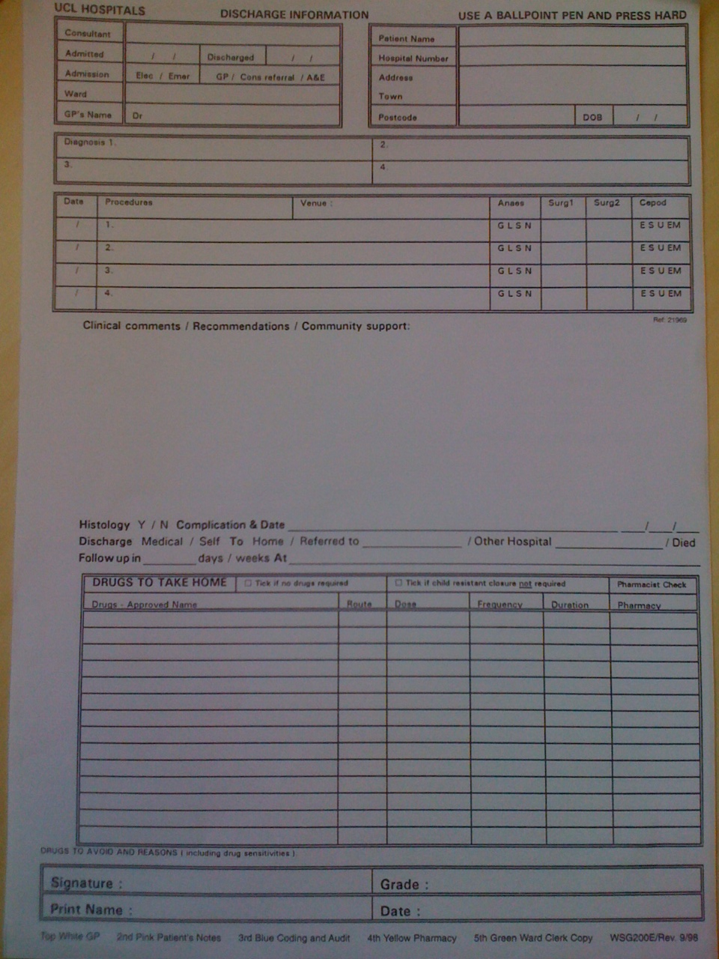

Patient 5

Mrs Jackson is about to undergo a cystectomy. She has heard that epidurals can be used for pain relief after this operation.

A How would you explain to her what an epidural is?

B What risks should she be warned about?

Problem 6

Mr Attah who underwent a thoracotomy 6 months ago for benign oesophageal surgery now presents for an inguinal hernia repair. He says that he still has a great deal of pain in the thoracotomy scar and is worried that that might happen again.

A Explain how you would reassure this patient?

Problem 7

Mrs Haji is seeing you in the GP practice. She has been given a date for her surgery, a reconstruction of her bladder. She has had multiple operations in the past and is suffering from chronic pain. She is very concerned about her pain relief afterwards as she is already taking MST 60mg BD and often needs extra morphine when the pain gets bad.

A How can she be reassured?

Problem 8

Dr Rita Das is seen in the preassessment clinic as she is scheduled for a shoulder replacement. She has an extensive medical history and says that she is very sensitive to opioids.

Qn: How would you advise her about her postoperative pain management?

Problem 9

Mrs Armstrong had an anterior resection 1 day ago and has now returned to the ward. She complains that she has very heavy legs.

You look at her observation chart below.

What do think happened and what should you do next?

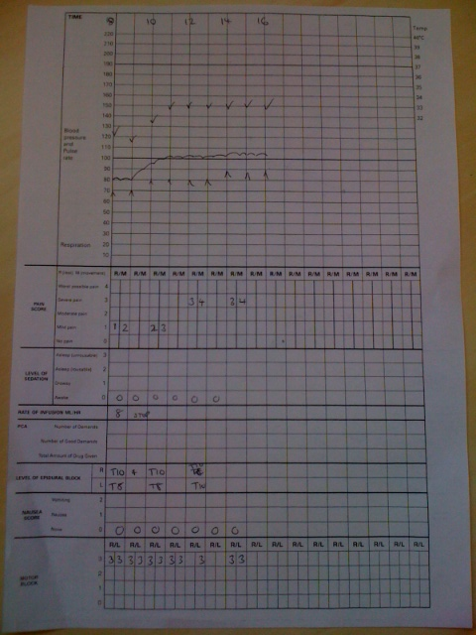

Chapter 6
Body Fluids

When you have worked through this section you should understand:

- The physiology of fluid compartments
- Blood products

Understanding body fluids ‘rule of 1/3’

Imagine an average adult. Body weight = 70 kg

About 2/3 rds of body weight is water, total body water (TBW)
(Males 60% and females 50%) TBW = 42 l

About 2/3 rds of the TBW is intracellular fluid ICF = 28 l
and 1/3rd is extracellular fluid ECF = 14 l

About 2/3 rds of the ECF is interstitial fluid ISF = 9 l
and 1/3rd is intravascular fluid IV = 3.5 l

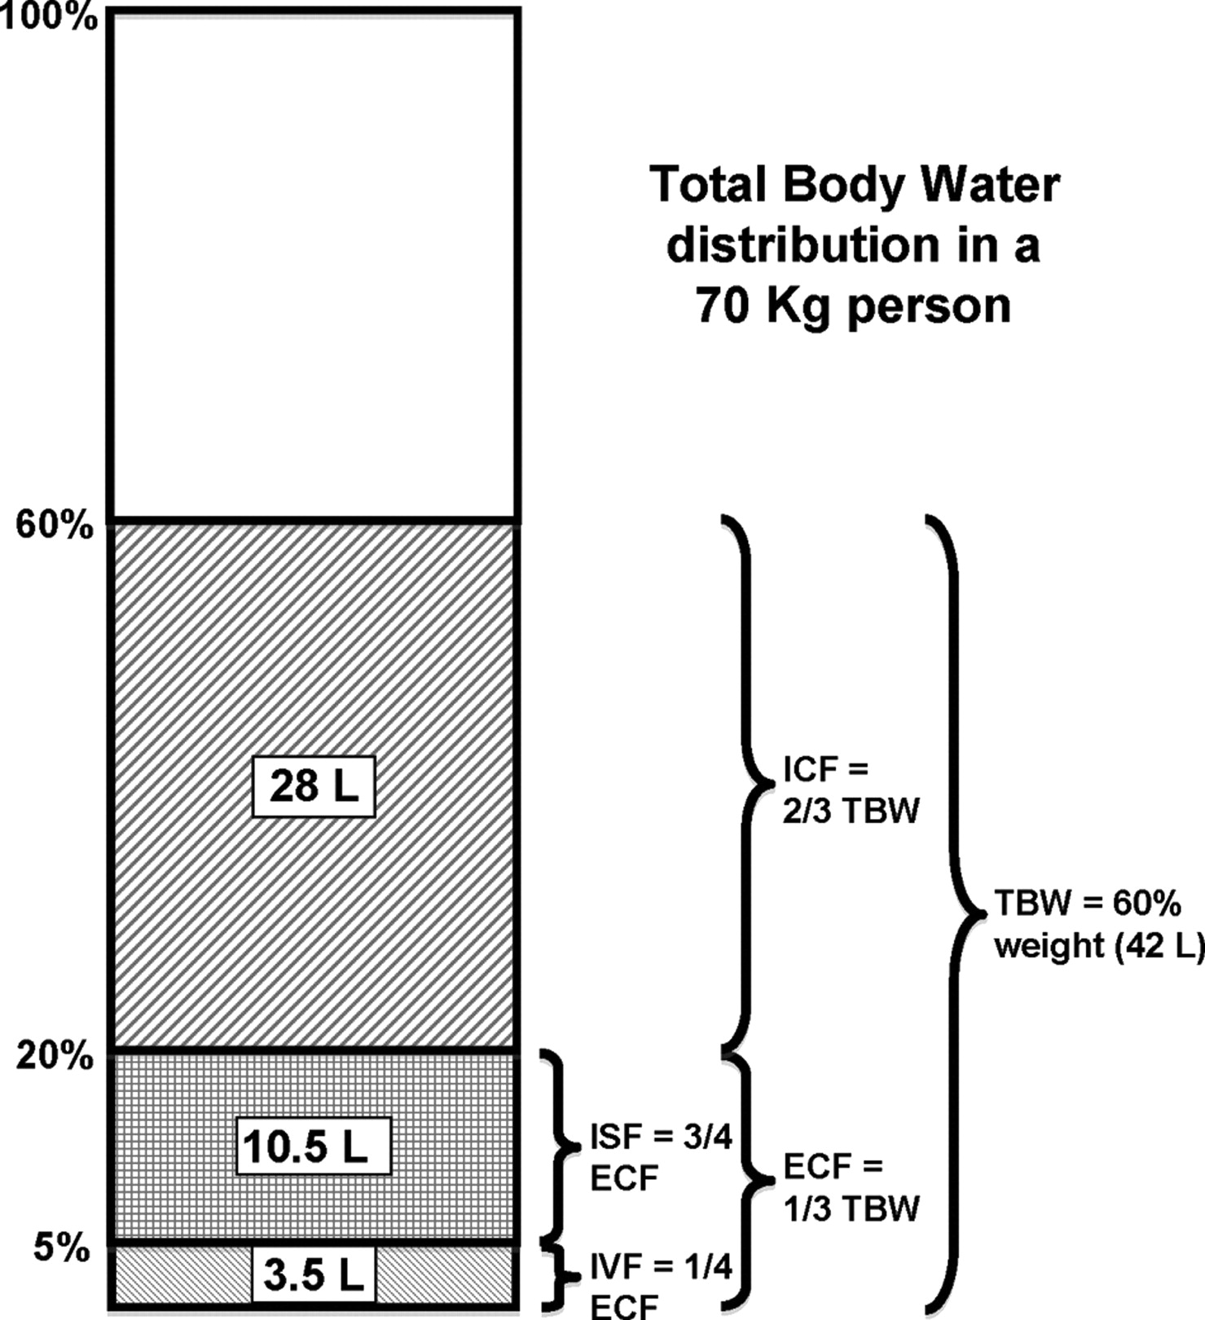

Average haematocrit (% of red blood cells in blood) is 40-45%, therefore total circulating volume is 3 l of plasma and 2 l of red cells i.e. 5 l of blood in an average sized adult (65 to 75 ml/kg).

1 litre of intravenous 5% Glucose ('Dextrose') is distributed evenly throughout the total body water. i.e. 2/3 rds is quickly distributed to the ICF, 1/3 to the ECF, of which approximately 100ml remains within the IV space.

Hartmann’s (= CSL, Compond Sodium Lactate) and 0.9% NaCl (‘normal’ saline) is kept out of the cells, because the sodium does not cross the semi-permeable cell membranes. Therefore when 1 litre of CSL or 0.9% NaCl is administered, 1/3rd remains in the IV compartment (333ml) but 2/3rds ‘leaks’ into the interstitial component.

Colloids are fluids containing up of suspended large molecules that do not leak out of the intravascular compartment so easily, therefore acting as ‘plasma expanders.’ The colloid component (eg gelatin) is suspended in a crystaliod carrier solution.

Dehydration (mainly depletion of the ICF) is best treated by slow infusions of 5% glucose.

Hypovolaemia (mainly depletion of the intravenous compartment) is best treated with Hartmann’s solution (a balanced salt solution), 0.9% saline, colloids or blood/blood products.

mmol/L Na⁺ K⁺ Ca⁺⁺ Cl⁻ Lactate⁻ Glucose
Hartmanns’ 131 5 2 111 29
Saline 150 150
Glucose 5% 50g/L
Glucose 4% 30 30 40g/L

Crystalloids Dissolved crystals!
Hartmann’s solution, saline, glucose and ‘dextrose saline’
5% Glucose (= Dextrose) - a way of giving free water as the glucose is metabolised. 1L of 5% has 50g of glucose in.
Dextrose saline has 1/5 saline and 4% glucose.

Colloids Gelofusine/geloplasma and albumin.
We now we only use gelatin- based colloids. Gelatins can come suspended in saline (Gelofusine) or in a Hartmann’s-like-solution (Geloplasma).
These fluids contain large particles designed to stay in plasma and maintain the plasma oncotic pressure within the intravascular compartment, and thereby keep fluid intravascular.
May be useful for replacing blood loss until blood is available,
May cause allergic reactions as bovine (cow) based.

Blood = Packed Red Cells
Fully cross-matched -planned transfusion vs
ABO and rhesus typed : ‘typed blood’ - emergencies vs
0-negative blood – extreme emergencies “flying squad”

Blood Platelets / fresh frozen plasma / cryoprecipitate
products To treat specific clotting abnormalities or during massive transfusion

Perioperative Red Cell Transfusions

The need for transfusion should be based on concentration of haemoglobin and considered along with other factors such as rate of blood loss, haemodynamic instability, anticipated postoperative bleeding and the oxygen carrying capacity of the blood. We are moving over from the old UK units of g/dL to g/L. There are a few basic themes:
- Red cell transfusions can have complications (see article on website)

• Preoperative anaemia should be investigated and treated appropriately prior to elective surgery. Generally we like patients to have Hb 100g/L before surgery.

- Take great care to correctly take blood for group and save and to check the blood before giving it.

• Red cell transfusion is rarely indicated when the haemoglobin concentration is above 100g/L.

• Red cell transfusion is indicated when the haemoglobin concentration is below 70g/L: packed red blood cells should be given in relation to the rate of ongoing blood loss. If the patient is otherwise stable, one unit of red cells should be transfused in an adult for every 10 g/L (or 1g/dL old UK units) increase in Hb you want to achieve (or the equivalent in children according to size) and the clinical situation and haemoglobin concentration should then be reassessed.

- Transfusion with haemoglobin concentrations between 70 and 100 g/dL is often not justified unless the patient cannot compensate because of B blockade, significant underlying cardiorespiratory or peripheral vascular disease. These patients should be transfused at 80 g/L or occasionally to 100g/L

• In acute blood loss, (loosing circulating volume) crystalloid or colloids should usually be used until blood is available unless sudden large volumes have been lost, or obvious ongoing bleeding is occurring.

Remember – Full cross-match takes approximately one hour. In urgent cases:
• Type specific (ABO, rhesus) can be available in about 30 mins.
• In life threatening acute blood loss, a limited amount of O Rh negative blood can be ordered and given without any cross-matching.

Fluid losses & shifts

Consider which compartments lose fluid in each of the following clinical scenarios :

- Pre-operative bowel preparation
- Persistent nausea and vomiting or diarrhoea
- Fever with increased insensible losses
- Haemorrhage
- Prolonged starvation before elective surgery- this should not happen now.
- Septicaemic shock - with dilatation of the intravascular compartment and leakage of intravascular volume into the interstitial space

Following manipulation of tissues during surgery or in sepsis, the vascular endothelium may become ‘leaky’ to proteins, allowing fluid to leak in to the interstitial space, resultin in oedema. Cell membrane ion pumps may also fail, disturbing the balance between ICF and ISF.

Normal renal function can compensate extremely well for changes in the daily provision of sodium and potassium, however following major surgery the ‘stress response to surgery’ - a neurohumoral response in direct proportion to the magnitude of the surgery - leads to a catabolic state with salt and water retention and potassium loss. It is sometimes necessary to give extra potassium in the intravenous fluid regimen.

For more information please see articles at
www.ucl.ac.uk/anaesthesia/StudentsandTrainees/students

- Articles
  - How to prescribe Fluid Therapy
  - NICE Ward Fluid Guidelines 2013
  - How to do: blood transfusion

- Podcasts
  - ‘Fluid therapy ‘

Chapter 7
Intravenous Fluid Therapy

When you have worked through this section you should understand:

- The rationale for prescribing pre- & post- operative fluids
- How to assess the volume of fluid losses

Fluid therapy on the Ward vs. Fluid therapy during trauma or surgery :

It is important to recognise the distinction between prescribing fluid for a patient on the ward and prescribing fluid for a patient during a trauma or surgery.

The National Institute for Health and Care Excellence (NICE) provides a guide for prescribing intravenous fluid therapy on the ward - not in theatres/ ICU/ ER. It oulines the 4 principles of prescribing IV fluids, each of which has its own algorithm:
Assessment
Resuscitation
Routine Maintenance
Replacement Redistribution

Resuscitation – Use crystalloids that contain sodium between 130 – 154 mmol/l and a bolus of 500 ml over less than 15 minutes. i.e. Hartmann's solution or saline.

Routine Maintenance – If the patient is only being given fluids for routine maintenance, then the initial prescription should include
25 – 30 ml/kg/day
1 mmol/kg/day of potassium, sodium and chloride
50 – 100 g/day of glucose -
These quantities must be adjusted for patients who are obese based on their ideal body weight. Less fluid should be prescribed for patients who are older or frail, have renal impairment or cardiac failure, or are malnourished.

Replacement and Redistribution – Adjust intravenous fluid prescription for existing/deficits of fluid and electrolytes, ongoing losses or abnormal distribution.

then..Reassessment - If the patient is given fluid for resuscitation, they first must be reassessed using the ABCDE approach, monitor their respiratory rate, pulse, blood pressure, perfusion, and measure venous lactate levels and/or arterial pH. Patients with continued IV fluid therapy, should be reassessed daily for clinical fluid status, laboratory values (such as urea, creatinine, and electrolyes), and fluid balance charts.

The full set of algorithms can be found here:
http://www.nice.org.uk/guidance/cg174/chapter/recommendations#algorithms-for-iv-fluid-therapy

Each patient on the ward should have an IV fluid management plan. This plan includes the fluid and electrolyte prescription for the following 24 hours and the assessment and monitoring plan. Remember to take into account all sources of fluid and electrolytes that are present: oral or enteral intake, intake from drugs, IV nutrition, blood and blood products.

Intravenous fluid prescriscriptions should contain both 1) the type of fluid and 2) the rate and volume to be administered.

Assessing intravenous fluid therapy :

Intravenous fluid therapy can be calculated using the above information together with clinical examination and results of blood tests. The average adult (70Kg) requires a maintenance fluid intake of 2-2.5 litres per day (2-3L 4% ‘dextrose’ saline with potassium added. or alternatively if that is not available 1-2 litres of 5% glucose with 500ml-1L of Hartmann’s solution) This basic fluid regimen is adjusted up or down depending on the patient’s size, fluid losses, and perceived fluid balance.

If you give too little fluid, the patient may develop signs of :
Dehydration (depletion mainly of the ICF) - thirst, dry mucous membranes, headache, listlessness,decreased skin turgor.

Hypovolaemia (depletion mainly of the i.v. compartment) - see section on hypovolaemic shock

If you give too much fluid, the patient may develop signs of :
Right-heart failure – tachycardia, peripheral oedema, raised JVP

Left heart failure – tachycardia, breathlessness, wheeze, pulmonary oedema.

Electrolyte imbalance – check the U & Es

In patients receiving intravenous fluid therapy it is necessary to look out for these signs, and to check their charted fluid balance (fluid in – fluid lost) on a daily basis. Haemoglobin, urea and electrolytes should be checked regularly as the results may help to guide decisions regarding choice/quantity of fluid.
A low plasma albumin may indicate the need for additional nutrition.

Understanding Hypovolaemia

Hypovolaemic shock is inadequate tissue perfusion due to loss of intravascular blood volume. The severity of shock, and the clinical signs apparent at the bedside relate directly to the percentage of the patient's total blood volume that has been lost and the ability to compensate. People can die from hypovolaemia, and if detected/treated early and correctly this can be prevented.

The blood volume of an adult = 70 ml per kg approx.

A bit of physiology revision;

CO = HR x SV
BP (mean) = CO x SVR

CO, Cardiac output: SVR, Systemic vascular resistance, SV= stroke volume
When blood is lost acutely, the quantity of blood returning to the right atrium falls, that is detected by the right atrial and carotid sinus stretch receptors. Because less blood returns to the right side of the heart, the heart pumps less blood out i.e. left ventricular stroke volume falls. This is initially prevented by the atrial stretch receptors initiating an increase in venous tone thereby maintaining venous return. When this is overwhelmed the first signs of shock develop. ADH, rennin-angiotensin, ANP+ BNP all contribute to this process.

ACUTE LOSS OF 15% of blood volume:

Atrial stretch receptors trigger output of catecholamines (adrenaline) leading to an increased heart rate in order to compensate for the fall in stroke volume. Catecholamines also cause an increased respiratory rate and a sense of anxiety, vasoconstriction- the patient may feel cool.
i.e. signs of early hypovolaemic shock = tachycardia, tachypnoea, & anxiety. Note that at this stage the cardiac output is maintained, therefore the blood pressure does not yet fall.
BP = CO x SVR

CO = ↑HR x ↓ SV

ACUTE LOSS of 15-30% of blood volume:

Increased catecholamine release results in greater rises in HR and RR. Although HR rises it cannot now compensate for the fall in stroke volume therefore cardiac output begins to fall. The increase in sympathetic tone mediated by baroreceptors induces peripheral vasoconstriction leading to an increased systemic vascular resistance. This is detectable clinically as a cool, poorly perfused periphery with delayed capillary filling in the nailbeds.

Catecholamines also trigger sweating so the periphery feels cool and sweaty with a clammy feel to the touch. The patient appears pale and is obviously unwell. The fall in cardiac output reduces perfusion to the brain (with altered conscious level) and to the kidneys (resulting in a reduced urine output.) The mean arterial blood pressure may still be maintained but there is a decrease in pulse pressure (the difference between systolic and diastolic pressure). A falling blood pressure is therefore often a late sign of blood loss.

normal/↓ BP = ↓CO x ↑ SVR

↓ CO = ↑HR x ↓↓SV

i.e the signs of severe hypovolaemic shock = tachycardia, tachypnoea, cool, sweaty periphery with delayed capillary refill. There may be a decreased pulse pressure, altered conscious level, and decreased urine output. The patient looks very unwell.

ACUTE LOSS of > 40 % of EBV

This results in an exaggeration of all these signs. Urine output now virtually ceases and blood pressure cannot be maintained. The conscious level falls and the patient appears deathly pale and sweaty. Peripheral pulses are difficult or impossible to feel, and the central pulses (femoral and carotid) are rapid and weak.

↓BP = ↓↓CO x ↑SVR

↓CO = ↑↑HR x ↓SV

Therefore in theory the clinical signs therefore can be directly related to the quantity of blood lost. The physician can estimate how much intravenous fluid to give rapidly to restore tissue perfusion.
Real life is much more complex- variation between individuals, drugs (eg b blockers), pain, hypothermia and disease all mean the ‘rules’ above do not universally apply. In reality we would give a fluid challenge and assess the response. In gerenal, young adults compensate well, and as we get older the signs of hypovolaemia appear earlier.

For more information please see articles at
www.ucl.ac.uk/anaesthesia/StudentsandTrainees/students

- Article
  - NICE Ward Fluid Guidelines 2013
  - ‘How to do: Blood Transfusion’
  - ‘How to prescribe Fluid Therapy’
  - ‘How to insert an Arterial Line’
  - ‘How to insert a Central Line’
  - ‘How to use inotropes and vasopressors’
  - ‘Basics of Fluids and Analgesia’
- Podcasts
  - Introduction to inotropes and vasopressors
Having read Chapters 6 & 7 you should be able to answer these questions :

1. What is the stress response to surgery & how does it affect fluid balance?

2. What clinical signs would you see in a young adult male who has lost 1,750 mls of blood?

3. What signs would you expect to see in an elderly lady who has had 2 days of bowel prep, followed by 6 hours of ‘nil by mouth’ ?

Case Studies – Chapters 6 & 7

Problem 1

Mrs Iwona Marek has had a hemicolectomy. She has a nasogastric tube in situ which is draining large quantities. She weighs 60 Kg. On the prescription chart, write an appropriate fluid regimen for her for 24hrs.

How would you modify this on a daily basis?

Problem 2

Betty Smith is due to undergo a hip replacement next week. She arrives at the preassessment clinic and is very anxious because she is worried about having a blood transfusion.

Prepare a summary of the risks and benefits of a blood transfusion in this lady for her to take home and consider before she is admitted

Problem 3

Charles Thorsthi is a 65 year old man who was admitted with vomiting & diarrhoea with abdominal pain. You see him on the ward round and he seems unwell. He is listless and sleepy. His mouth is very dry with cracked lips and his eyes are sunken.

A What is the problem?

B How would you manage this patient?

Problem 4

Mohammed Alzir is 36 years old, and has been in chronic renal failure for 4 years. He presents with acute abdominal pain and the surgeons wish to perform a laparotomy. His Full blood count and U&E are shown below.

What treatment should he have pre-operatively?

Haematology

Hb 8.5 g/dl
RBC 3.8 x 10¹²/l
MCV 65fl
MCHC 25g/dl

Urea and Electrolytes

Urea 22 mmol/l
Creatinine 400μmol/l
Sodium 148 mmol/l
Potassium 5.5 mmol/l
Problem 5

A 19- year old man is bought into A&E unconscious. He has fractures of both femurs, and both calcaenia. He also has a suspected pelvic fracture. He is thought to have fallen or jumped from a 4th storey window. Blood has been taken for cross matching, and iv access is established.

A What fluids should he be given at this point?

B How would your choice change as the resuscitation proceeds?

Problem 6

You are called to the ward to see Mrs Sara Mackie. She has sever pain in her abdomen, looks pale and sweaty with a thready pulse. She also is crying in pain in her abdomen.

A What do you think is happening?

B How should this patient be managed?

Problem 7

Richard Fellows, a diabetic patient returns from theatre on an insulin infusion (1 IU/hr) and is written up for 5% dextrose 3 litres a day. The post-operative U&E are as folllows

Sodium 119 mmoles
Potassium 3.2 mmoles
Creatinine 119 mmoles
Urea 4.5 mmoles.

A What do these results indicate?

B How would you modify the IV Fluids?

Problem 8

Ahmet Gulsen is admitted after an RTA. He is having some difficulty breathing and his Glasgow coma score is 11. He is being given 60% oxygen by a Ventimask and his arterial blood gasses are:

PH 7.32
PO₂ 13 Kpa
pCO₂ 7.9 Kpa
Bicarb 23 mmol

A What do these results show?

B How would you manage this patient?

Problem 9

Caroline Horley, a 20 year old diabetic patient has the following blood gasses on air

PH 7.15
PO₂ 12.6 Kpa
pCO₂ 2.9 Kpa
Bicarb 10 mmol
sBEx -12

A What do these results show?

B What additional investigations do you require?

C Write up appropriate treatment on the chart opposite.

D Explain your rational for this treatment
Chapter 8
Risk, Safety and Quality.

When you have worked through this chapter:

- You should be aware of risks to the patient and the risk to you
- You should be aware of the ways of reducing such risk

Patient Safety

It is estimated that 8 million operations occur per year in the UK (with over 3 million general anaesthetics given). The peri-operative period exposes the patient to significant risk of healthcare associated adverse events:

- Wrong site surgery
- Drug error
- Complications directly related to the surgery eg Surgical site infection
- Complications indirectly related to the surgery eg MI, Cardiac Failure etc

The true rate of adverse events is unknown but has been variously estimated to lie between 7%-33% of all surgical admissions. Of these, it is thought that around half of the events are preventable. One study suggested that medical errors was the third most common cause of death, after Cancer and Cardiovascular disease (Makary 2016).

Patient's 'Risk'
We often try to asses someone's risk a procedure- in many ways a complex area.
We have to think of
- What does the patient want?- the no 1 thing
- What's the risk of the procedure - often 30 day death rate (eg 5% etc)
  - depends on the procedure
  - depends on their physical state, comorbitities
  - depend if its an emergency or planned
  - probably depends on the hospital, surgeon, team
- What's the risk of NOT doing the procedure (including background mortality)
- What alternative treatments (eg Chemo/Radio/other therapy) are ther
- What are the potential compications

Risk Scores
It can be useful to have a sense of the % chance of dying or living immediately after a procedure. We can use this information in discussion about consent.
We use several
- ASA score - below. General, open to interpretation
- SORT surgery (www.sortsurgery.com) based on several factors.
- P-POSSUM based on several preoperative factors, and estimating intra-operative ones

ASA I | A normal healthy patient, non-smoker or alcohol drinker
ASA II | A patient with mild systemic disease
ASA III | A patient with severe systemic disease
ASA IV | A patient with severe systemic disease that is a constant threat to life
ASA V | A moribund patient who is not expected to survive without surgery
ASA VI | A declared brain-dead patient who is donating his/her organs

ASA- Americal Society of Anesthesiology Scoring system

Example:

Mr Jones has pre-operative bloods taken for a blood 'group and save' prior to knee surgery. Inadvertently, blood is drawn from the patient into a bottle containing another patient’s details (which were entered beforehand to increase efficiency) and is sent to the lab. A unit of blood is prescribed post-operatively and the patient suffers a transfusion reaction requiring resuscitation and prolonged intensive care, but eventually recovers.

Causes of error can be classified:
- Human factors
- Equipment
- Organisational/system issues

Technical skills
Such as a more experienced anaesthetist or surgeon less likely to error or take longer during a procedure

Non-Technical Skills
Task fixation during emergencies leading to reduced situational awareness of a monitor that’s alarming. These can be learned by practice in simulation to a certain extent and by use of Standard Operating Procedures (SOPs) and drills

Equipment
Much better monitors more widely available eg. Capnography (CO2 detection) to confirm tracheal intubation and ventilation.

Organisational/System/Hospital
Unfortunately there have been many cases of administering a drug meant for intravenous use into the CSF (intrathecal route) resulting in death of patients undergoing treatment for leukaemia (vincristine)

What examples can you think of?

The Operating Theatres environment poses a number of potential risks to healthcare staff such as

- contact with patient’s bodily fluid- Hepatitis B, C and HIV
- risk of sharps injury and inoculation
- radiation exposure
- slips and falls
- back injury
Good sharps practice:

- always wear examination gloves for venepuncture / cannnulation
- consider eye protection
- bring sharps bin nearby
- use safety cannulae and needles
- dispose of sharps immediately
- never re-sheathe needles
- in event of needle stick, encourage local bleeding, wash under running water and contact Occupational Health department for advice

What can you do as a junior doctor?

- Practise excellent hand hygiene (at very least wash your hands before and after every patient contact)
- If taking a blood sample, confirm the patient’s name and then write the details on the bottle
- Be vigilant at work and speak up if you think something wrong is happening
- Prescriptions (no omissions, ? allergy status, ensure legibility, limit length)
- When you look at notes, results, X-Rays etc check first 4 identifying features of the patient and when it was taken- you’ll be surprised how many pages are filed in the wrong notes!
- Take part in ward/theatre Team Briefs and WHO safe surgery checklists
- Practice drills eg. ALS, BLS, Anaphylaxis
- Report adverse events
- Attend morbidity meetings (to learn from other peoples’ "errors")
- Recognise that ‘to err is human’ but try to ensure errors are reduced to the minimum
- Be kind to yourself and your colleagues- we all make mistakes
Case Studies – Chapter 8
Problem 1
What are the problems with this part of the drug chart?

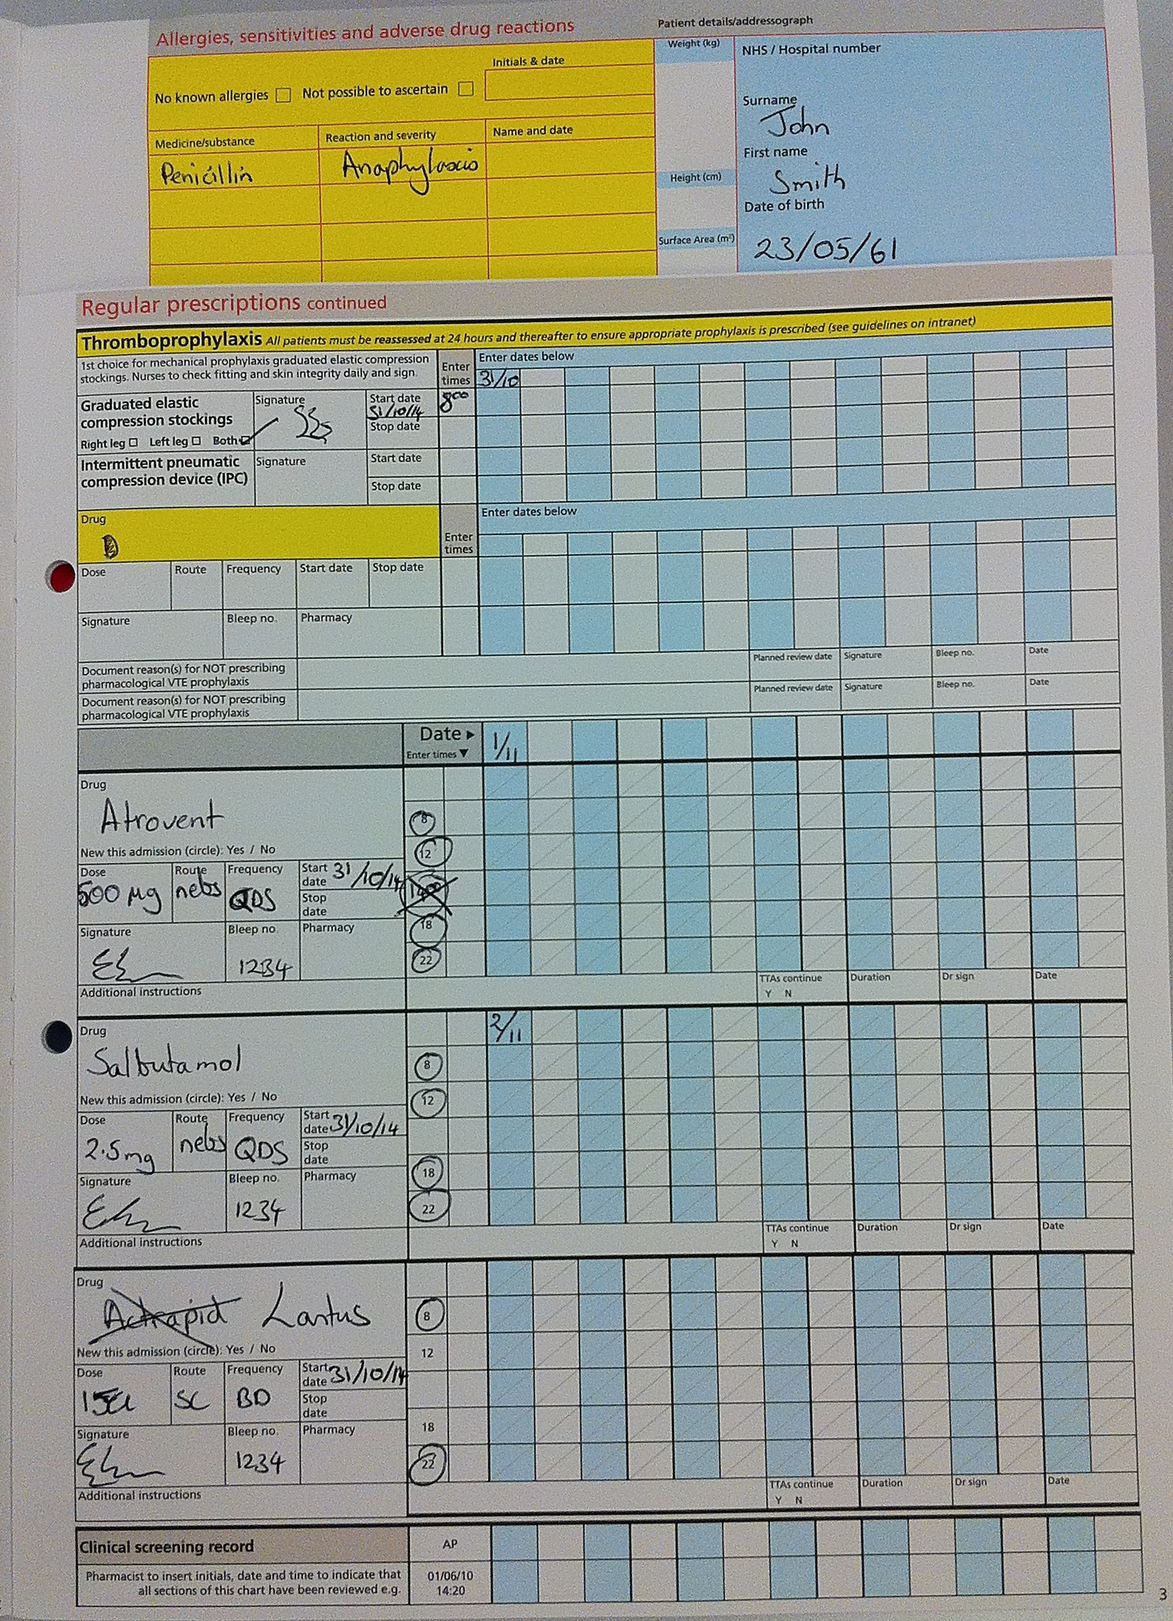
Problem 2 - What is wrong with this drug chart? 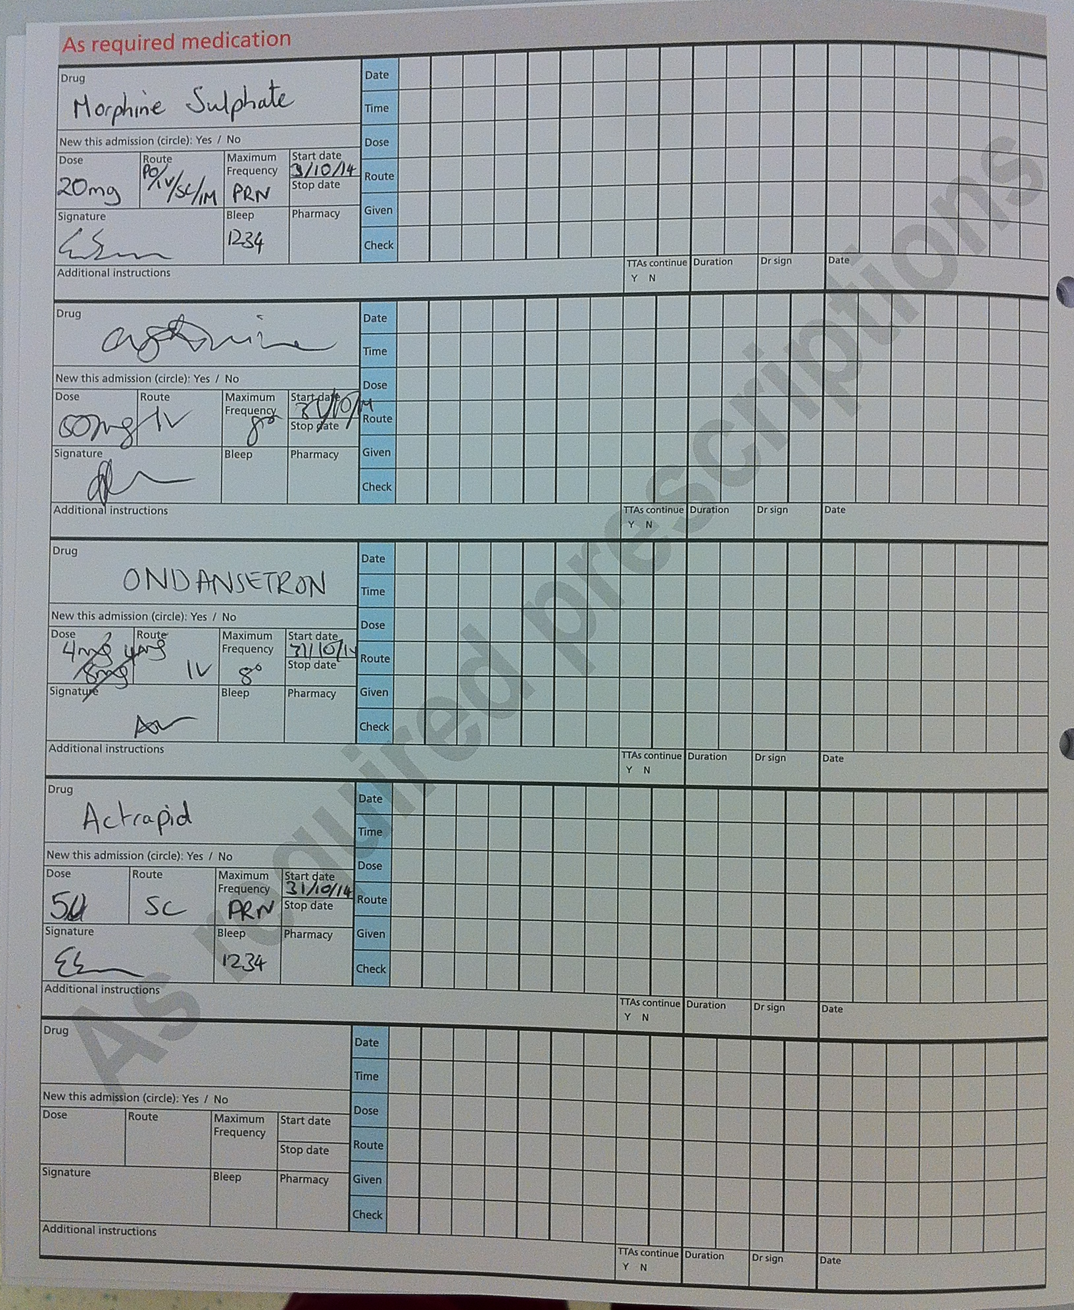

Problem 3

Mr Arthur Patterson is receiving a blood transfusion post-operatively. The nurses call you because he has developed a rash and is hypotensive. He has pain in the arm of the transfusion.

A What do you think is happening?

B How would you manage this patient?

Problem 4

Mr Jones is scheduled for a right knee replacement. You are in the operating theatre and you notice that the left knee is marked just before the drapes go on in the operating theatre.

Discuss or Role play with your tutor how you would approach this incident.

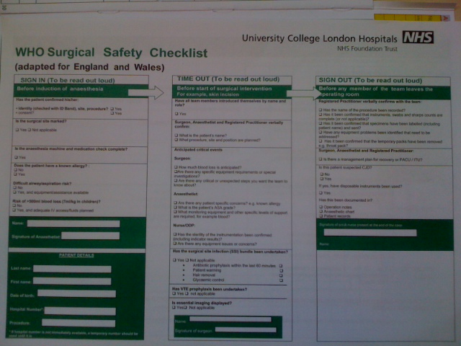
Problem 5

Lob Rudder is a 20 year old man who is on the ward having had an open reduction and fixation of a fractured forearm the previous day. The nurse gives him his 3rd dose of cefuroxime intravenously as prescribed. 10 minutes later, he complains of difficulty with breathing and you are called urgently to review him. On arrival, you find him to be short of breath and gasping one word answers. He looks very flushed and the heart rate is 130/min.

What do you think is happening?

Problem 6

You are the A&E FY1. An elderly man is coming in with reduced level of consciousness. As you cannulate him you get a needlestick injury from the bloody sharp.

What should you do?

Problem 7

Mr Dave Foundation, a 49 year old builder has returned to the ward from the Recovery room after having a laparoscopic cholecystectomy. He is being managed as an in patient due to his type I diabetes mellitus.

As the surgical FY1 you are called by the nursing staff to see him because he is complaining of missing a tooth at the back of his dentition.

How should you proceed?

Chapter 9
Assessing acutely ill patients

Objectives

- Know what to do when you hear about an acutely ill patient
- How to prioritise and organise your approach
- Work through DR ABCDE

Introduction: don’t worry
As a doctor you will be involved in the assessment and management of sick patients. This may seem like a daunting task, especially if you’ve not yet given an IV drug or plugged in the paddles of the defibrillator! However, despite the apparent complexity of the situation, it’s rarely the nightmare you think it will be. By applying basic common principles to your management strategies, you can provide safe and effective early treatment for acutely ill patients (at least until the cavalry arrives!).

What to do when you’re called to assess a sick patient
When you get called (e.g. by a ward nurse) to assess a sick patient, the referral may be clear and ordered (if you’re lucky), but will commonly be vague (e.g. “I’m really worried about this patient”).

The most important thing is not to panic – you usually have more time than you think. In this situation, you have three initial priorities:

- Buy yourself and the patient some time by supporting the vital functions.
- Get basic background information and examine the patient as you go -the principle of simultaneous assessment and resuscitation.
- Call for senior help early- and don’t be afraid to call the cardiac arrest team before the patient arrests!.

While you’re on the phone, some questions you may want to ask include:
• Age of patient
• Reason for current admission and length of stay
• What the current (acute) problem is
• Level of consciousness (GCS or AVPU)
• Basic observations (BP, heart rate, respiratory rate, oxygen saturation, temperature, urine output)

This information will help you to think about a list of differential diagnoses.
? Use the ‘SBAR’ approach- Situation Background Assessment Recommendation

First few seconds @ the bedside
When you approach the patient, take a moment to look at them as a whole. Use this time to make an assessment of how unwell you think they are. This will help you decide whether or not immediate action is warranted.

Say who you are and explain that you are there to help them. “ I’m one of the Doctors on the team- and I’m here to help you”. This may also be reassuring to the nurses, who might have had to cope with a difficult situation outside their normal experience. A simple question (e.g. “How are you?”) can provide you with a lot of information. For example, a normal verbal response from the patient tells you that they have a patent airway, they are breathing, and that they are perfusing their brain!

During your initial management, it’s really important to keep things simple. Do not make assumptions or take things for granted. If you do the basic things well, you’ll usually help the patient.

Priorities: Immediate Assessment and Treatment
Most life-support courses teach the rapid detection and simultaneous treatment of potentially life-threatening emergencies. You’ll probably be familiar with the DR ABCDE system. The reason that assessment and actions are done in this order is because, usually, airway obstruction is more immediately fatal than breathing problems, which in turn kill faster than circulatory problems (e.g. haemorrhage).

Look
In a patient who has an obstructed airway but is making respiratory efforts, there may be paradoxical chest and abdominal movements (especially if the obstruction is complete). This means that there will be a “see-saw” pattern of breathing, i.e. during inspiration there will be outward movement of the chest, but in-drawing of the abdomen (with the opposite occurring during expiration).

If the patient has a facemask on (e.g. a Hudson mask), then the mask should “fog” when the patient expires (if they have a patent airway). Remember that if the patient is not breathing, these signs will not be present, but this does not mean that they have a patent airway! If in doubt, perform manoeuvres to open the airway (see below).

Listen
In partial airway obstruction (i.e. when there’s still some air going in and out), there will often be noisy breathing, e.g. gurgling, “snoring”, or even stridor.
In complete airway obstruction, there are no breath sounds at all!

Feel
This is possibly the most important method of assessing the airway. Simply feel for the presence of air movement at the patient’s mouth by placing your own face or hand in front of their mouth. If you can’t feel any air movement, they may have an obstructed airway.

If you think that the patient has an obstructed airway, you need to act immediately. Call for expert, senior help (e.g. an Anaesthetist or arrest team) and attempt to relieve the obstruction in the meantime. The obstruction may be partial or complete, and may occur at any level of the respiratory tract from mouth to trachea. The potential causes of airway obstruction are many, but include: reduced level of consciousness (when the patient’s tongue falls backwards and obstructs the pharynx); foreign bodies (including vomit or blood); trauma; infection; and allergic reaction/anaphylaxis.

Airway
How do you tell if the patient has an obstructed airway? It’s simple – use your senses! Patients with potential airway obstruction should have 100% 0₂. If a patient can speak, then their airway must be -broadly speaking- patent. Don’t perform airway manoeuvres on a patient who’s speaking to you – they won’t appreciate it!

Management of airway obstruction:
In most cases, you just need to use simple measures to create a patent airway.
• Suction the oropharynx to remove secretions.
• Use basic airway manoeuvres: head tilt, chin lift, and jaw thrust.
• Try airway adjucts (e.g. an oropharyngeal/Guedel airway or a nasopharyngeal airway).

If none of these works, the patient will probably need to be intubated, but this
will usually be a job for one of your seniors.

Breathing
Use a similarly systematic “look, listen, feel” approach during your assessment of the patient’s breathing-ventilation. Are there any signs of respiratory distress or hypoventilation? The important things to look for are

- Respiratory rate, pattern, and depth. This indicates the patient’s work / effort of breathing. A rate of >25 is a worrying sign because it indicates that the patient is using a lot of energy simply to breathe. Normal resting respiratory rate is 12-20 per minute.
- Can the patient speak in full sentences? If they can’t, this is again a worrying sign of increased work of breathing.
- Use of accessory muscles of respiration.
- Chest movement – observe both the adequacy/volume of chest movement, and also whether or not it is symmetrical (unilateral chest movement suggests underlying unilateral disease (e.g. pneumothorax, pneumonia, pleural fluid).

A thorough examination of the respiratory system (with inspection, palpation, percussion and auscultation) can then be performed. This may pick up other signs of collapse, consolidation and infection for example.

Other useful tests: Pulse Oximetry, Peak Expiratory Flow Rate, and Arterial Blood Gases. A bedside CXR may be warranted to confirm clinical signs, but stabilising the patient should be your first priority.

Management of breathing problems:
The specific treatment for your patient will depend on the cause of their respiratory disorder. However, the priority during your initial assessment is to diagnose and treat any immediately life-threatening conditions (e.g. severe asthma, pulmonary oedema, tension pneumothorax). Treat any of these conditions urgently, before progressing to any further patient assessment. In all critically ill patients, you should administer high-flow oxygen.

Be wary of the patient who is tiring from increased work of breathing – these patients are at higher risk of respiratory arrest, and you need to seek experienced help early. They may benefit from early intervention with non-invasive ventilation, or may even require intubation and formal ventilation on the ICU.

Circulation
The “look, listen, feel” approach can also be applied effectively to the circulatory system.

After taking basic observations (see below) you should observe the colour of the patient, feel for warmth/coolness and measure capillary refill time as markers of peripheral perfusion.
Assessing the Circulation
Pulse – rate, rhythm, volume, character
Blood pressure, JVP, urine output
Perfusion – warmth to tips? Capillary refill – should be < 2secs
Ensure working IV access; consider fluid challenge: Hartmann’s 500ml

Then perform a full cardiovascular examination paying particular attention to the pulse and blood pressure to establish whether or not there is high or low cardiac output.

MAP = CO x SVR

As a very rough guide, depending on the peripheral perfusion, the patient can be described as being in either a high (‘warm’) or low (‘cool’) cardiac output state:

Rash/wheeze Anaphylaxis
Warm
Pyrexia Sepsis
Peripheries
JVP not raised Hypovolaemia (or septic shock)
Cool
JVP raised Cardiogenic shock

So your physical examination of the cardiovascular system may give you some more ideas about the differential diagnosis.
Disability and Exposure: completing your initial exposure

Disability Gross neurology (GCS/AVPU)
Pupils equal and reactive?
Check blood glucose
Recent Drugs- look at drug chart; ask nurses
Exposure Any additional findings? (e.g. oedema, blood loss, rash, DVT)

Now you may want to phone for senior help. Let them know what you have found, what you have done, how the patient has responded + whether they need to come now or can wait.

Then consider other data (bloods and ABGs, 12 lead ECG and CXR), compare with old results and reassess the patient. Take a full history once the patient is more stable and form an idea about the differential diagnosis.

Not for ‘resuscitation’
You may be called to see a patient who is ‘not for resus’. For whatever reason, these patients, their carers and doctors have decided they should not have CPR in the event of a cardiac arrest. They should never be denied excellent medical care though. In these situations you should involve your seniors as it may be decided that their acute illness or deterioration is a result of an irreversible pathology that should not be actively treated. However these patients may also have easily reversible conditions or want to try non-invasive treatments such as antibiotics, oxygen, fluids, analgesia.

A few final tips:
- Consider & document inspired oxygen (FiO₂) when interpreting PaO₂ as there should only be a 10-15kPa gap eg on 60% O₂ your pO₂ should be ~45-50kPa
- A venous blood gas will suffice if an arterial stab is too difficult: the PO₂ is much lower but the PvCO₂, pH, HCO₃/BEx can be used as ballpark figures.
- Many patients on the ward will have a mild metabolic acidosis secondary to volume depletion, leading to inadequate tissue perfusion. A fluid bolus of 300-500ml fluid may be enough to raise plasma volume and enable the myocardium to improve its performance

Summary
- Use the DR ABCDE system to perform a rapid assessment. You don’t need to do anything complex, just do the simple things well. This allows you to prioritise the most important things, even in complex cases
- Don’t be afraid to take immediate action if there is a life-threatening airway and respiratory/circulatory problem.
- Don’t ever be afraid to call for help – no one expects you to be able to do everything by yourself!
- Practice some of these skills here in theatre with an anaesthetist.
Chapter 10
Critical Care

Objectives
- What's special about Critical Care?

What is Critical Care = Intensive Care
- = care of critically ill patients, with impaired/declining organ function /potential for decline
- Lots of Staff 1:1 nursing; ↑ Doctors 24/7; physiotherapy; Microbiology; Labstaff etc
- Special Equipment to monitor +/ replace organ function

Purpose of Critical Care Units
- Stop worsening organ function
- Support/replace organ function for some organs
- Optimise (=improve or maximise) organ function before surgery/radiology
- Monitoring ‘high risk’ interventions eg epidural, spinal drain, i/v vasopressors

Indications for admission- Early discussion is important
Varied / controversial
Depends on
potential recovery from illness and likelyhood of success of Rx
which country (Eg USA /Australia vs UK)
and consent & agreement of patients

Emergency indications for admission
Often in reality a patient become suddenly unwell over a day or a few hours, with the facilities on the ward being unable to cope or improve the patient. For example the oxygen saturations on a simple facemask may not increase enough as the respiratory pathology has become too severe. Usually, if you think 'the ward can't cope' - call and talk to ICU or the ICU outreach nurses or 'PERT' (Patient Emergency Response Team) nurses. For admission, in general, there has to be a chance that the patient's condition might improve with ICU care- otherwise you are doing that patient and his/her relatives no service at all. Here are the ways to think about why people 'need' ICU.

1) ↓ organ function Eg CVS / RS / Hepatic / GU / Neuro / Metabolic / Burns etc
ie – leave it up to the ward clinicians

or 2) use ‘Trigger Values’
General Looks unwell or you are worried
CVS Heart Rate >125 or <50
CVS Systolic Blood Pressure <90mmHg or >200mmHg or fall >40mmHg
RS Resp Rate <8 or >25
RS Sa0₂ <90 if Fi0₂ >35%
GU Oliguria more than 4 Hrs
Metabolic Repeated Hypoglycaemia
NS Sustained Altered Consciousness

When a patient has values outside normal – the 'PERT' team is called
- this approach may↓ Cardiac Arrest/deaths but more ? ICU admissions.

These trigger Vvalues may be incorporated in a 'NEWS' score = National Early Warning Score below
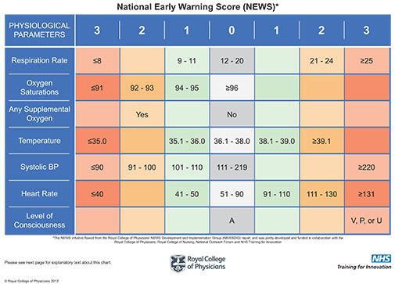

Elective indications for admission
Patients with comorbidies or having surgery with a high complication rate
A preoperative risk score eg 'SORT' may help
Preoperatively – if Major surgery / Comorbidities to ‘Optimise’
Postoperative eg AAA/Neurosurgery
for Monitoring - eg epidural or certain drugs

What Actually happens there
- Aim to discharge patients in as good as their long- term state

Monitor Therapies

CVS Continuous ECG, CVP, Art Line Inotropes, Pressors, Anti-Dysrhymic Rx
Cardiac Output (Eg PA Catheter) Intra-Aortic Balloon Pump, LVAssist Device
RS Continuous RR, Sa0₂, Pa0₂ 0_{2,} CPAP, Intubation, Ventilation
Renal Urine Output, Cardiac Output, Drugs (?), Haemofilter
Liver IVC pressures Support other organs/ Extracorporial Liver?
Neuro Intracranial Pressures/Flows Support other organs/ Inotropes etc

Sepsis
Sepsis= Proven/suspected infection plus organ dysfunction; It affects all body systems.
There have been many public campaigns to improve recognition and treatment of sepsis
eg surviving sepsis campaign and 'sepsis 6'

The qSOFA score (quick Sepsis related Organ Failure Assessment) is
- More qSOFA, higher sepsis risk
- Reassess if you suspect but score 0-1
- 'Sepsis 6' if you diagnose/score 2-3
- Don't forget Dr ABCD and the basics
altered RR>22 systolic <
CNS state 100mmHg

Sepsis 6
An example of a 'care bundle': a group of interventions for the same treatment.
'3 out, 3 in'
3 out Take blood cultures
Measure accurate urine output
Measure serum lactate and send full blood count.
3 in Titrate oxygen to a saturation target of 94%
Give empiric intravenous antibiotics.
Start intravenous fluid resuscitation.

Don't forget DR ABCD and to do sensible things such as find/deal with the source of sepsis.

ICU Issues to discuss
How do we decide when to 'stop' or withdraw care?
How do we decide in real life who goes there?
Is it OK/useful for people/patients to receive care there if they don't want CPR/intubation?
What are the 'side effects' or negative aspects of ICU?
How could you make it a better experience for patients?
Who should not come to ICU?
How can we/can we consent someone for surgery if they are on ICU?

Appendix:

1.The Prescribing Highway Code.

What you need to know for Safe Prescribing and administration of Drugs.

Introduction

Prescribing drugs is a legal responsibility given by Parliament to Doctors on the General Medical Register, Veterinary Surgeons, and certain appropriately trained nursing staff. When you prescribe a drug you have to fulfil certain legal requirements, depending on the class of drug.

In the GMC document Good Medical Practice, the following paragraphs relating to Providing Good Clinical Care are relevant to Prescribing;

Above all you should make the care of the patient your first concern.

1. You should prescribe drugs, including repeat prescriptions, only when you have adequate knowledge of the patient’s health and are satisfied that the drug serves the patients needs.

2. You should provide effective treatment based on the best available evidence.

3. You should take steps to alleviate pain and distress.

4. You should respect patient’s rights.

5. You should keep clear records that are accurate and legible.

6. You should make good use of the resources available to you.

The instructions in this guide follow from these rules.

Importance of good prescribing.

Drugs are dangerous. Even over the counter drugs, in overdose or combination with prescribed drugs are potentially harmful to the patient. 40,000 drug errors occur in the NHS each year, about 2000 cause moderate to severe injury to patients. This includes errors in prescribing, dispensing errors and administration errors. Prescribing is the first link in the chain and it is very obviously essential that prescribing is appropriate, clear and legal!

In the following part of this guide you will be given a set of rules for prescribing.

RULE 1

Check that you have the correct patient.
= First Name / second name / birth / hospital number

This may sound obvious, but 2 patients may have the same name, you may be asked to do prescribing for several patients at once and given a number of prescription cards. Can you identify which patient belongs to which card? Do patient label, notes and prescription card all have the same number? If you are satisfied proceed to rule 2. If not Check again! This is the same for blood transfusions.

RULE 2

Check the patient’s history for drug allergies.

Do not rely on the Prescription card, go back to the original clerking, and if possible confirm with the patient that you have an accurate list of any drug allergies, look for medic alert bracelets and drug allergy alerts in the older part of the notes or on procedure charts such as anaesthetic charts.
Satisfied? Continue to rule 3.

RULE 3

Look at the current prescription for potential drug interactions, or drugs of the same class already prescribed.

If you are not sure use the British National Formulary to check if the drug you intend to prescribe will interact with existing prescriptions. Then consider which drug you should omit.
Satisfied? Continue to rule 4
TOP TIP 1
Don’t prescribe in a hurry!!
If you are asked to prescribe, take a deep breath, concentrate on what you are being asked to do and follow the rules!!

RULE 4

Use the generic name of the drug not the trade name. Write it legibly in the appropriate place on the chart e.g. ibuprofen rather than ‘Neurofen”.

Using the generic name is safer than using trade names as it more clearly identifies the class and action of drug in your mind. It is ABSOLUTELY ESSENTIAL that the person who will administer the drug is able to read what you have written. If your hand writing is bad PRINT the name of the drug in capital letters.

RULE 5

The dose must be specified either in full or using agreed abbreviations.

Many errors occur in relation to poor writing of the dose. Numbers including the position of the decimal point must be CLEAR. The units of these numbers, milligrammes, microgrammes or even grammes, are best written out in full, as it is very easy to confuse mg with µg when using hand writing, and this can result in overdoses.

RULE 6

The route of administration must be clearly written.

It is essential to clearly state the route that the drug should be given. Again writing out intravenous, intramuscular or intrathecal is better than using IV IM or IT. Drugs given by the incorrect route, especially the intrathecal route, can cause extensive damage!!

RULE 7

The frequency of the drug must be clearly stated.

The frequency of administration may be stated in terms of the hourly interval (6 hourly, 8 hourly 12 hourly) or ‘times a day’ (three times, four times a day). It is better to use these terms rather than the archaic terms ‘bd’ or ‘tds’. For preference on inpatient prescribing charts, use the timed boxes on the chart to specify time of administration.

RULE 8

Define the duration of administration, or a date for review of the prescription.

How long should the patient continue to take the drug? If there is a specific course such as with antibiotics, define the finish date. Antibiotic prescriptions should have a clinical indication clearly visible on the chart. All prescriptions should be reviewed at regular intervals to ensure appropriate use of the drug.

RULE 9

Write any specific instructions regarding administration on the prescription.

This may include relationship to food, duration of administration by a particular route, for example slow intravenous injection, or important instructions regarding other drugs or food items for instance not taking grapefruit with statins.

RULE 10

Date and sign the prescription, print your name and give contact details.

A prescription is like a cheque, it is only valid if it is dated and signed. You must print your name and give contact details to ensure that if there is any problem at the following stages of drug administration, dispensing and administration, you can be contacted and the problem resolved rapidly in order that the patient can begin their treatment.

TOP TIP 2

If someone rings you to check or question your prescribing, they are doing it for the safety of the patient! However tired and stressed you are, take a deep breath and answer politely and patiently. Then go and see if you have followed the rules—and write clearly and legibly, including special instructions if appropriate next time!!!

How do I access the information I need to prescribe appropriately and safely?

There are a variety of sources for information relating to the prescribing of drugs check out:

- The British National Formulary - on every ward.

- The Clinical Practice guidelines - on the intranet.

- Your Ward Pharmacist

A good source of all types of information, also the person who will probably carry out your DOPS assessments.

TOP TIP 3
If some one else tells you what to write on the chart, check it yourself using one of these sources! Your signature is on the prescription so you are responsible for it. Better safe than sorry, and looking things up helps you to learn!

Basic Adult Life Support 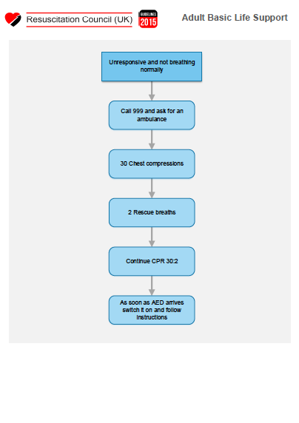
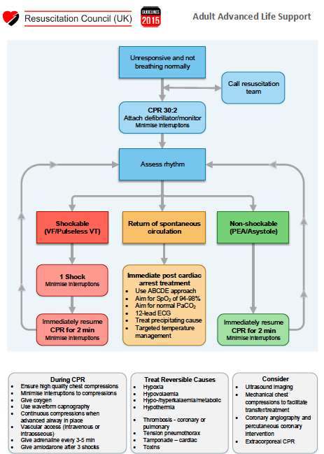

ECGs made very easy

The Normal ECG

There are two main things that we look for in the peri-operative period:
- Is normal sinus rhythm present?
- Are there signs of ischaemia?

Looking for Arrhythmias

1. First Name, Second Name, Date of birth, Hospital Number. Look at the patient not the piece of paper. If awake and talking, they do have a cardiac output! In an anaesthetised patient, look at the pulse oximetry trace and feel for a pulse (peripheral and central).

2. Is there any electrical activity?

3. Are there recognisable complexes?

4. Work out the heart rate (300 / number of big squares between R-R)

5. Now look at the rhythm

Is it regular? Are there any P waves? Are the P waves of uniform shape? Are the P waves always followed by a QRS complex? Does the QRS complex look normal?

Now put it all together:

Looking for Signs of Ischaemia / Infarction

Old Injury

• Pathological Q waves
• T wave inversion

Acute Ischaemia

• ST depression, ischaemia
• ST elevation, infarction

Goals and Objectives

At the end of your time in your peri-operative care teaching, you should have achieved the following goals and objectives. Summarised in the curriculum guide on the website.

PRE-OPERATIVE CARE

* Be able to explain what the patient will experience up to the moment they go to sleep and upon waking
* Understand the role of the pre-assessment clinic
* Assess their medical fitness, the relevance of their pre-operative medications, the need for "routine screening tests" and the need for additional special investigations
* Assess the need for
- peri-operative IV fluids and predict their likely need for blood transfusion
- prophylactic antibiotics
- VTE prophylaxis
* Select patients requiring specific additional peri-operative treatment – e.g. physiotherapy, bronchodilators, antihypertensives, post-op HDU/ITU
* Understand the rationale for pre-operative fasting
* Understand the reason for pre-operative optimisation of the acutely ill patient

INTRA-OPERATIVE CARE

* Understand the principles of intra-operative monitoring
* Understand the specific needs of an unconscious patient
* Understand the principles of anaesthesia and sedation
* Observe the application of the principles of cardio-respiratory physiology as they govern the need for fluid resuscitation, ventilation and blood transfusion
* Understand the principles of emergency surgery
* Observe the use of regional/local anaesthetic techniques and understand the possible complications

POST-OPERATIVE CARE

* Be able to assess patients’ pain, write a prescription for simple analgesic drug regimes and explain the need for more complex regimes
* Be able to assess severe pain, write a prescription for an opioid and explain the side effects
* Recognise abnormalities of pulse, BP, temperature, urine output and CVP
* Be able to prescribe an appropriate post-operative fluid regime
* Understand the role of HDU and ITU in special circumstances and how to access specialist advice
* Understand the role of the Outreach Team special and when to access it
* Know how to detect and treat post-operative respiratory failure, cardiac failure, renal failure, and sepsis in their early stages
* Know how to treat post-operative nausea and vomiting
* Understand the principles of O2 therapy and monitoring

ANAESTHETIC SKILLS

* Maintain the airway of an unconscious patient
* Ventilate a patient by hand using bag-valve-mask technique
* Insert an intravenous cannula
* Use suction apparatus to clear a patient's airway of secretions
* Draw up and administer intravenous drugs
* Select an appropriate oxygen mask for a hypoxic patient

SAFE SURGERY

* Be aware of the WHO surgical checklist
* Be aware of principles of safe transfusion
* Be aware of safe prescribing

