Introduction to Cardio-Pulmonary Exercise Testing (CPET): Summary

What is CPET?
CPET measures the cardiopulmonary system response to increasing work/exercise to assess fitness.
It can be used to identify cardiac, respiratory, muscular and metabolic abnormalities.

What is VO₂ ?
VO₂ is the volume of oxygen consumed and is measured throughout CPET.
Measured in either ml/min or l/min.
Peak VO₂ is sometimes mistakenly referred to VO₂ max which is a true physiological limit and not always achieved in a patient population. Best to always say Peak VO₂

What are 3 determinants of fitness? Fit = High peak VO₂ & VO₂ @AT, low VE/VCO₂
- Peak VO₂ = the highest recorded O₂ consumption at peak exercise (usually averaged over 30s)
  - Expressed in l/min (absolute) or ml/kg/min (relative)
- VO₂ at the Anaerobic threshold (AT)= When oxygen supply does not meet demand and a person’s muscles add anaerobic metabolism to aerobic metabolism. Oxygen consumption is measured at this threshold
  - Expressed in l/min (absolute) or ml/kg/min (relative)
- Ventilatory Equivalents for carbon dioxide (VE/VCO₂)= A marker of lung efficiency, how much (in L/min) a person would need to breathe to eliminate 1L of CO2.

Fit = High peak VO₂ & VO₂ @AT, low VE/VCO₂

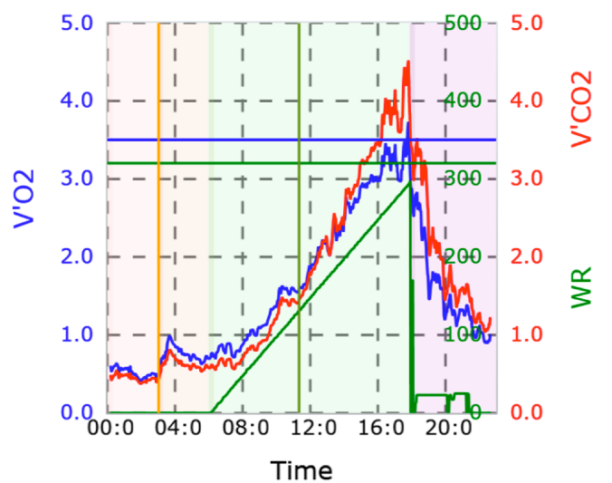
Panel 3: Test Overview

This panel can show you:
- Whether it was an adequate test (duration, work achieved)
- Peak VO₂ (blue line)
- Peak work rate (green triangle)
- If there is an appropriate increase in oxygen consumption parallel to the ramp.
- Comparison to predicted values

What do we do with the information?
- Identify the ‘high-risk’ patient- may benefit from ICU care postoperatively
- Estimate risk of morbidity and mortality- low fitness optimise the patient preoperatively?
- Identify unanticipated disorders e.g. Ischaemia may refer for echo/MPS
- Inform and aid in shared decision-making- surgical techniques and anaesthetic plans.
- Guide prehabilitation programmes to improve fitness.

