How to Insert a ‘Central Line’

Jonny Rajan is a Speciality Registrar Level 1 in Anaesthesia, University College London, London

Kiran Kaur is a locum Consultant in Anaesthesia, University College London, London

Sanjay Bajaaj is a Specialist Registrar in Anaesthesia, University College London, London

Robert CM Stephens is a locum Consultant and Research Training Fellow in Anaesthesia, Institute of Child Health, University College London, London.

INTRODUCTION

The ability to insert a ‘central line’ (a catheter in a vein leading directly to the heart) is an essential skill for many physicians. Central venous catheters (CVCs) help monitor central venous pressure in acutely ill patients, provide access when no peripheral veins are available, and allow for administration of vasoactive and inotropic drugs that cannot be given peripherally. Around 200,000 CVCs are inserted annually in the NHS, with failure rates estimated to be as high as 35% in the literature.
Central venous pressure measurement: a fluid resuscitation aid

To take Central venous gas measurements: a fluid resuscitation aid

When peripheral venous access is difficult

When vasoactive, inotropic or hypertonic agents are required that should not be administered peripherally (eg Adrenaline, Noradrenaline or total parental nutrition)

For haemodialysis, plasmapheresis, temporary cardiac pacing or chemotherapy
Table 1 Indications for CVP lines and line siting

CVC’s can be situated in 6 sites (see Fig 1 and 2). The choice of CVC insertion sites will depend on the indications, risk of complications and expertise of the doctor. It should be remembered that (except the external jugular) most central veins are often deep and have to be located without the aid of direct vision. This is associated with damage to nearby structures, especially in the hands of an inexperienced operator. Successful catheterization by either the internal jugular or the subclavian route therefore relies on a thorough understanding of the anatomy of the neck and use of 2D ultrasound. The internal jugular vein is located at the apex of the triangle formed by the heads of the sternocleidomastoid muscle and the clavicle. The subclavian vein crosses under the clavicle just medial to the midclavicular point. Ultrasound (2D) guidance is recommended for CVC in both the elective and emergency situation. It allows precise location of the target vein, anatomical variation and thrombosis within the vein. Audio-guided Doppler ultrasound is not recommended.
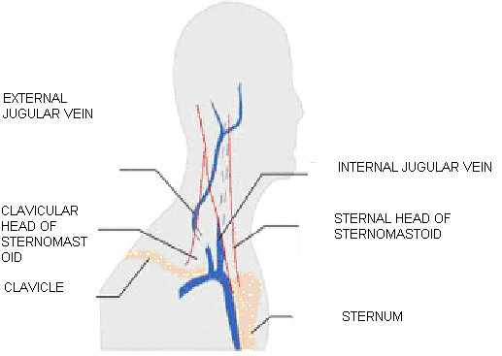
Fig 1. Anatomy of the neck in relation to internal jugular vein catheterisation.

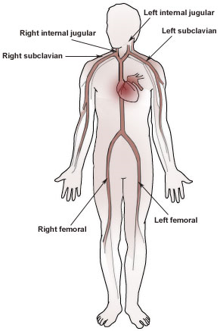

Fig 2. Sites of central venous line insertion.

Patients should be assessed for contraindications. These include an uncooperative patient, uncorrected bleeding diathesis, skin infection over the puncture site, a pneumothorax or haemothorax on the contralateral side or the presence of only one functioning lung. Factors that might increase the difficulty of catheter insertion, such as a history of failed catheterisation attempts or the need for catheterisation at a site of previous surgery, skeletal deformity, or scarring should also be considered. When a difficult catheterization is anticipated, the importance of patient safety dictates that the procedure be performed or supervised by an experienced physician.

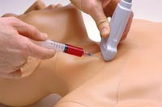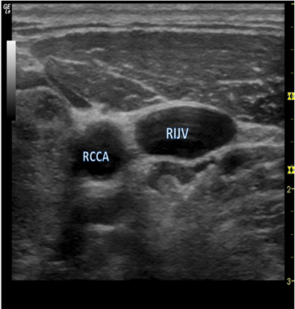

Fig 3. Ultrasound to guide CVC.

Figure 4. Ultrasound views of CVC showing right common carotid artery, (RCCA) and compressed right internal jugular vein, (RIJV.)

Equipment
Venous catheters (see fig 5.) are available that differ in length, internal diameter, number of access ports, material and methods of fixation. Adult catheters for subclavian or internal jugular lines are commonly 20 cm in length although, if the right sided neck veins are cannulated shorter 15cm catheters should be used to prevent right atrial catheterization.

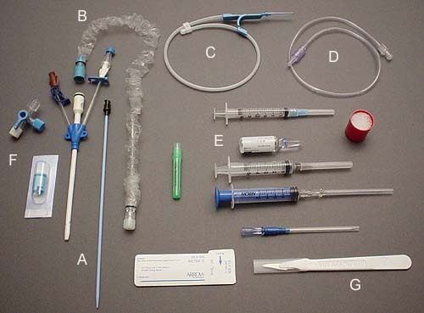 Fig 5. Equipment in a CVC pack

Fig 6. Comparison of CVC Insertion sites
 | Internal Jugular | Subclavian | Femoral
Compressibility of vessels in bleeding | ++ | + | +++
Ease of access during active resuscitation | + | ++ | +++
Ease of use with US guided techniques | +++ | + | +++
Patient comfort and maintenance of dressing | ++ | +++ | +
Arterial puncture | ++ | ++ | +++
Thrombosis and Haematoma | ++ | + | +++
Haemothorax and Pneumothorax | + | ++ | -
Infection risk | ++ | + | +++

Technique of insertion
The patient is consented then commonly positioned in the trendelenberg position (feet up, head down to increase vein size) for internal jugular vein or subclavian vein CVC insertion. For femoral vein CVC the supine position is adopted. Landmarks are then identified and ultrasound is then used to identify the desired vein and adjacent arteries.

Full sterile technique (sterile gown and gloves, mask, cap with ultrasound probe in sterile sheath) must be used. The area should be cleaned in a sterile fashion using an appropriate disinfectant, followed by sterile draping. Lignocaine can then be used to anesthetise the venepuncture area as well as the suture area. The artery is usually medial to the vein, smaller and pulsatile and unlike the vein, is not compressible. The needle is advanced, under Ultrasound while applying negative pressure to the syringe until a flash of blood is visualized. The seldinger technique (guidewire through the needle which is then withdrawn to leave the guidewire only) is then used to insert the catheter after which a chest radiograph is required to confirm position and exclude a pneumothorax

Figure 8. Complications of CVC.

Malposition of the catheter | Air emboli
Haematoma | Catheter embolism
Arterial puncture | Thrombosis
Pneumothorax | Haemothorax
Haemorrhage | Cardiac tamponade
Sepsis | Cardiac arrhythmias

Central Venous pressure
The central venous pressure (CVP) is expressed in cmH₂O above a point level with the right atrium. The normal value is 0-8 cmH₂O and is measured with the patient lying flat. It gives a useful indication of filling status and right ventricular preload. A volume challenge of 250 mls of colloid over 15 minutes: an increase in CVP of less than 5cm H₂O (or 3 mmHg), or one that is not sustained for more than 10 minutes suggests hypovolaemia. Serial readings are much more useful than a single reading. The presence of anatomical variants such as tricuspid regurgitation which may alter the baseline CVP reading of the patient must be taken into account.
Causes of a raised CVP include
Increased intrathoracic pressure
Impaired cardiac function (failure, tamponade. Only useful for information regarding the right side of the heart).
Hypervolaemia
Superior vena cava obstruction
Caues of a decreased CVP include:-
Hypovolaemia
Reduced intrathoracic pressure (e.g. inspiration)
Managing the patient with CVP cannula .

Patients should be monitored for signs of complications. Central lines with drugs/fluids etc. being infused should be clearly labelled in order to minimise the risk of accidental bolus injection. Lines should be regularly flushed to help prevent thrombosis and a 500ml bag of 0.9% normal saline connected to the line should be maintained at a pressure of 300mmHg. All connections must be secure to prevent exsanguination, introduction of infection and air emboli. Furthermore the insertion site should be frequently and carefully assessed for signs of infection. The length of the indwelling catheter should be recorded and regularly monitored. CVP lines should be removed when clinically indicated, and with the patient in the head down position if the neck has been used as the site of insertion.
The tip should be sent for microbiological culture.
Summary

- CVC is a common procedure performed by a range of specialities.
- Ultrasound guidance is recommended.
- Administration of drugs and volume status monitoring is facilitated.
- It has numerous possible complications.

