UCL Alumni Volunteer Guidance

Data Transfer of Alumni Group Event Attendees

Transferring data from alumni group events must be done in a secure manner.
As indicated in the events best practice guidance, you should share your event registration list with your UCL Alumni Relations Team contact after the event, to update on who has attended the event. This should be done as soon as possible after the event has taken place. Once data has been transferred to UCL all copies must be deleted.

Please find below instructions for the process on how to safely transfer event registration data to the UCL Alumni Relations Team.

Transfer using a dedicated UCL SharePoint file

To upload attendee lists to UCL, follow the guidance below for phone or computer.

On a phone

- You will have received an email with a link to the folder. Click on the open button.
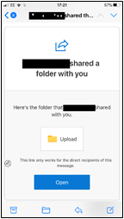

- This will then open SharePoint where some secondary authentication will be required. Click on the Send Code button.
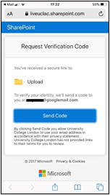

- You will now receive a second email with an eight digit number. Copy this number and enter it into box and click verify.
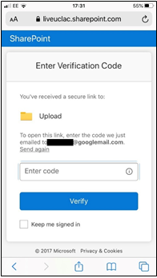

- Click on the three dots beside the magnifying glass and select Upload.
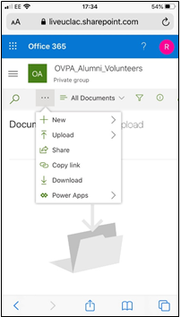

- Choose Files.
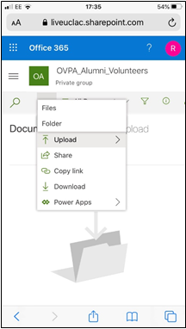

- Select a photo or browse to a file.

- You file will now appear in the folder.

- The file will then disappear as it will be automatically be moved to another folder.

- You can now close the browser

From a computer

- You will have received an email with a link to the folder. Click on the open button .

- This will then open SharePoint where some secondary authentication will be required. Click on the Send Code button.

- You will now receive a second email with an eight digit number. Copy this number and enter it into box and click verify.

- Select Upload.

- Choose Files.

- Select a photo or browse to a file.

- You file will now appear in the folder.

- The file will then disappear as it will be automatically be moved into another folder.

- You can now close the browser.

