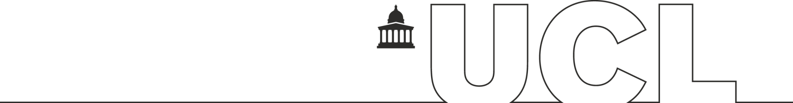

UCL Academic Partnerships

Termination of an Academic Partnership Form

This form is to be completed when an academic partnership is to be terminated or allowed to expire with no further renewal without withdrawing a degree programme or a route on a degree programme. Where a degree programme or route is also withdrawn, the standard programme withdrawal process set out in the Programme and Module Approval and Amendment Framework must be followed.

Before submitting this form, you should seek agreement from the partner organisation that the collaborative arrangement is to end. You should submit evidence that the partner has been consulted and is in agreement with this form.

Once this proposal has been approved at Departmental and Faculty levels, it should be submitted to the Academic Policy and Quality Assurance team by email to academic.partnerships@ucl.ac.uk. If the proposal is to disestablish an international partnership, the Global Engagement Office should be informed of the termination.

Partnership information

Name of partner organisation:

Date of expiry in the Memorandum of Agreement:

UCL programme(s) delivered under this partnership:

Number of students currently enrolled on the programme(s):

Date when students would normally complete their programme(s) of study:

Date when all students should complete, allowing for extensions, deferrals and resits:

Termination arrangements

1. | Provisions within the MOA relating to termination (copy relevant text below)
2. | Reason(s) for termination of the partnership.
3. | Please summarise the exit strategy and state whether or not this has been agreed with the partner institution. If possible, please attach the full exit strategy to the form when submitting it to Academic Services.  [Please also attach a copy of the draft Termination Letter to be sent to the partner institution by e-mail, provided and drafted by the Academic Policy and Quality Assurance team].
4. | Any other relevant information.
6. Sign off and approval

6.1 Signature of Programme Director

Signature: |  |  | Date:
Print Name |  |  | Role:
6.2 Approval by Head of Department/Director of Division/Institute

Signature: |  |  | Date:
Print Name |  |  | Academic Department
6.3 Approval by Dean of Faculty or Faculty Tutor

Signature: |  |  | Date:
Print Name:

Please return the completed form with all signatures (e-signatures or confirmatory emails are accepted) and other documentation to Academic Policy and Quality Assurance, email academic.partnerships@ucl.ac.uk

