Annex 4.4.3: Full Exam Board Agenda Template
Updated May 2023

The right-hand column includes points which can be included in the Chair’s Agenda as a prompt/reminder. These should be omitted from the standard agenda that is circulated to members of the Board.

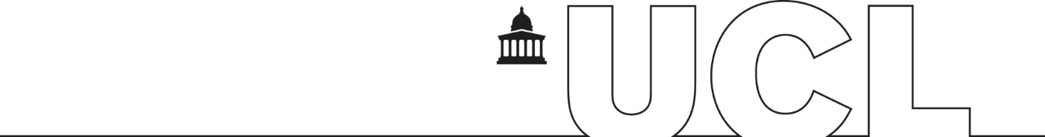

BOARD OF EXAMINERS
<Name of Board>
<Date>, <Time>, <Location>

Agenda

 | Agenda | Notes for Chair’s Agenda  (delete this column from the formal agenda)
 | Welcome, apologies and announcements | - Welcome External Examiner(s) and Faculty Representative  - Introductions to Internal Examiners as appropriate  - Confirm that the meeting is quorate  - Remind members of confidentiality restraints pertaining to business of Board and results  - Confirm that there are no conflicts of interest (e.g. a relationship to a student) from members of the Board  - Give a brief report on the session’s examining procedures
Minutes of the last meeting
<Date of last meeting>
 | Matters arising from the minutes | Provide updates on any issues which were delegated for Chair’s Action
Minutes of any Sub Boards held since the last meeting
<Dates of meeting(s)>
 | External Examiner report for previous session and departmental response
 | Report on preliminary meetings | Where applicable, receive reports from pre-meetings, pre-boards, Academic Misconduct Panels etc that have a bearing on the decisions the board is about to make.
 | Conduct of assessment | Where applicable, report any significant changes to the assessment process relating to the results which are about to be considered, such as Covid 19 changes and any material irregularities that may have been addressed.  Relevant regulations: Changes to the regulations for Covid-19
 | Module results | Formal approval of marks.  Review of statistical data.  Review of attainment gap data  Module Mark Report and Exam Board Statistics – Module Comparison Report to be tabled.  Relevant regulations: Module Assessment
 | Progression and Award decisions | Progression Summary and Classification Summary reports to be tabled.  Discussion to concentrate on students without a single clear outcome generated by the progression and award calculation. The Detailed Progression and Classification Reports for individual candidates can also be used to inform this discussion.  Relevant regulations:  - Module Assessment  - Progression & Award (inc Condonement)  - Classification  - Classification for UG students first enrolling in 2017-18 or earlier  - Deferrals  - Resits and Repeats  - Interim Qualifications
 | Comments from the External Examiner and provisional response from the Chair | Note that the formal EE report will need to be filled in via Portico within one month of receiving the email with the Portico report link (this email will be sent within a week of the Board of Examiners meeting),
 | Comments from the Faculty Representative
 | Nominations for prizes (if relevant)
 | Discussion of potential future developments and enhancements to module assessment | Initial discussion of any changes which might need to be made in the light of this year’s assessment experience.
 | Examination dates and procedures for next year
 | Confirmation of External Examiner(s) for next year | Record a list of:  - External Examiners who will be continuing next year  - External Examiners who will be finishing their term at the current Board  - The arrangements for replacement Externals, if applicable
 | Any other business
 | Dates of next meeting(s)
 | CLOSE

<Name>
Secretary to <xxx> Board of Examiners
<Job title>
<Date>

