UCL Academic Manual 2019-20
Chapter 6: Student Casework Framework
Annex 6.2
Managing the impact of industrial action on assessment, progression, and award
Guidance

This annex has been prepared for Faculty Tutors and Heads of Department to provide guidance on managing the impact of industrial action on assessment, progression, and award. The impact of industrial action varies across UCL; therefore, each situation will need to be considered on its individual merits in line with the regulations set out in the UCL Academic Manual. The key principles that inform the approach are: fairness to students and maintenance of academic standards.
Education Committee Task Group

On the 28th February 2018 Education Committee established a Task Group to consider issues arising from the impact of the University and College Union (UCU) industrial action to ensure consistency of treatment for students and the maintenance of academic standards. In the event of future industrial action that impacts assessment, progression, and award, Education Committee should establish a Task Group with the following Terms of Reference:
- To consider requests from Faculty Boards of Examiners for advice and mitigation arising from the industrial action and to agree on guidance and suspensions of regulations as appropriate to ensure that:

a. Students are not unfairly disadvantaged in assessment
b. Academic standards are maintained.

- To report to Education Committee on mitigating actions agreed.

The Task Group should be co-chaired by the Chairs of the Academic Regulations and Quality Assurance Sub-Committee and the Quality Review Sub-Committee. Membership should include the Director of Academic Services and at least two other members of Education Committee.
The Task Group set up for the 2018 UCU industrial action developed the following guidance for use in the event of any future industrial action.

General Principles

- Examinations should go ahead as planned.
- UCL should not take actions that undermine our academic standards.
- UCL should send clear messages to students to let them know that UCL will ensure that students are not disadvantaged in assessments and examinations by industrial action. Frequently asked questions that should be sent to students are provided below.
- Students wishing to complain about industrial action should refer to Chapter 6, Section 10: Student Complaints Procedure.
- The Material Irregularities procedure will be used (Chapter 6, Section 6) to deal with any impact on assessment; students should not be asked to submit extenuating circumstances requests.

Cancelled classes and student attendance requirements

All students
- Programme Administrators are expected to keep clear records of classes that are cancelled.
- The 70% student attendance requirement does not apply to cancelled teaching events as students cannot be penalised for not attending classes that did not take place.
- Where teaching has not been affected by industrial action, it expected that students will attend. If students have chosen not to attend teaching events, then they are not entitled to any mitigation for assessment.

2.2 Tier 4 visa students

- Those responsible for monitoring student engagement should mark the student as engaged for classes affected by industrial action. This ensures that students are not penalised due to cancelled classes and reduces the burden on administrative colleagues.

Applying Mitigation

General Principles

- Where it is clear that a module has been affected by industrial action, the material irregularities procedure set out in the Academic Manual (Chapter 6, Section 6) should be followed. The Faculty Board of Examiners may then make adjustments in line with the procedure. The Faculty Board of Examiners may agree a delegation framework, but it is critical that oversight of decision making is maintained. Students should not be asked to submit Extenuating Circumstances Forms to seek adjustments, the Material Irregularities procedure gives an opportunity to make and communicate pro-active decisions about the impact of industrial action.
- Module and Programme Leaders are best placed to reach a judgement as to whether their modules have been sufficiently affected by industrial action to require mitigation; it is not possible to make a single institutional judgement about the consequences of missing a single lecture, lab or seminar.
- Programme Boards of Examiners should review the mark profiles of students carefully to ascertain whether industrial action has had a material impact on the performance of students despite mitigation, they should compare student profiles against unaffected modules and the performance of previous cohorts. Where further mitigation is required, the Faculty Board of Examiners should be consulted.
- Faculty Boards of Examiners are responsible for the application of the Material Irregularity procedure, they may delegate responsibility to individuals or bodies at Department level if appropriate. However, a clear allocation of delegated authority must be reported to the Task Group, for the record, and clear guidance must be provided to the individuals or bodies with delegated authority so that the procedure is applied consistently.
- Due to the varying magnitude of impact on students it is considered that an impact of up to 30 credits can be mitigated without significantly affecting decisions on progression, awarding, and classification; this is because the remaining credits will provide sufficient evidence of students’ academic achievements for a Programme Board of Examiners to make a decision.
- Should the impact on students on a module vary, the Task Group advises that mitigation is applied consistently to all students regardless of whether they were directly affected; this is to ensure parity of treatment for all students.
- Students undertaking research projects/dissertations may be affected differently depending on their supervision and support arrangements. As with other modules, mitigation should be applied consistently to all students in a cohort but there may need to be different forms of mitigation applied to students in the same cohort e.g. some might require extensions where others do not depend on the extent of industrial action in a particular department.
- Students must be informed proactively and as soon as possible about the mitigation that has been applied and the rationale for applying that mitigation.
- Students who wish to complain about the mitigation applied should do so when they are advised of the mitigation and before they have received their marks. In accordance with Paragraph 39 of the Student Complaints Procedure, all complaints must be received by the Casework Team within twenty-eight days of the formal date of notification of when the decision causing the complaint occurred (this would be taken as the day when students were informed of the decision).

Rescheduling In-class Tests

- Where in-class assessments have been missed because of industrial action, the Task Group advises that the assessment should be rescheduled. If it is impossible to reschedule the assessment, then the component should be excluded and this applied to entire cohort.

Adjusting Exam Papers and Assessments

- Chapter 6, Section 6, paragraph 6.d) of the UCL Academic Manual includes adjustment of an existing exam paper or assessment. This may involve adjusting a question, removing certain questions, removing entire sections or adjusting the rubric. Where it is agreed that the most appropriate mitigation for missed teaching is to adjust questions or tasks in an assessment/examination, this should be applied consistently to the whole cohort of students to ensure that the assessment is equitable to all students.
- When adjusting an existing exam paper or assessment, external examiners only need to be informed, UCL will not require external examiner approval for the change.
- In the event of industrial action affecting the exam period, the deadline for the submission of examination paper to the SRS examinations office will not change. Please ensure that exam papers are submitted by the deadline as normal.
- Ideally, any adjustments that may be required to examination papers should be made before they are submitted. However, if there is a paper where it is expected there may need to be a change due to industrial action, the Programme Administrator or Examination Liaison Officer responsible should flag this to the SRS examinations team when the exam paper is submitted. A replacement paper can then be submitted to the SRS examinations team up to two weeks before the start of the exam period.
- Please note that oral corrections in the exam hall are not permitted (because of the number of complaints from students about disruption to their exam in previous years). As a result, departments will have the opportunity to check the printed paper after it is returned from the printers and this timeframe will be reduced in the event that a replacement paper is provided.
- The SRS examinations team can only accept a replacement paper where it is a consequence of industrial action.

Changing the Method of Assessment

- If changing the method of assessment is proposed (e.g. replacing an exam with an essay), the external examiner needs to be consulted and approve the change.
- If the preferred option is “Offering the student another opportunity to take the assessment as if for the first time and without penalty (deferral)”, this must be agreed before students submit assessments or sit an exam.

Component and Module Exclusions

- Where the impact on assessment involves fewer than 30 credits, Faculty Boards of Examiners can take appropriate action in accordance with Material Irregularity procedures. Advice can be sought from the Task Group if required.
- Where more than 30 credits are affected, the Task Group advises that the options in the Material Irregularity procedure under Chapter 6, Section 6, paragraph 6 a)-f) can be applied to any number of credits, as these mitigating actions do not directly affect academic standards and still allow students to sufficiently demonstrate their academic ability.
- In exceptional circumstances where option g) is required (Exclusion of the affected component/module from completion, progression, award or classification decisions), the following approach should be followed:
- a component(s) exclusion of up to and including 50% of the module mark can be applied to any number of credits and still provide an Exam Board with sufficient evidence to make a decision about progression, awarding and classification;
- where a component(s) exclusion amounts to more than 50% of the module mark, this is allowable in up to and including 30 credits and can be approved by the Faculty Board of Examiners;
- where a component exclusion amounts to more than 50% of the module marks in more than 30 credits up to and including 60 credits, this will need to be considered by the Programme Board of Examiners and approved by the Faculty Board of Examiners - this decision cannot be delegated;
- where a module exclusion is applied, this is allowable in up to 30 credits and can be approved by the Faculty Board of Examiners;
- where a module exclusion is applied in more than 30 credits, up to and including 60 credits, this will need to be considered by the Programme Board of Examiners and approved by the Faculty Board of Examiners, this decision cannot be delegated;
- if component exclusions amounting to more than 50% of module marks or module exclusions of more than 60 credits have been applied, then a decision about progression, awarding and classification cannot be made; the Faculty Board of Examiners must consult with the Education Committee Task Group to identify suitable options to support students to complete their programme.

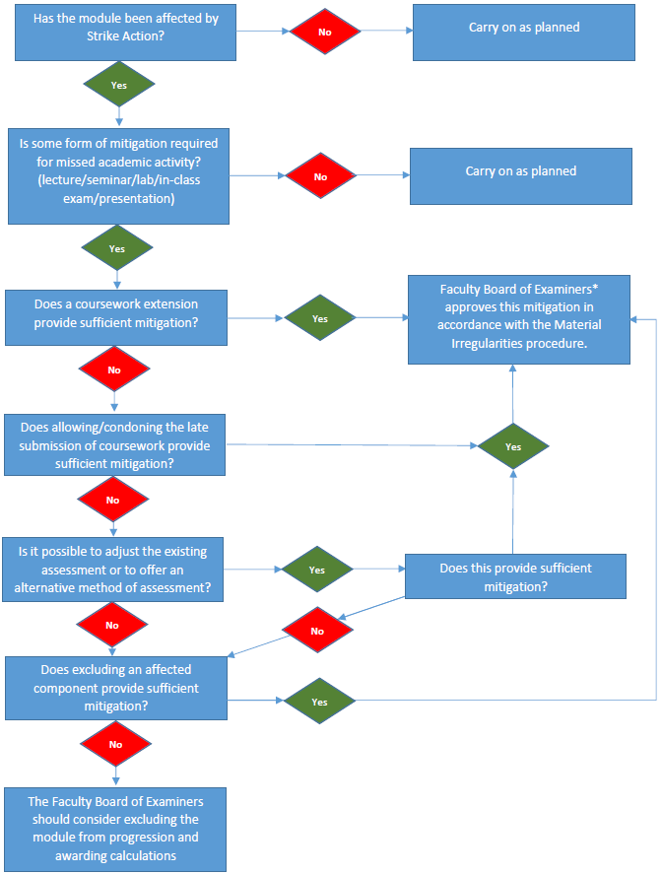
Industrial Action Mitigation flowchart

* A Faculty Board of Examiners may delegate decisions. Decisions to exclude components of more than 50% of the entire module mark or module exclusions cannot be delegated.

Industrial Action Mitigation Cumulative Effect flowchart
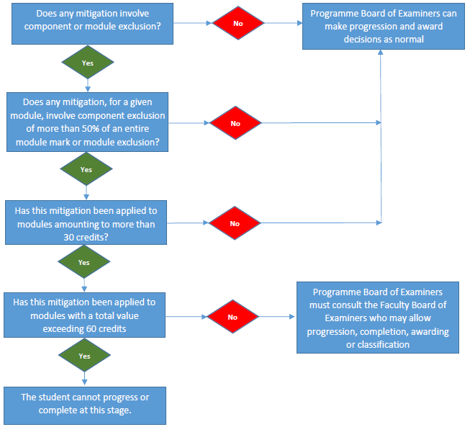
In order to reassure students and manage the assessment process effectively, mitigation will need to be applied before a Board of Examiners meets to make decisions about progression, completion, awarding and classification. In order to safeguard academic standards, a Board of Examiners will need to assure itself that the cumulative impact of any mitigation does not undermine academic standards.

External Examiner Resignations

Guidance

- The University and College Union (UCU) has previously called on External Examiners to resign their duties as part of industrial action. UCU has previously advised them to fulfil all contractual obligations, including notice period and this is UCL’s expectation too. In the event of External Examiner resignations, the following approach should be followed:
- All EEs appointed from Autumn 2017 will have received an appointment letter specifying a notice period of 3 months. In addition, UCL’s regulations were updated in 2016 to specify a 3-month notice period. UCU have previously advised External Examiners to complete their notice periods, and UCL would expect them to do so.
- If the Programme Board of Examiners falls outside the notice period, Departments are encouraged to seek and appoint a replacement to cover the Board meeting. It would be permissible to appoint a recently retired External Examiner to cover one meeting.
- Should a strike be called off before the Board, the Examiner Examiner’s resignation can be rescinded if no replacement has been found; Departments are encouraged to err on the side of caution, not to hope that a strike will have been called off.
- If, for whatever reason, the External Examiner is not going to participate in the Programme Board of Examiners then Departments are advised to ask another External Examiner on the Board (or perhaps from another, closely related Board) to cover the module (adjusting their payment to take account of the additional credit and student numbers). To ensure that the workload is reasonable in the circumstances, the scrutiny of these extra modules can be limited to the following:
- Ensuring the Department has adhered to regulations in running the Programme Board of Examiners;
- That Second Marking has been undertaken with sufficient rigour;
- Examiners do not need to produce a written report on the additional modules.
- If it is not possible for another External Examiner to cover the duties on this occasion, Departments are encouraged to make an interim single year appointment to cover the duties. To help facilitate this, the Task Group may agree to temporarily suspend all of the following appointment criteria from Chapter 9, Section 4 of the Academic Manual for Boards affected by industrial action:

- 5) EEs are not expected to hold more than the equivalent of two substantive External Examinerships at the same time.
- 8) Former members of UCL staff must not be appointed as External Examiners before a lapse of at least five years and provided that all students taught by that member of staff have left the programme being examined.
- 12) Only one External Examiner from the same Department/Division and Faculty of an institution will be appointed to examine the same programme at any one time
- 13) An External Examiner may be appointed from the same Department/Division of an institution only after at least two years have elapsed since the termination of the previous appointment from that Department/Division.

- If these attempts have been exhausted and no External Examiner has been appointed to cover the duties, the following steps need to be taken:
- The Chair of the Board must inform the Chair of the Faculty Board of Examiners in advance of the meeting
- The Chair must report at the meeting what action the 'resigned' External Examiner had already undertaken e.g. scrutiny of exam paper, confirmation of change of assessment method
- Faculty Observers at Boards should use the proforma to report any issues identified during the meeting
- The Faculty Board of Examiners overseeing the meeting must report to Education Committee that UCL regulations were applied properly and that the second marking procedures were applied rigorously and/or request that regulations are suspended to enable student progression, and award.

Resignation of External Examiners flowchart
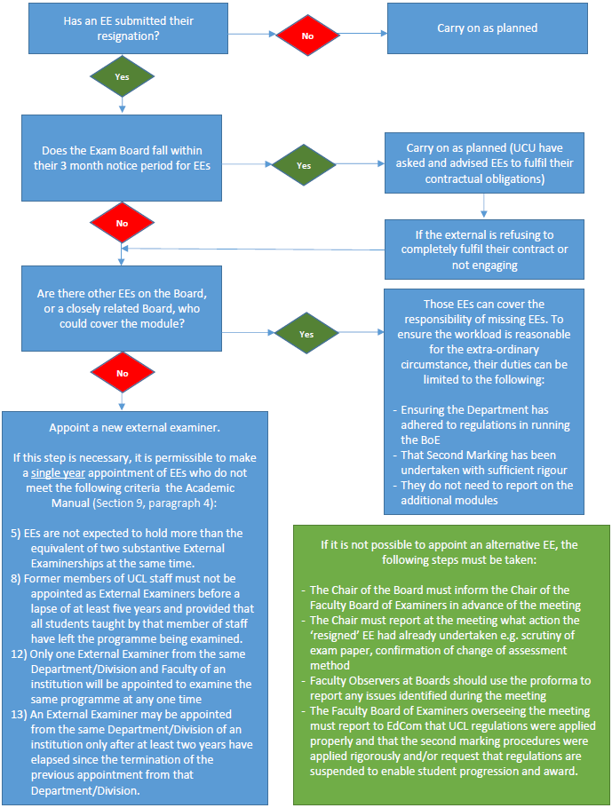

Further questions

Please contact academicregulations@ucl.ac.uk if you have further questions about industrial action and its impact on assessment, progression, and award.

Advice to provide to students
Do I need to submit an extenuating circumstances form?
You do not need to submit an extenuating circumstances form as we have information about the impact of strike on your classes.

Will my results be affected?
Our examination boards have procedures that they can use to ensure that no student is disadvantaged in assessment or examinations. UCL’s Student and Registry Services is also fully equipped to deal with more complex questions from the examination boards and to ensure that we take a consistent approach across UCL.

What will happen about examinations?
UCL knows about the classes that have been cancelled due to industrial action and will take this into account either in the exam paper that we set for you or when we consider your results.

What about coursework assessment?
Your department will advise you on arrangements for coursework assessment. These will vary from no change through to extensions to allow more time for you to submit the work.

What about labs and in-class tests that I have missed?
Your department will advise you on whether your labs or in-class tests will be rearranged to take place on a non-strike day, or whether they will be cancelled. If they cannot be rescheduled, we will discount these components from your overall module mark, in line with our regulations, so that you are not penalised as a result of the cancellation.

Will my degree be devalued if I missed some of my teaching and in-class assessments?
Please bear in mind that the teaching, learning, and assessment for your programme of study takes place in a range of different ways, not just in the classroom. You can use your reading list and on-line materials as usual to ensure that you continue to have a wider learning experience.

Will I be penalised under the attendance policy where my classes were cancelled?
We will not penalise you for not attending classes that we have cancelled due to industrial action. These classes will not count towards the 70% attendance requirement.

What if my classes were running, but I didn’t want to attend them?
We would expect all students to attend classes where they are running.

I am a Tier 4 visa student – will I be penalised for not attending classes?
If you are a student on a tier 4 visa you will not be penalised if you are unable to attend classes that have been cancelled due to industrial action. We will assume that you are engaged with your studies in other ways if your classes are not running.

Has your question been answered?
If you have any other questions that you would like to ask about industrial action and its impact, please speak to staff in your local departmental staff who may be able to help. Alternatively, contact academicregulations@ucl.ac.uk.

