CURRICULUM VITAE

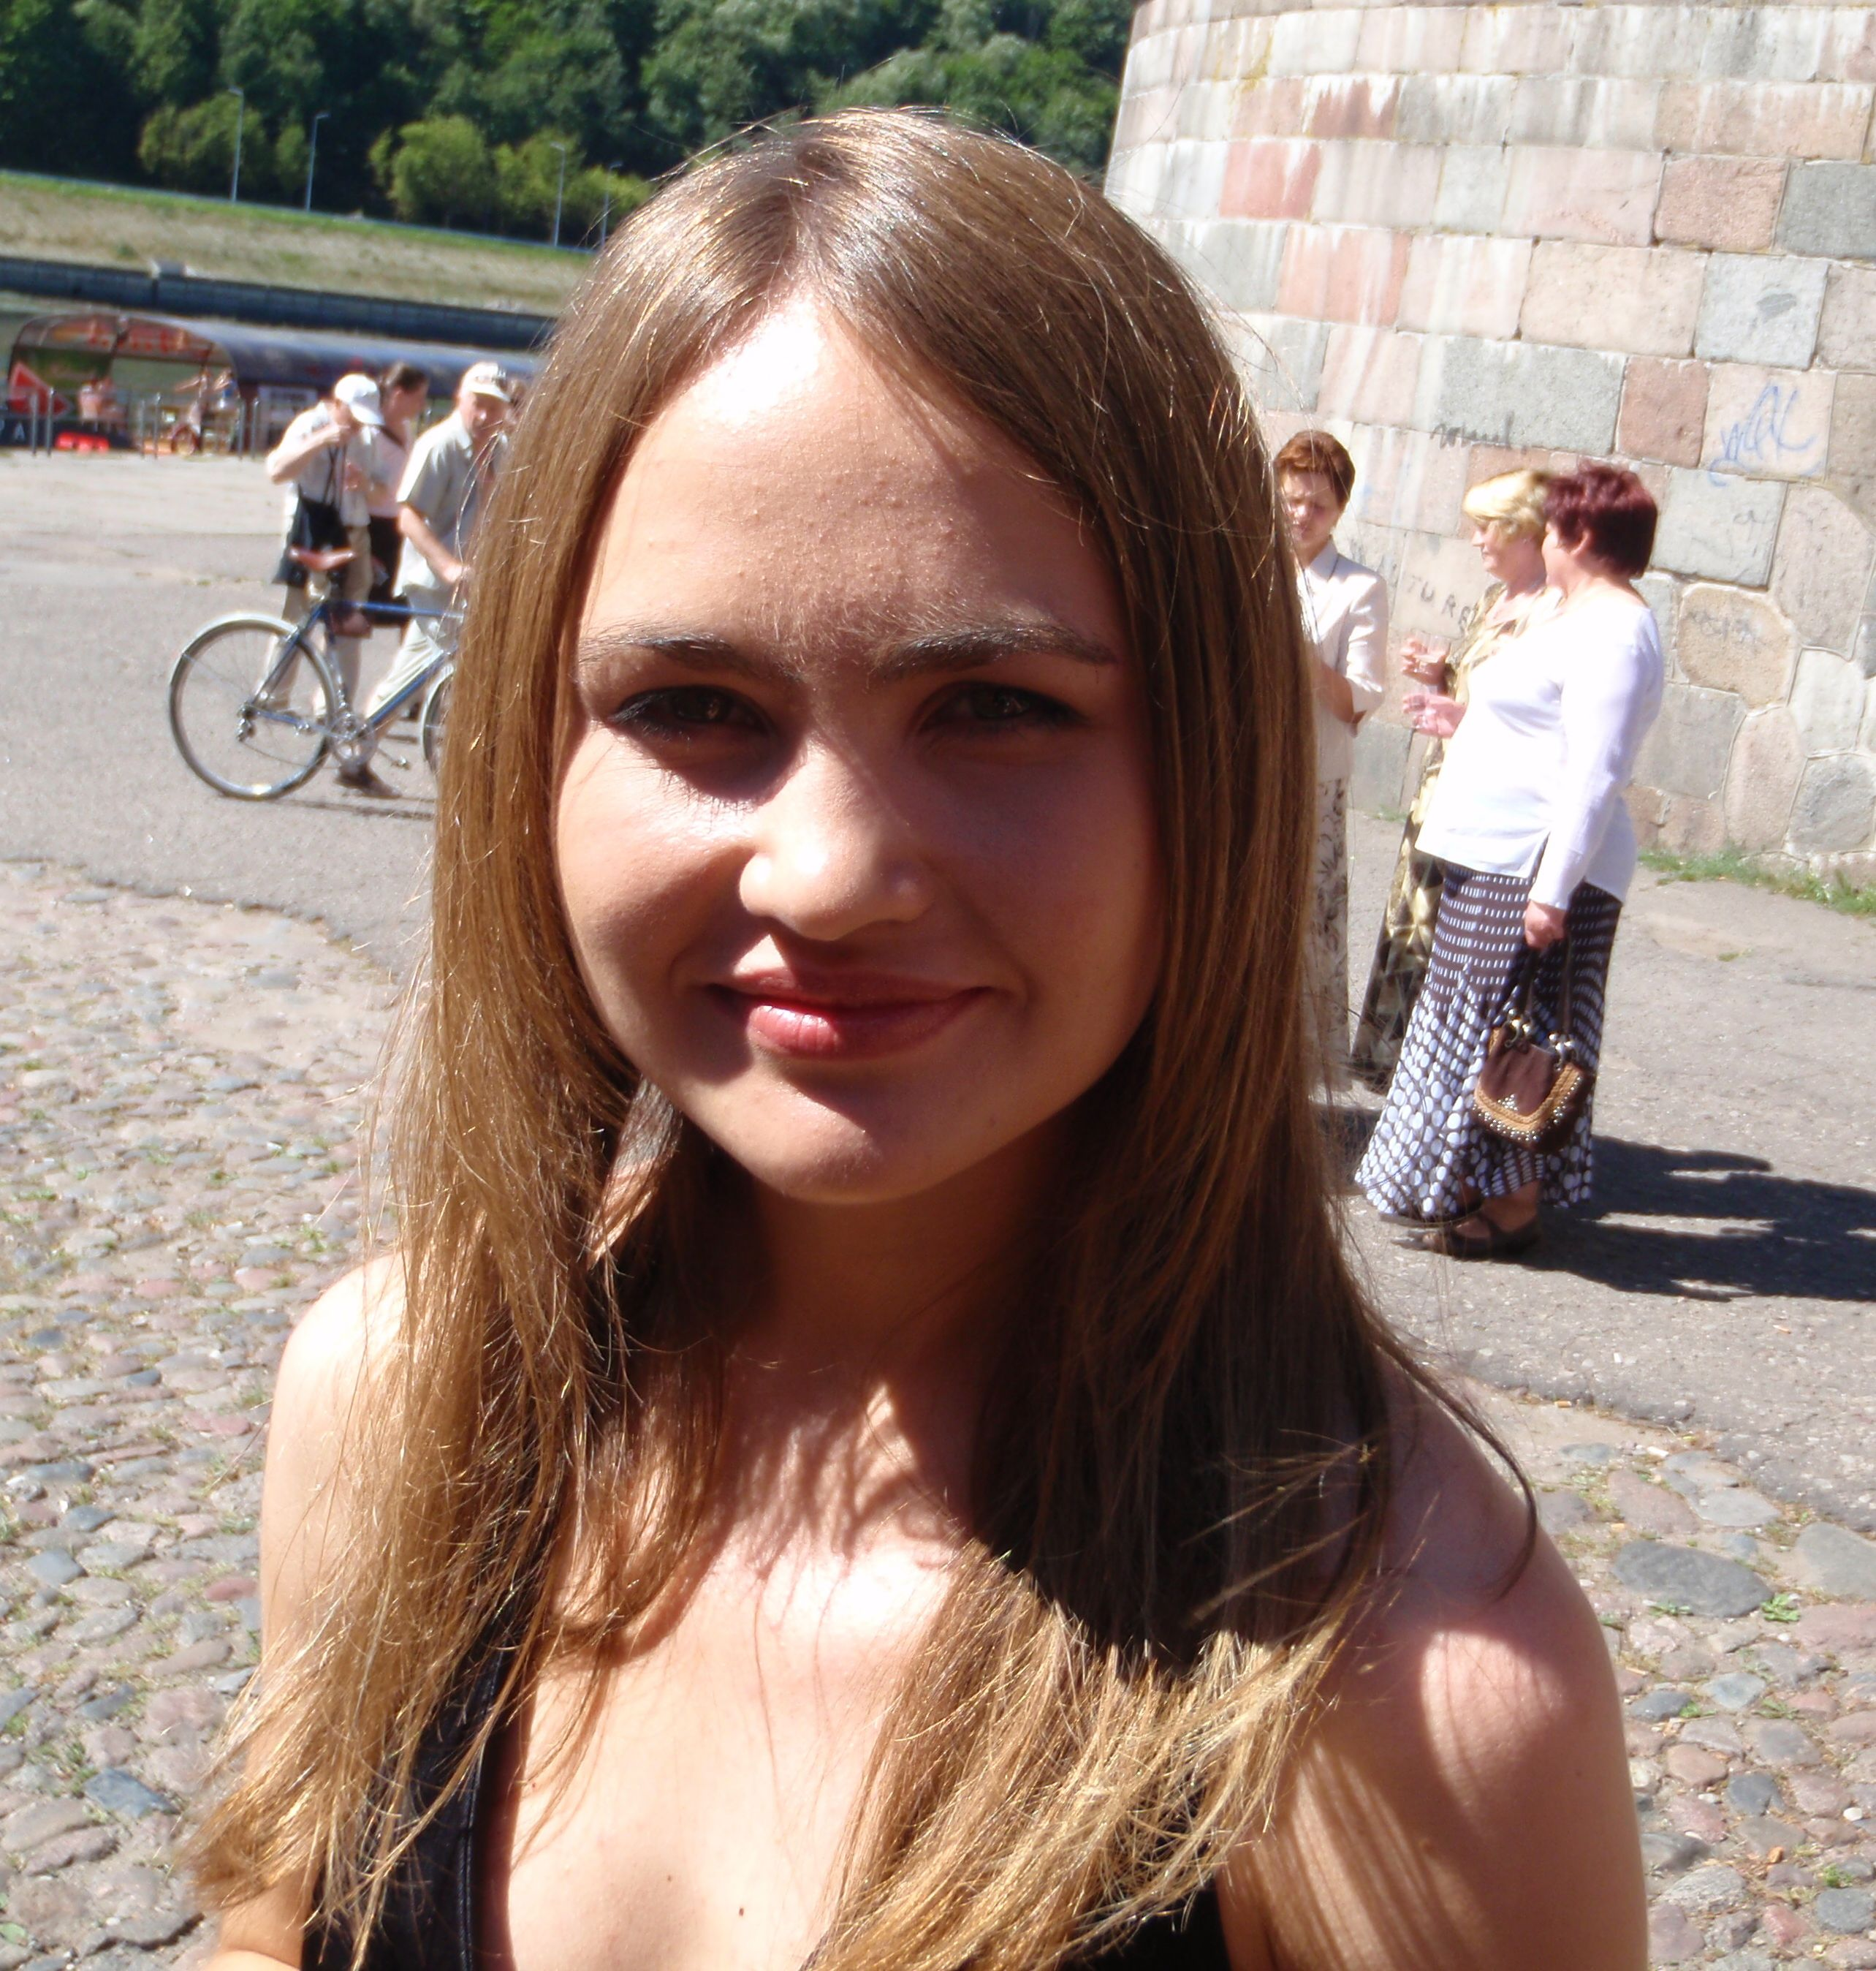
- Personal Details
- Name - Julija Krupic
- Sex - Female
- Date of Birth – Feb 5, 1984
- Citizenship – Lithuanian (EU)
- Marital Status – Single, no children

- Education
  - MRes/PhD in Neuroscience – London PhD Centre for Mathematics and Physics in the Life Sciences and Experimental, University College London (UK), 2007 – 2011
  - MRes in Bioimaging Science – Imperial College London (UK), 2006-2007
  - BSc in Physics (cum laude) – Vilnius University (Lithuania), 2002 – 2006
  - Bilingual Diploma of the International Baccalaureate Organization – Vilnius Lyceum of Science and Mathematics, Vilnius (Lithuania), 2000 – 2002
  - School of Lithuanian Young Mathematicians, 1999 - 2001
  - School of Physics “Fizikos Olimpas”, 1999 - 2002
  - School of Physics “Fotonas”, 1999 – 2002

- Achievements
- III Prize in Lithuanian Physics Olympiad (2002)
- International Baccalaureate Math Marathon Diploma (2001)
- II Prize in Lithuanian Physics Championship (1999)
- III Prize in Lithuanian Physics Championship (1998)

- Languages
- Lithuanian (mother tongue)
- Russian (mother tongue)
- English (fluent, TOEFL computer based 277 (2006 June))

- Programming Skills
- Matlab
- Fortran
- Maple

- Scientific Interests
- Imaging techniques of the neural activity in the brains in vivo and in vitro
- Application of nonlinear dynamics and nonlinear time series analyses for mathematical description of neural dynamics in the brains
- Possible applications of interests mentioned above in clinical practice

- Research Experience
- Electrophysiological recordings in behaving rats
- Analyzing the data from two-photon brain imaging (in in vivo experiments) using nonlinear time series analyses methods (2006 - presently)
- Numerical modeling of nonlinear non-collinear three-wave interaction processes in nonlinear BBO crystal (2005 - 2006)
- Numerical modeling of processes in plasma (2003 - 2005)
- Investigating the behaviour of leukemia cells after application of photodynamic therapy (PDT). Constructing a suitable light emitting diodes (LED) based light source for PDT (2003 - 2004)

- Teaching Experience
- Lectures in the School of Physics “Fizikos Olimpas” on complex problem solving techniques including homework (2002-2004)
- Physics lectures in Vilnius Lyceum of Sciences and Mathematics on ‘Waves’ (2002 spring)

- Hobbies
- Music (I finished a music school (piano) in 2000 and from 2002-2006 I was singing in a female choir of Vilnius University “Virgo”)
- Literature
- Traveling

- Publications
- Schultz, S.R., Kitamura, K. Post-Uiterweer , A., Krupic, J. and Hausser, M. (2008) Spatial pattern coding of sensory information by climbing-fibre evoked. (in press)

- Krupic, J., Stabinis, A. (2006) Spatial-temporal frequency band of optical parametric amplifier, Opt. Commun. 271:564-568.

- Referees
- Prof John O’Keefe, University College London, Department of Cellular and Developmental Biology, e-mail: j.okeefe@ucl.ac.uk
- Dr Simon Schultz, Imperial College London, Department of Bioengineering,
e-mail:s.schultz@imperial.ac.uk
- Dr Mauricio Barahona, Imperial College London, Department of Bioengineering,
e-mail: m.barahona@imperial.ac.uk

