Brecknock Road Estate  Islington,  London | Groundwork North London  Groundwork Project No: 811-13  Start date: July 2005  End date: September 2006
Report author(s): Gemma Moore (UCL), Anna Walnycki (Gwk), Karen Partridge (Gwk)
Date of completed report: November 2008
Summary:

This report details the review of an open space regeneration project undertaken by Groundwork North London, Brecknock Road Estate Tenants and Residents Association and Homes for Islington which was completed in September 2006.

The project aimed to physically transform two large courtyards (north and south) on the Brecknock Road Estate into inclusive, multi-use, accessible play areas. The courtyards were calling out for refurbishment both previously renovated during the 1980’s. The courtyards were run down and not fit for purpose: broken, vandalised, unsafe play equipment, railings, paving, and rotten, unusable seating. Subsequently there was nothing for local young people to do except congregate in the areas around the walkways and entrances to the blocks.

The Brecknock Road Estate Tenants and Residents Association (BRETRA) campaigned to improve these spaces on their estate. They successfully bid for funding from a range of sources and worked in partnership with Groundwork North London and Homes for Islington to undertake the project.

The project involved the renovation of the two courtyards, including the provision of new play equipment, a kick about pitch, new fencing, new paving, new seating, new planting and the general re-landscaping of the areas. Alongside the physical improvements the tenants and residents association organized a number of community-focused events including planting days and community carnivals within the play areas.

The project was highly commended at the National Federation of Arms Length Management Organisation (ALMO) awards for most inspired resident-led program (see HFI Annual Report 2007/2008).

Key words:

- Community-driven project;
- Inner city housing estate;
- Play areas;
- The provision of an inclusive range of facilities e.g. play, games and seating;
- The improved appearance of the local environment through landscaping, paving and planting;
- Community-run activities to engage fellow residents.

Location:

http://maps.google.co.uk/maps?t=h&hl=en-GB&ie=UTF8&ll=51.553647,-0.133499&spn=0.002248,0.006952&z=18

Before and After…

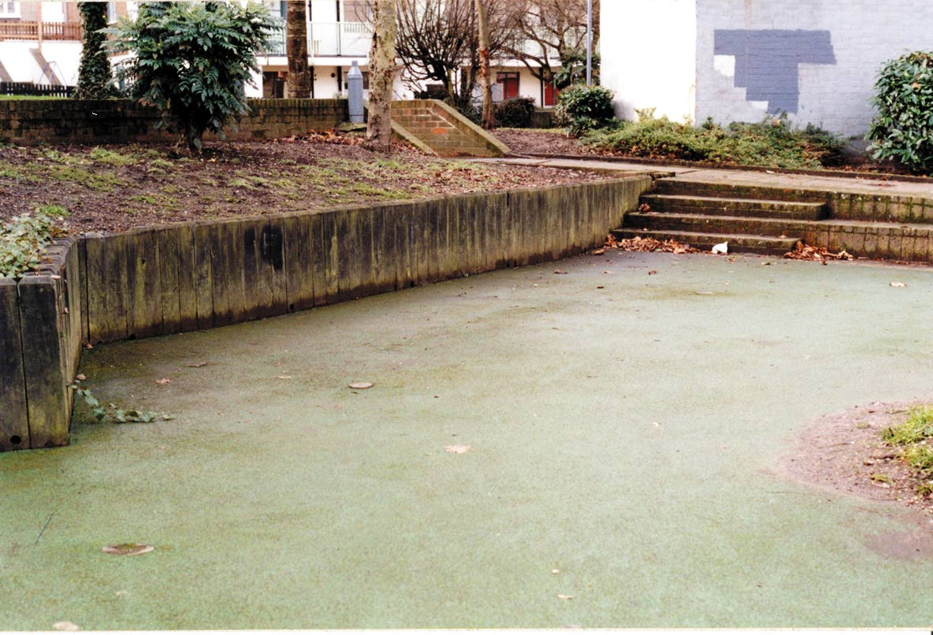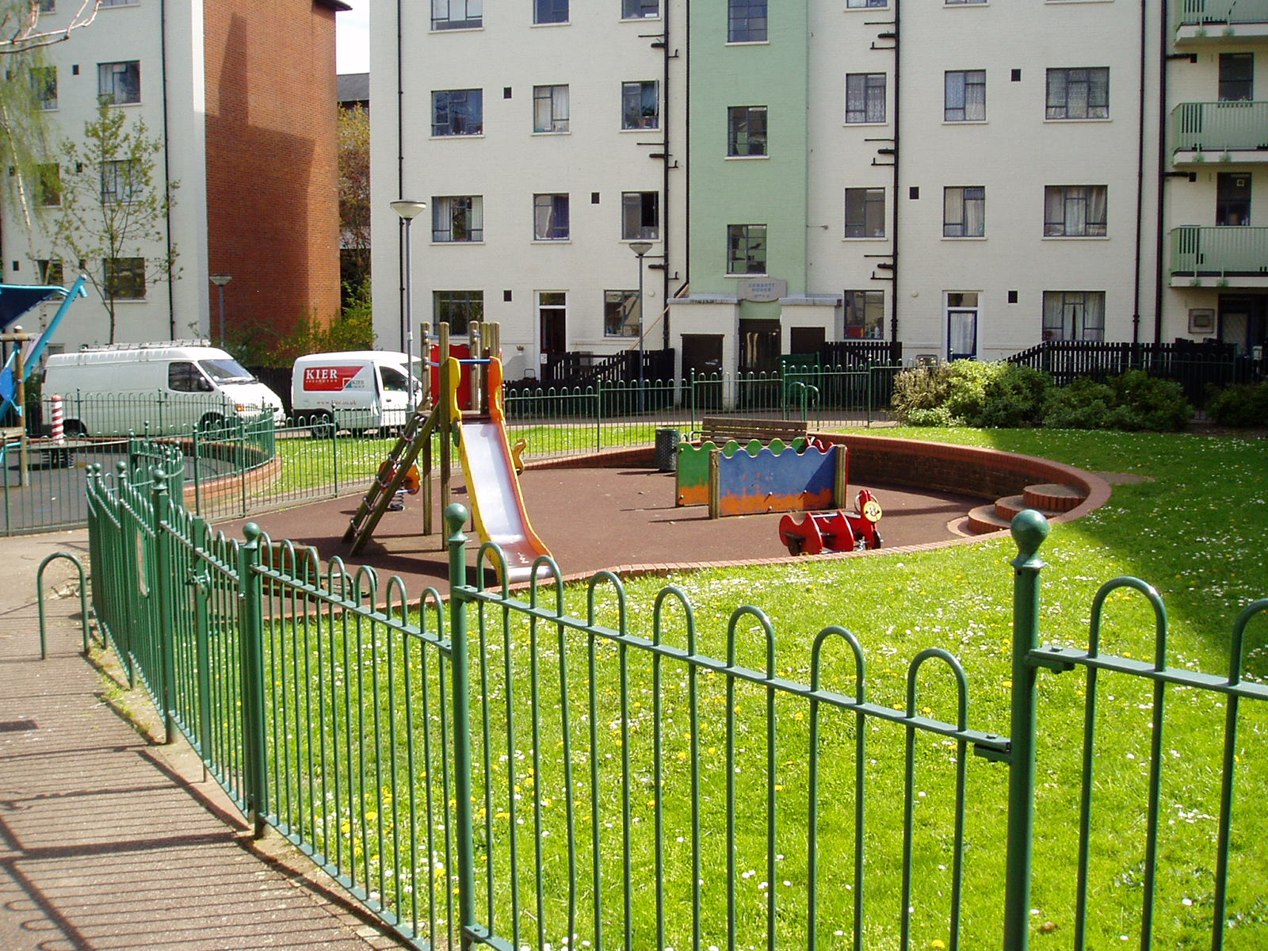

Key partners:

- Brecknock Road Estate Tenants and Residents Association (BRETRA) (Judith Williamson – Chair)
- Groundwork North London (James Littlewood, Operations Director and Tom Landell-Mills, Senior Landscape Architect)
- Homes for Islington (Liza Durrant, Community and Service Development Officer)

Funding:

Name of source / funder(s) | £
Big Lottery | £63,400
LBI | £15,000
Neighbourhood Renewal Fund | £39,885
Islington Tenants’ Compact | £30,007
Awards for All | £5,000
TOTAL | £153,292

Project evaluation and assessment:

Post completion project evaluation and assessment was undertaken. The review was undertaken on the project one year after completion during November and December 2007. A number of methods were used which included a questionnaire, interviews, observations and a site audit and assessment survey (full details please refer to the RETILE COMBEEP methodology document).

A questionnaire survey developed within the RETILE project was conducted both on-site and via the post with residents living on the estate. The aim was to understand the impact the project has had on the residents.

36 questionnaire surveys were completed, key findings included:
Both courtyards were completely renovated providing spaces for all the local community to play, socialise and relax – and in turn this has improved the quality of life of people living on the estate and their pride in where they live. The residents’ involvement in the scheme has raised their levels of empowerment. The estate was also featured in a double page spread in the Homes for Islington magazine which goes to all Homes for Islington Tenants (estimated around 40,000 households). The improvements were launched by the local MP Jeremy Corbyn.

Residents have shown what improvements they can achieve if they want to. This has improved their self confidence and belief in getting other improvements for their estate.

Residents have learnt new skills in planning, dealing with contractors, dealing with project budgets, gaining consensus amongst themselves, organising events and gardening.

Unsafe play areas have been made safe. Positive activities have been provided for young people to help discourage anti-social behaviour.

The project has brought together all residents on the Brecknock Estate who have worked together to agree the improvements they wanted on their estate, to help implement the improvements and to hold a celebratory event. For example this has involved children on the estate choosing the play equipment – in doing so they have worked with the older residents on the estate. Children and older people have also worked together to plant some of the soft landscaping and will continue to look after this. In addition both young and old worked together to plan and run the Brecknock Carnival which celebrated the completion of the main works.

Residents have learnt new skills in planning, dealing with contractors, dealing with project budgets, gaining consensus amongst themselves, organising events and gardening.

The project has brought together all residents on the Brecknock Estate who have worked together to agree the improvements they wanted on their estate, to help implement the improvements and to hold a celebratory event. For example this has involved children on the estate choosing the play equipment – in doing so they have worked with the older residents on the estate. Children and older people have also worked together to plant some of the soft landscaping and will continue to look after this. In addition both young and old worked together to plan and run the Brecknock Carnival which celebrated the completion of the main works.

Two interviews were undertaken.
Interviews were undertaken with the key partners to understand the processes interaction between different project stakeholders and their experiences and impacts of being involved within the project. See the methodology document for the interview schedule.

Key points to come out of the interviews included:
- Processes around communication and roles within the project should have clarified at the beginning
- The project brought the residents of the estate together and encouraged participation through fun days and planting days
- Many of the issues that slowed the project down were put down to ‘clashes of personalities’
- While the project was time consuming it was perceived as a success by the landowners HFI
- Both interviews highlighted the need to manage the expectations of all partners involved in the project

Project Audit and Assessment
A project audit and assessment tool (details outlined in methodology document) was used to review the condition, quality and fitness for purpose of the courtyards (output evaluation). The tool enabled the measurement of quality of the courtyards, aiming to identify any strengths and weakness of courtyards. The audit and assessment sheet outlined certain quality criteria, which were both rated and commented upon. The rating system is based on a point score between 0 and 4, they have been made specific for each category, but follow the general principles of: 0 – Not relevant, 1 – Poor in condition, quality or suitability, 2 – Unsatisfactory in condition, quality or suitability, 3 – Satisfactory in condition, quality or suitability, 4 – Good in condition, quality or suitability. This was undertaken during a site visit to the project by a Groundwork member of staff independent to the project.

The average ratings for both the courtyards was 3.6 and both achieved an overall score of 29 out of 40. The main points that were picked up on were that all the equipment needed to be cleaned up, though was generally in good condition, and some maintenance of the planting was required. The safety of the areas needed to considered as some safety surfacing was missing, hidden corners could cause problems and there didn’t seem to be enough access points. On the plus side the areas seemed to be very well used, the design was pleasant and the two areas were generally being well maintained.
Issues which emerged during the project and examples (if any) of how they were tackled:

The information collected from these various methods has been combined, alongside secondary information gathered on the project (e.g. project files, press articles), to understand, review and evaluate the project undertaken on the Brecknock Road Estate.

Project inputs (time, resources, knowledge)
- The TRA was crucial in campaign and fundraising for the refurbishment, in particular it’s chair who took a strong lead on this project. The vision and leadership within the local community was key to the project being delivered and the subsequent activities undertaken.
- Construction over ran- there are a variety of reasons for this:
- The head of the TRA was a particularly strong personality, who had a strong vision of how the courtyard should look. Her commitment to the project meant that she was heavily involved in the project at every stage of its development and implementation
- The contractors were not very quick to address some of the snagging issues during the work, which had pointed out by the TRA.
- The difficulty in to efficiently manage the contractors in line with the expectations of the TRA led to the project over-running

Project processes
- This was an unusual project for Gwk inasmuch as we were not involved until after the initial consultation was completed. Gwk would have found the project easier had they been involved in the initial consultation and design stage
- Roles should have been clearly defined from the start, along with what could be expected from the various stakeholders involved for more efficient project management
- A communication plan was not agreed to from the start, as a result of this partners expected project managers to be readily available at all times, which was not viable.

Project outputs

- The design and appearance of the courtyards: the physical changes that took place on the estate were commented on as a positive output of the project. The audit and assessment tool illustrated that the design, appearance, maintenance of the area was high quality.
- The project audit and assessment enabled the quality of the courtyards to be rated on a number of factors (illustrated in Figure *). As illustrated in Figure * the assessment of the courtyards scored highly in physical appearance, no factor was below satisfactory. Additional comments highlighted that the facilities are in good condition, the play areas look well used, the equipment is in a good, useable condition, the sites look well maintained (when visited, the bins were empty and the grassed areas freshly cut). Regarding the planting, some shrubs at back of play area by swings (in the north courtyard) are overgrown and need trimming back, also a few dead plants need removing.

Project impacts

- The celebration festival has galvanized the community; this has become a yearly event on the estate. Attracts people and residents have commented that it really has brought the community together
- New members of the TRA and increased participation in estate-based community activities such as planting days
- Increased use of court yards by children, parents and young people

Things we’d wish we’d known when the project started:

- Importance of securing funding, it is easier to engage people when they know money is available.
- Vision and leadership within the local community was key to the project being delivered and the subsequent activities undertaken.
- Clarity around purpose and objectives is essential within multi-partner projects;
- Be realistic in timescales and deadlines;
- Ensure that the roles and responsibilities of partners and Groundwork Project Officers are clearly defined from the project outset.
- Not everyone from the local community may want to be involved, but they still benefit. Those people that are, should have the skill, capacity and time to sustain their involvement.
- Keep records and background information so easy to review the project.
- Always keep people up to date with progress throughout the whole life of the project; particularly if there are delays.
- The process of the project matters as well as its outcomes. Involving partners and community should be recognised as an end itself.

More information:
Homes for Islington (Annual Report 2006/2007)

