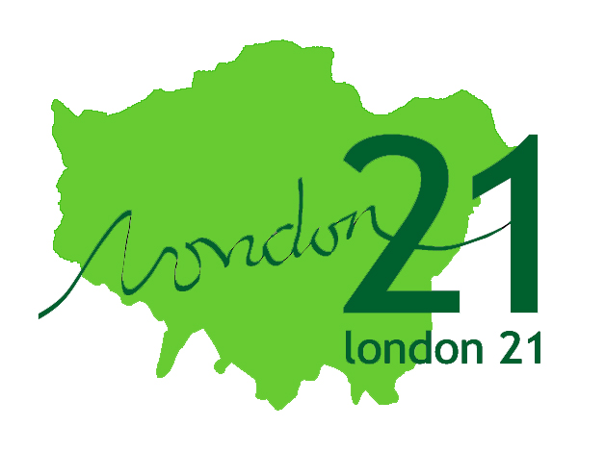


Hackney Wick Community Map
On Saturday 1st March the Mapping Change for Sustainable Communities held the second of our community workshops in collaboration with Planning Aid for London and London Thames Gateway Forum, which marked the launch of a community mapping process in Hackney Wick. We also launched the first pilot version of the Community Maps website, to allow the communication of information collected during this and previous workshops. People have already begun adding information to the map.
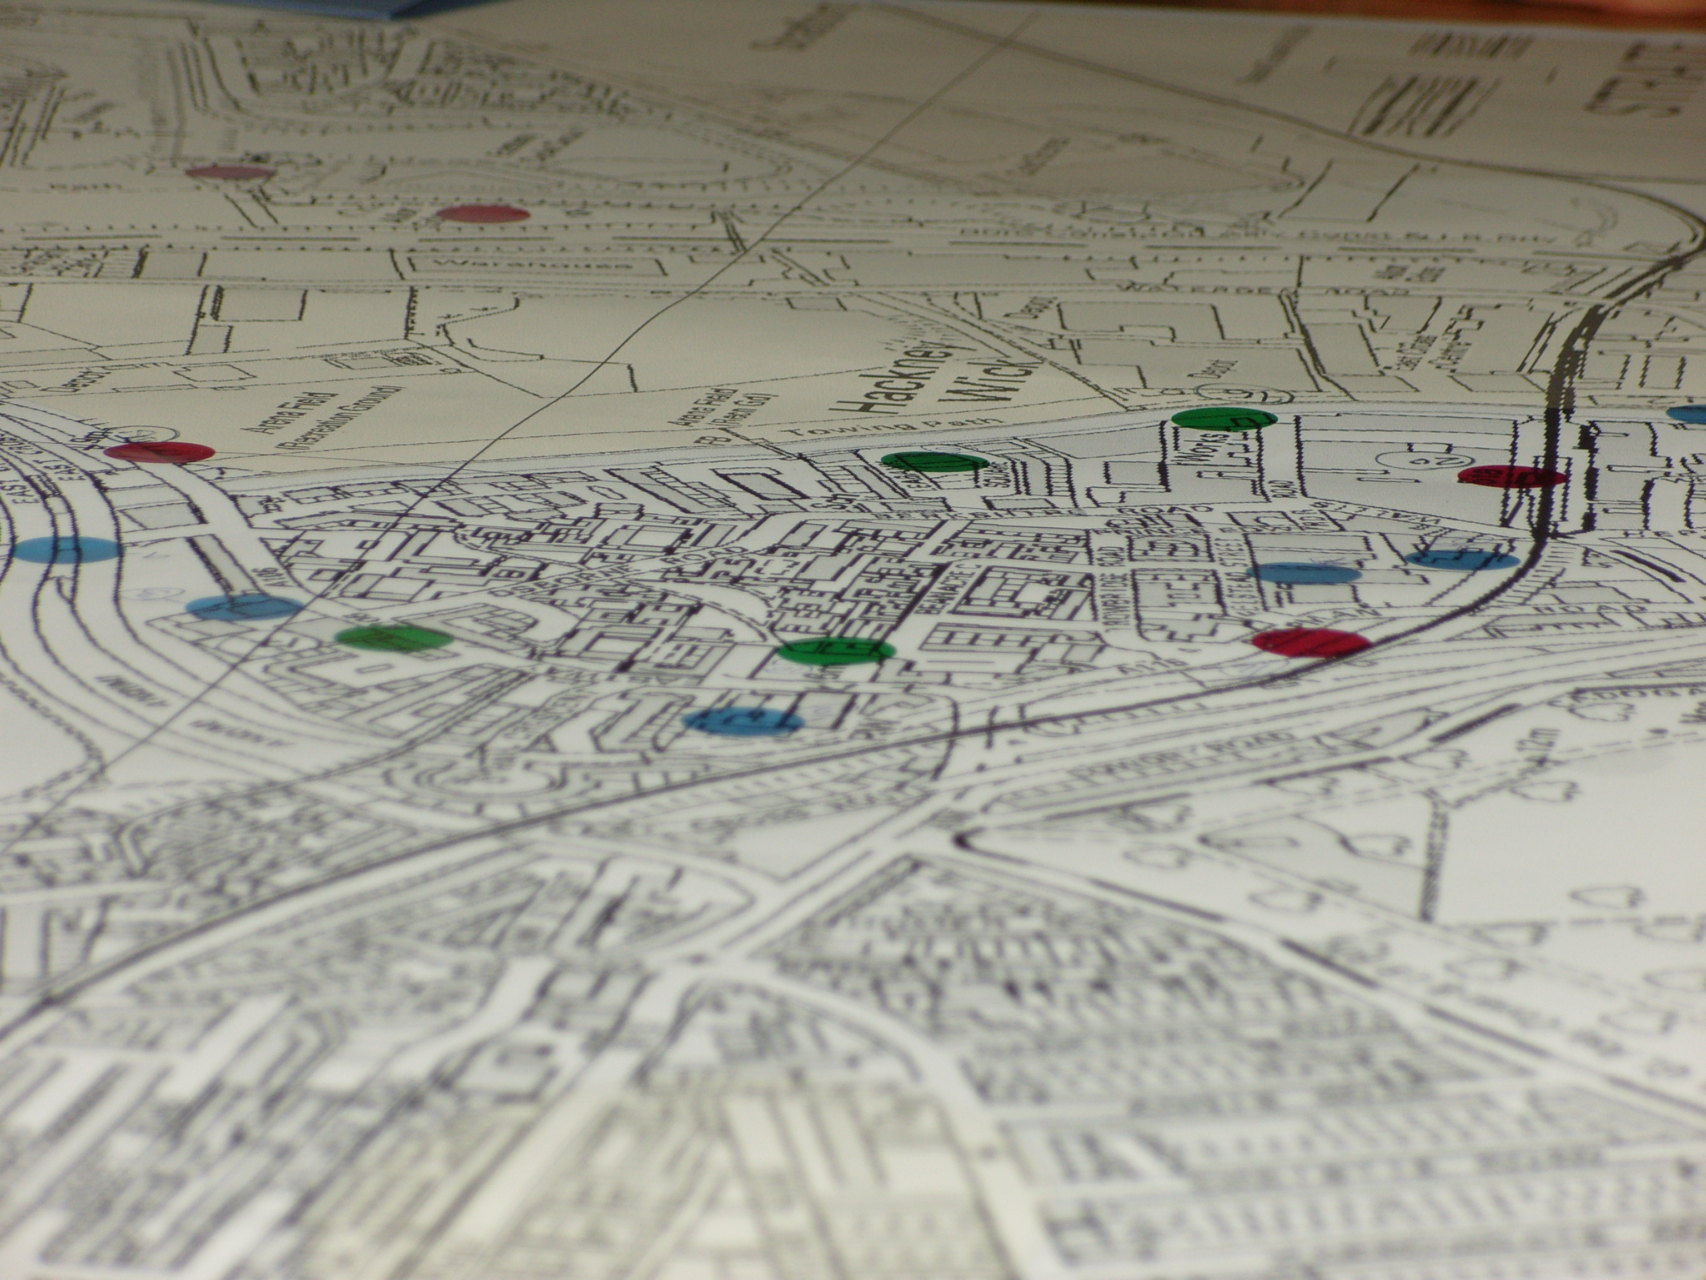
The event was attended by local residents, organisations and representatives of the local authority. Participants made a start by sharing their ideas as to what should be shown on their map and their knowledge of Hackney Wick. A number of local organisations were highlighted, some of which have already been placed on the community map website. See http://www.communitymaps.london21.org.

Local issues and concerns ranged from whether to create a wildflower meadow at Homerton Station, to the loss of Arena Field and Manor Gardens allotments to the Olympic Site. The Hackney Wick community will be encouraged to begin populating the map and to use it as a resource to share information among community members and highlight things people want to celebrate.
Following on from concerns raised at the workshop about the loss of community facilities due to the Olympics development, we have begun assisting the community to develop a historic map layer. The layer will depict elements within the community that have, or will be lost to development, regeneration, and local authority and regional policies. The map will highlight places, facilities and buildings that are important to the community and represent a real sense of loss. A historic map of Hackney Wick will also provide a way to capture local history and heritage, in addition to serving as a ‘community memory’ resource which can be used by all. Many of the elders within the community have amazing stories and can paint images of the area that will be great to capture. It is important to reflect on how Hackney Wick continues to change and ensure that focal elements are not forgotten, but are integrated into new development.

In addition local residents will be working to develop a cycle route element to the community map, which will highlight various routes in and out of the community for cyclists of varying abilities.

We are planning to hold a biomapping workshop within Hackney Wick in the coming weeks.

If you would like to get involved or find out more about the Hackney Wick Community Map please contact:
Louise Francis or Colleen Whitaker
Phone: 020 7471 6795
Email: louise.francis@london21.org
colleen.whitaker@london21.org

