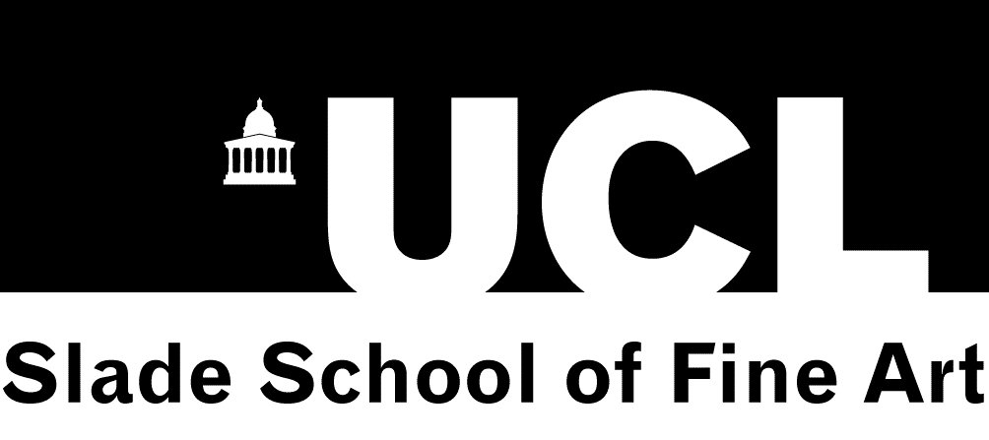
SLADE SCHOOL OF FINE ART SUMMER SCHOOL APPLICATION
S
Personal Detail
Title Choose an item
Click here to enter your Name | Click here to enter your D.O.B.
Name (First, last, middle initial) | Date of Birth
Click here to enter your email address | Click here to enter your post code
Address | Post Code
Click here to enter your phone number | Click here to enter your email address
Primary phone number | Other phone number | Email address

Course Details
Please select your course(s)
☐Summer School Foundation £3,450
☐Drawing £740
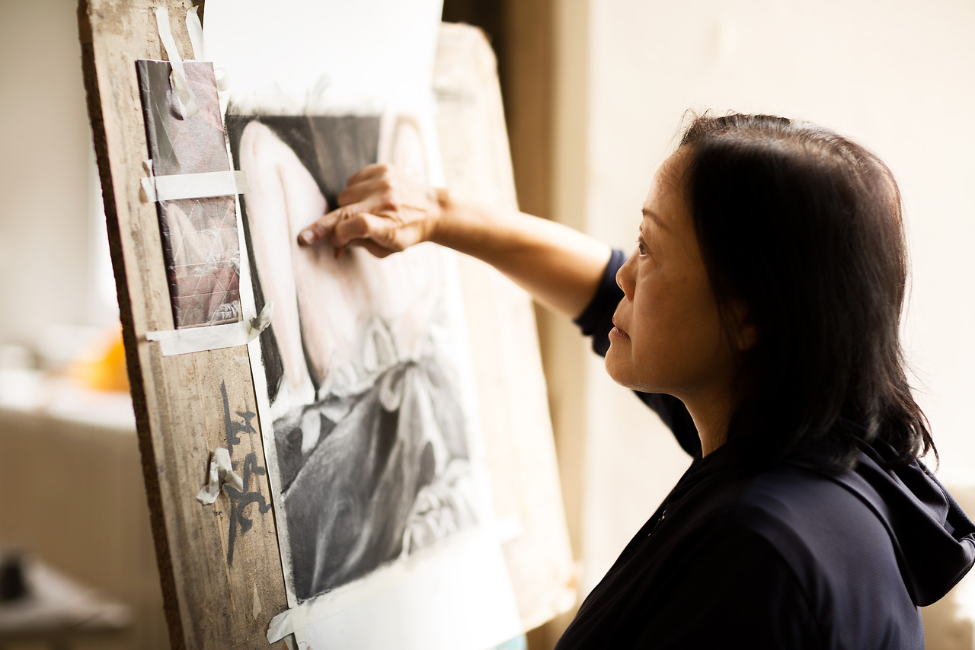
☐Evening Class: Drawing £340
☐Evening Class: Painting £340
☐Etching 1 £390
☐Etching 2 £390
☐Low-Tech Photography £390
☐Wood Engraving Workshop £240
☐From Drawing to Painting £740
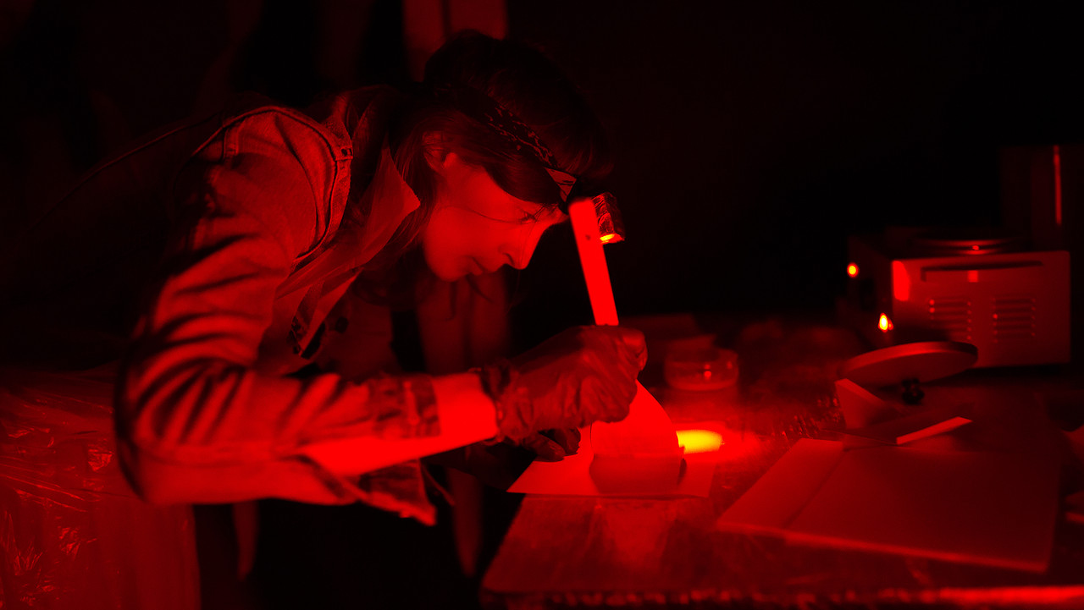
☐Portraiture: A New Perspective £740
☐Painting 1 £740
☐Painting 2 £740
☐Life Drawing £740
☐Contemporary Painting 2 weeks £740
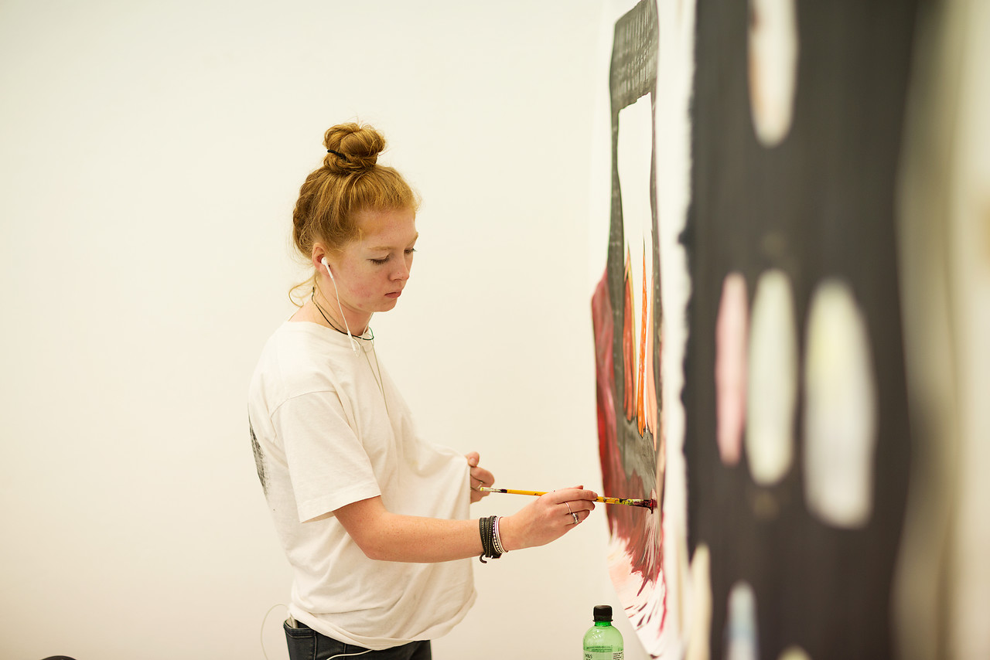
☐Contemporary Painting 3 weeks £1,090
☐Good Artists Copy; Great Artists Steal £390
☐The Expanded Field of Drawing 2 weeks £740
☐The Expanded Field of Drawing 3 weeks £1,090
☐Life Painting £740
☐Material Journeys: Representation into Abstraction £740
☐Colour in Practice: Understanding Colour £740
☐Portraiture: Drawing and Painting the Head £740
☐Life Painting: the Sustained Pose £740

Please select the category that applies to you*
Choose an item
Early Bird Discount are available for anyone booking with discount code.
Please enter Discount Code
Discount are available for UCL current students and staff. Please enter your UPI number available on your UCL card
How did you find out about this course?
☐Slade Website | ☐Recommended by Friend/Colleague | ☐Other Website
☐UCL Short Courses Website  ☐Summer School Flyer | ☐Received Promotional Email From Slade Summer School | ☐Other

Payment of Fees
Summer School Foundation Fees can be paid in full at the time of booking or in two instalments. The first instalment is £ 1,000 and must be paid at the time of booking. The second instalment of £ 2,450 is due before or on the 10th of August 2018. Two/Three-week courses Fees can be paid in full at the time of booking or in two equal instalments. The first instalment is due at the time of booking. The second instalment is due before or on the 10th of August 2018. One-week courses Fees must be paid in full at the time of booking.
Method of payment – Please tick below your method of payment
☐Payment online  You will be sent an automatic email with the online payment link. | ☐Payment by credit/debit card over the phone  Please contact the Slade office on 02076792317 | ☐British cheque  Please make cheque payable to UNIVERSITY COLLEGE LONDON

Terms and Conditions:
Please Note:
1. Please note: all courses are full time (excepting evening classes). Course fee does not include the cost of materials unless otherwise noted. 2. Data Protection Act 1998: The personal information that you give will be used to administer your studies at the Slade School of Fine Art. 3. The language of instruction at UCL is English. Applicants should have a level of spoken English that will allow them to benefit fully from the course. Please contact the Slade office if you would like to discuss this further. 4. If you have a disability we encourage you to contact the Slade office prior to making an application, to discuss any requirements you may have. 5. Slade Short Courses are designed for adults and the students attending our courses usually span a wide range of ages. Applicants who are below the age of 18 (17+) will be asked to provide additional documentation. For full details see: http://www.ucl.ac.uk/slade/shortcourses.

☐ Please tick here to confirm that you agree and accept the terms and conditions

